

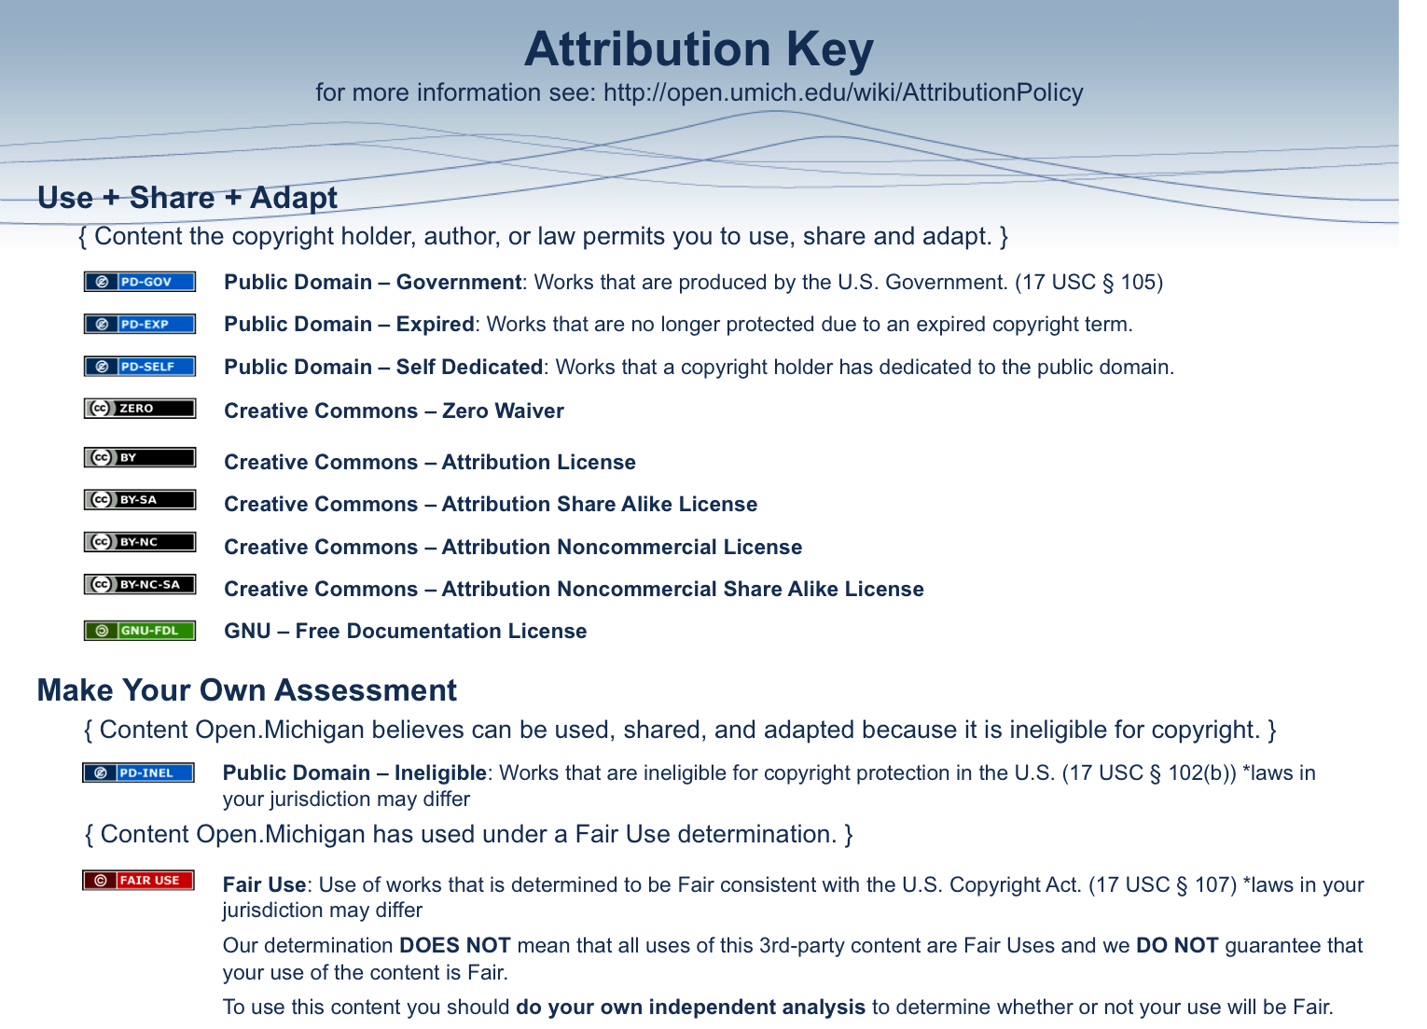

Name: ________________________________________ Date: ______ Nov 2010

Select one:  Dental Student  Resident  COHO* E-mail: ____________________

Applied Cariology – Short Course

Directions: The following questions have been designed to measure your perception of your knowledge, experience, and confidence on various items. With each statement are three indicators of your involvement. For each of the questions indicate how you feel about your knowledge, experience, and confidence.

Example:
Select one indicator in each of the three boxes.
knowledge
low high
1) Perform CPR | A B C D E
experience
low high
2) Perform CPR |  | A B C D E
confidence
low high
3) Perform CPR |  |  | A B C D E
This would mean that I have a great deal of knowledge (response of E=high) about how to perform CPR, I have little experience (response of A=low) performing CPR, but I am moderately confident (response of C=medium) in my ability to perform CPR.

Now continue to complete all of items below.

knowledge
low high
1) Explain the caries process to a patient or a patient’s parent. | A B C D E
experience
low high
2) Explain the caries process to a patient or a patient’s parent. |  | A B C D E
confidence
low high
3) Explain the caries process to a patient or a patient’s parent. |  |  | A B C D E

* COHO: Community Oral Health Officer

knowledge
low high
4) Explain the physiologic demineralization and mineralization processes to a patient. | A B C D E
experience
low high
5) Explain the physiologic demineralization and mineralization processes to a patient. |  | A B C D E
confidence
low high
6) Explain the physiologic demineralization and mineralization processes to a patient. |  |  | A B C D E

knowledge
low high
7) Explain the difference between caries, fluorosis, and erosion to a patient or patient's parent. | A B C D E
experience
low high
8) Explain the difference between caries, fluorosis, and erosion to a patient or patient's parent. |  | A B C D E
confidence
low high
9) Explain the difference between caries, fluorosis, and erosion to a patient or patient's parent. |  |  | A B C D E

knowledge
low high
10) Explain the difference in progression patterns between smooth surface caries and fissure caries to a health care worker. | A B C D E
experience
low high
11) Explain the difference in progression patterns between smooth surface caries and fissure caries to a health care worker. |  | A B C D E
confidence
low high
12) Explain the difference in progression patterns between smooth surface caries and fissure caries to a health care worker. |  |  | A B C D E

knowledge
low high
13) Advise caries management steps to control the disease to patients and patient’s parents. | A B C D E
experience
low high
14) Advise caries management steps to control the disease to patients and patient’s parents. |  | A B C D E
confidence
low high
15) Advise caries management steps to control the disease to patients and patient’s parents. |  |  | A B C D E

knowledge
low high
16) Perform ART as a caries management strategy. | A B C D E
experience
low high
17) Perform ART as a caries management strategy. |  | A B C D E
confidence
low high
18) Perform ART as a caries management strategy. |  |  | A B C D E

knowledge
low high
19) Improve the oral health behavior of my patient. | A B C D E
experience
low high
20) Improve the oral health behavior of my patient. |  | A B C D E
confidence
low high
21) Improve the oral health behavior of my patient. |  |  | A B C D E

Directions: Mark if each of the following statements is either true or false.

 | Statement | True | False
22) | 2002-2005 WHO-data from Ghana showed a 26% increase in caries prevalence. |  | 
23) | Enamel has a tubular, highly inorganic structure. |  | 
24) | The volume% of organic material in dentin is ten times higher than that of enamel. |  | 
25) | In response to a small incipient caries lesion in enamel, the dentin demineralizes and forms reactive dentin. Bacterial invasion is the first step in the caries process. |  | 
26) | Due to its composition, dentin is more vulnerable to the caries process than enamel. |  | 
27) | Once started, the carious process in the enamel spreads in all directions. |  | 
28) | A cavity that is kept clean will remineralize by exposure to healthy saliva. |  | 

Directions: Answer each of the following questions with no more than 5 sentences. Please do not guess. If you do not know the answer, please leave the question blank.

29) | List four things that are necessary for caries disease to progress (Keyes diagram).
30) | What are the two major diseases important for the differential diagnosis of caries?

31) | Describe the start of the caries process resulting in an incipient lesion.
32) | Describe the difference in progression patterns of fissure caries compared to smooth surface caries.
33) | Describe the natural defense mechanisms in dentin and pulp.



