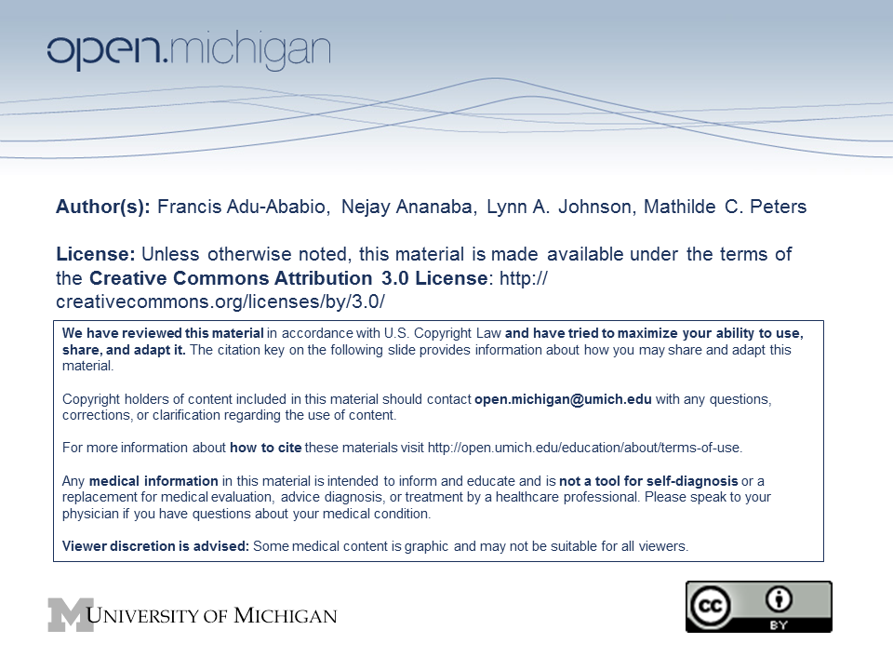
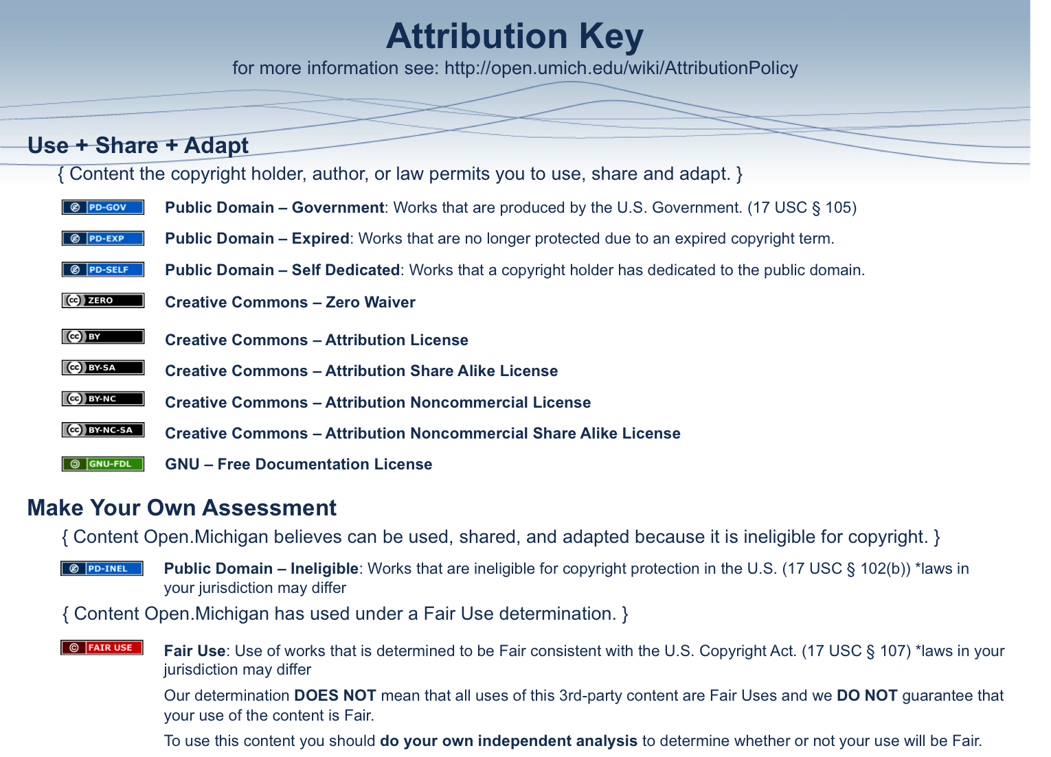

Dr. Francis Adu-Ababio
KNUST
Kumasi, Ghana
Phone: 233-51-60990

SCREENING FORM
Healthy Teeth Project

Study Code: ___________________

Screening Date: _______________________________

Basic School: KNUST/Okyerekrom
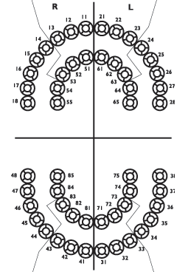
Gender: M / F Age: ___________________

SES: Father’s job: ________________________

Mother’s job: ________________________

Medical History: No special attention / ALERT
If ALERT Please provide details:

DMFT: (count) ________

Potential study teeth: (count) ________

Eligible Teeth | Tooth # | Surfaces Involved (circle)
A |  | M O D B L
B |  | M O D B L
C |  | M O D B L
D |  | M O D B L

DMFT=Count of decayed, missing or filled teeth

