
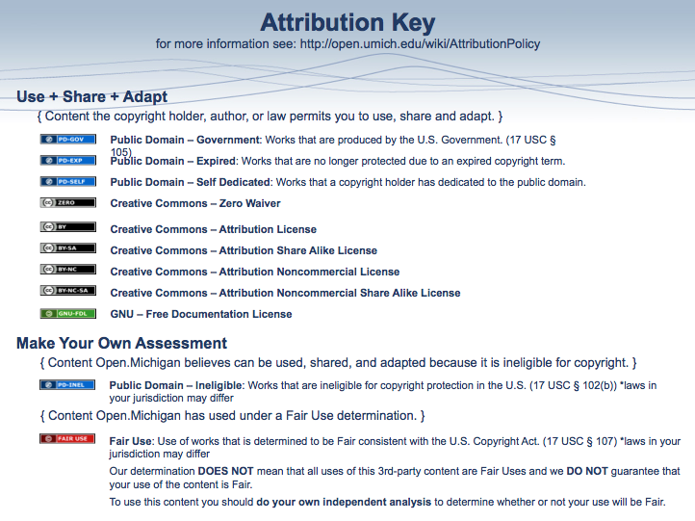

Brain Anatomy Worksheet
Choose the brain structure that has is best described below and then label it on the brain picture below.
a. Spinal Cord | d. Reticular Formation | g. Thalamus | j. Corpus Callosum
b. Medulla Oblongata | e. Midbrain | h. Hypothalamus | k. Cerebral Cortex
c. Pons | f. Cerebellum | i. Pituitary Gland

____ Governs basic movement patterns such as eating, drinking and grooming (e)
____ Forms the most important connection between the two hemispheres of the brain (j)
____ Relays sensory information to higher brain regions (g)
____ Largest structure of the brain containing the four lobes (k)
____ Releases hormones which stimulate and regulate endocrine glands (i)
____ Carries somatosensory information to the brain and carries motor-control information to the motor neurons (a)

____ Regulates motor messages travelling from higher brain regions to the cerebellum (c)
____ Controls vital physiological functions including heartbeat, circulation, and respiration (b)
____ Helps initiate and control rapid movements of the limbs (f)
____ Helps regulate the internal environment of the body (h)
____ Monitors general activity and maintains arousal in the brain (d)
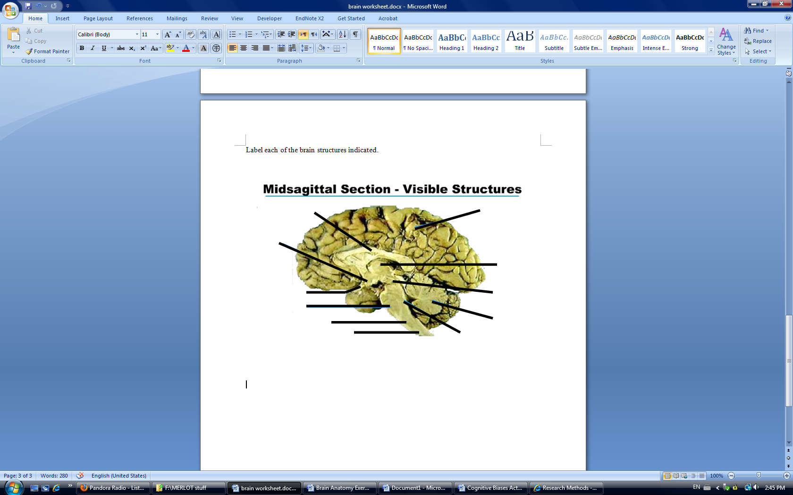

Quiz Questions

- An animal whose spinal cord has been severed from the rest of the brain retains __________. (flexion reflexes)

- The medulla controls functions such as ___________, ___________, and ___________ meaning humans and mammals will ___________ without a functioning medulla. (heartbeat, circulation, and respiration; die)

- The pons regulates motor messages travelling from __________ to ___________. (higher brain regions; cerebellum)

- Severe damage to the reticular formation can lead to ___________. (permanent state of sleep)

- The midbrain acts to modify visual and auditory messages by ________________ _________________________________________________________________. (suppressing or amplifying visual/auditory neural information)

- The cerebellum is most active during _______________ and during ________________. (learning of new movements; unpredictable chains of movement)

- All _______________, excluding those of the ______________, are relayed through the thalamus on their way to the cortex. (sensory messages; sense of smell)

- It is thought that the limbic system evolved from a system for the _______________, explaining why __________________ can be emotionally potent. (sophisticated analysis of smell; odours)

- The hypothalamus is able to regulate _______________ through _____________ receptors within the hypothalamus itself. (blood-sugar levels; glucose)

- The pituitary gland can affect and is affected by emotional states. _________________, for example, can produce hormonal changes that can make an individual more susceptible to ____________________________. (chronic fear or stress; anxiety or depression)

- Severing the corpus callosum can reduce the severity of _________________________. (some forms of epilepsy)

- The primary motor area occupies the _____________ portion of the ____________ lobe. (posterior; frontal)

