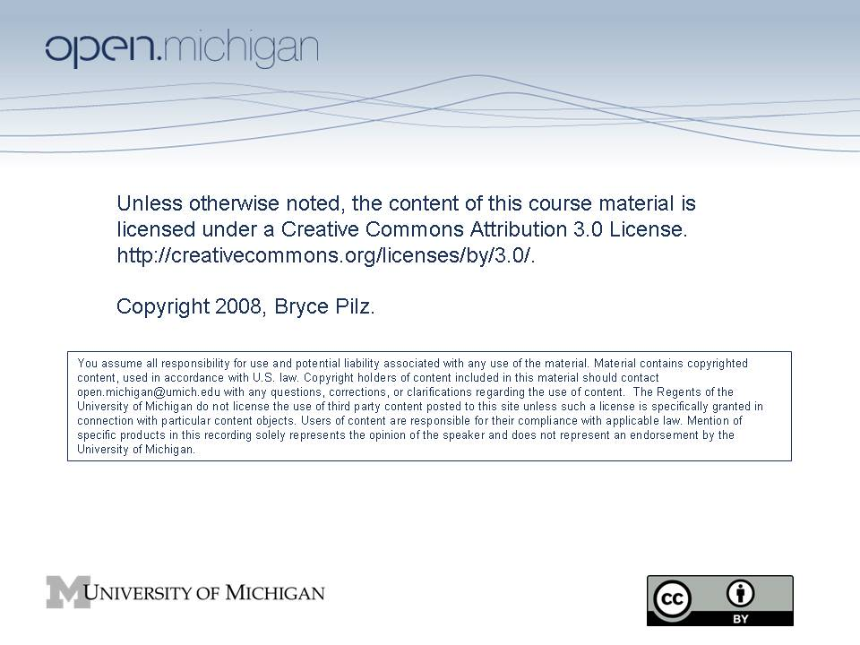

Lori Drew Case – Class Exercise

SI 519 / PubPol 688

Bryce Pilz

Fall 2008

Class 14 – December 5, 2008

Lori Drew Discussion – Group 1: “Breaking Up Is Hard To Do”
After the Lori Drew incident, Missouri enacted new legislation attempting to cover the Drew facts. Analyze this new legislation and identify any concerns you have (for instance under the First Amendment or the statute’s over-breadth). I have highlighted some possible relevant sections in bold.

New Missouri Cyber-bullying Statute (SB 818)

[Available: http://www.senate.mo.gov/08info/BTS_Web/Bill.aspx?SessionType=R&BillID=147]
“1. As used in this section, the following terms shall mean:
(1) `Course of conduct', a pattern of conduct composed of a series of two or more acts, which may include communication by any means, over a period of time, however short, evidencing a continuity of purpose. Constitutionally protected activity is not included. . . .
(2) `Credible threat', a threat communicated with the intent to cause . . . the target . . . to reasonably fear for his or her safety, or the safety of his or her family, or household members or domestic animals or livestock . . . . The threat must be against the life of, or a threat to cause physical injury to, or the kidnapping of, the person or the person’s family, or . . . household members or domestic animals or livestock. . . .
(3) `Harasses', to engage in a course of conduct directed at a specific person that serves no legitimate purpose, that would cause a reasonable person under the circumstances to be frightened, intimidated, or emotionally distressed.
2. A person commits the crime of stalking if he or she purposely and repeatedly, through his or her course of conduct, harasses . . . another person.
3. A person commits the crime of aggravated stalking if he or she purposely and repeatedly, through his or her course of conduct, harasses . . .another person, and:
(1) Makes a credible threat with the intent to place that person in reasonable fear of death or serious physical injury, commits the crime of aggravated stalking; or
(2) At least one of the acts constituting the course of conduct is in violation of an order of protection and the person has received actual notice of such order; or
(3) At least one of the actions constituting the course of conduct is in violation of a condition of probation, parole, pretrial release, or release on bond pending appeal; or
(4) . . . the other person is seventeen years of age or younger and the person harassing the other person is twenty-one years of age or older; or
(5) He or she has previously pleaded guilty to or been found guilty of domestic assault, . . . or any other crime where the other person was the victim.
4. The crime of stalking shall be a class A misdemeanor for the first offense. A second or subsequent offense within five years of a previous finding or plea of guilt . . . shall be a class D felony.
5. The crime of aggravated stalking shall be a class D felony for the first offense. A second or subsequent offense within five years of a previous finding or plea of guilt . . . shall be a class C felony.”

Lori Drew Discussion – Group 2: “Where did it all go wrong?”
Lori Drew was a Missouri resident who used her computer in Missouri to access the Internet and create a fictitious MySpace account. The victim was a local Missouri resident who committed suicide in Missouri based on communications over the Internet with the fictitious MySpace identity created by Drew.
MySpace is a California company that maintains its servers in California.
In order for a federal court to have jurisdiction over an alleged Computer Fraud and Abuse Act (CFAA) violation, the conduct must involve interstate commerce. Do you agree that interstate commerce was involved here?
As between different geographic jurisdictions (like California v. Missouri), criminal jurisdiction generally exists wherever one of the acts of the crime was committed. Recall that the CFAA generally criminalizes:
•Intentionally accessing a computer without authorization; or exceeding authorized access,
•And thereby obtaining information from any protected computer
•Involving interstate or foreign communication
Do you feel that California was an appropriate venue to bring charges? Why or why not? Are there any problems with the fact that Drew might not have had any idea that she was involving California interests (if she was at all)?

Lori Drew Discussion – Group 3: “It’s Just Like Your Mortgage Agreement”
USA Today ran the below editorial this week. What are the author’s key points. Do you agree with him? In particular, do you agree with his analogy between the MySpace Terms of Service and a “No Trespassing” sign? How about the analogy to a mortgage agreement?
Ackerman, Nick. "The law fits the crime." USA Today. 3 December 2008. Find this article at:
http://www.usatoday.com/printedition/news/20081203/oppose03_st.art.htm
Lori Drew Discussion – Group 4: “Let’s Be Civil”
USA Today ran the below editorial this week. What are the author’s key points. Do you agree with her? In particular, do you agree that cyber-bullying cases like the Lori Drew case should appropriately be handled in civil court rather than criminal? A few differences you might want to consider are that civil defendants have far fewer constitutional protections, civil defendants face monetary penalties but not the threat of incarceration, the burden of proof in civil cases is only preponderance of the evidence rather than beyond a reasonable doubt.
"MySpace case bends the law." USA Today. 3 December 2008. Available:

http://www.usatoday.com/printedition/news/20081203/edit03_st.art.htm

Lori Drew Discussion – Group 5: “What About MySpace?”
The article below discusses whether MySpace can be held civilly liable for improper contacts that it is aware that its website enables. Recall that §230 (of the Telecommunications Act of 1996) is typically used to shield service providers for liability for content they publish (such as in defamation claims). Do you feel §230 should shield MySpace for liability in Cyber-bullying cases (under a theory that MySpace should provide better safeguards against Cyber-bullying).

Higgins, Donna. “U.S. Top Court Won't Review Dismissal of MySpace Rape Case.” Find Law. 20 November 2008. Available: http://news.findlaw.com/andrews/bt/cmp/20081120/20081120_doe.html

Lori Drew Discussion – Group 6: “Who’s There?”
You work as a policy analyst for the Obama administration. You have been asked to explore proposing a narrow federal statute to criminalize anonymous users of the Internet who use their anonymity to do really bad things (arguably such as Lori Drew, or perhaps worse). Can you propose such a short statute? Do you fundamentally agree that such a statute is proper, even assuming it could be narrowly tailored to capture only the really “bad stuff.”
As one example, pending federal legislation (H.R.6123 Megan Meier Cyberbullying Prevention Act) targets anyone who uses “electronic means” to transmit “in interstate or foreign commerce any communication, with the intent to coerce, intimidate, harass, or cause emotional distress to a person.” Many have criticized this has too broad because of ambiguity of the alleged misdeeds. Could you narrow this statute to apply only to certain misdeeds and in the context of using the anonymity of the Internet?

