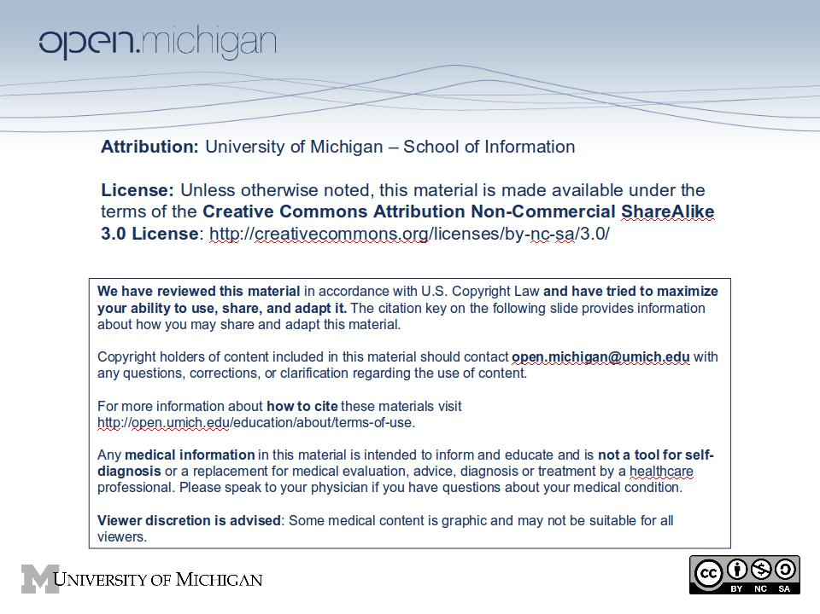

Courtesy Allison Muri, http://headlesschicken.ca/eng204/texts/MedievalSatire/index.html Jan 2007

The History and Future of the Book

14th- & 15th-century Satire
These are some satirical images taken from 14th- and 15th-century manuscripts found in the Liber Floridus database, which contains images of illuminated manuscripts from the Mazarine and the Sainte-Geneviève libraries in Paris.
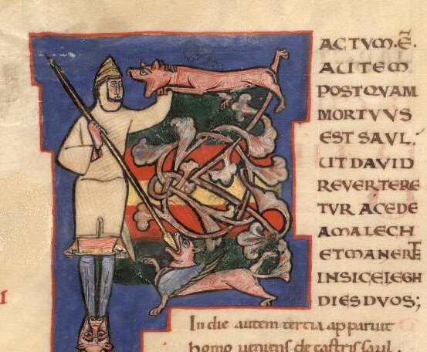
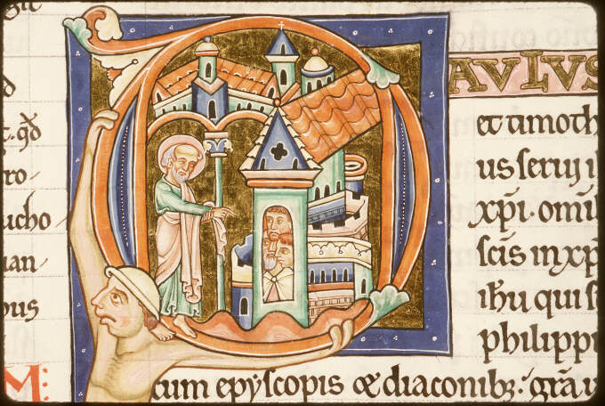
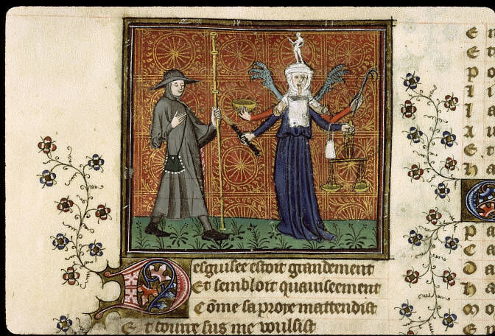
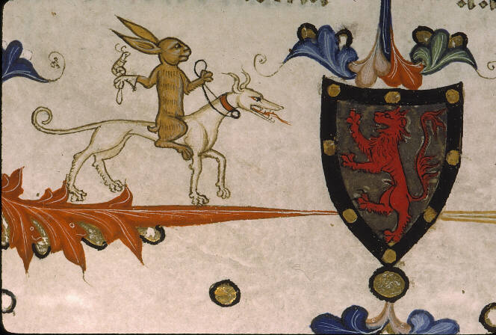
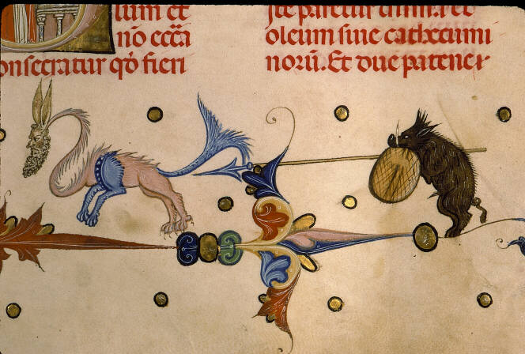
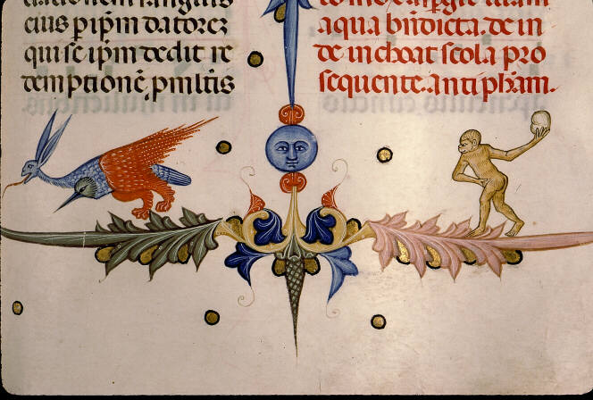

Source:

Courtesy Allison Muri, http://headlesschicken.ca/eng204/texts/MedievalSatire/index.html Jan 2007

