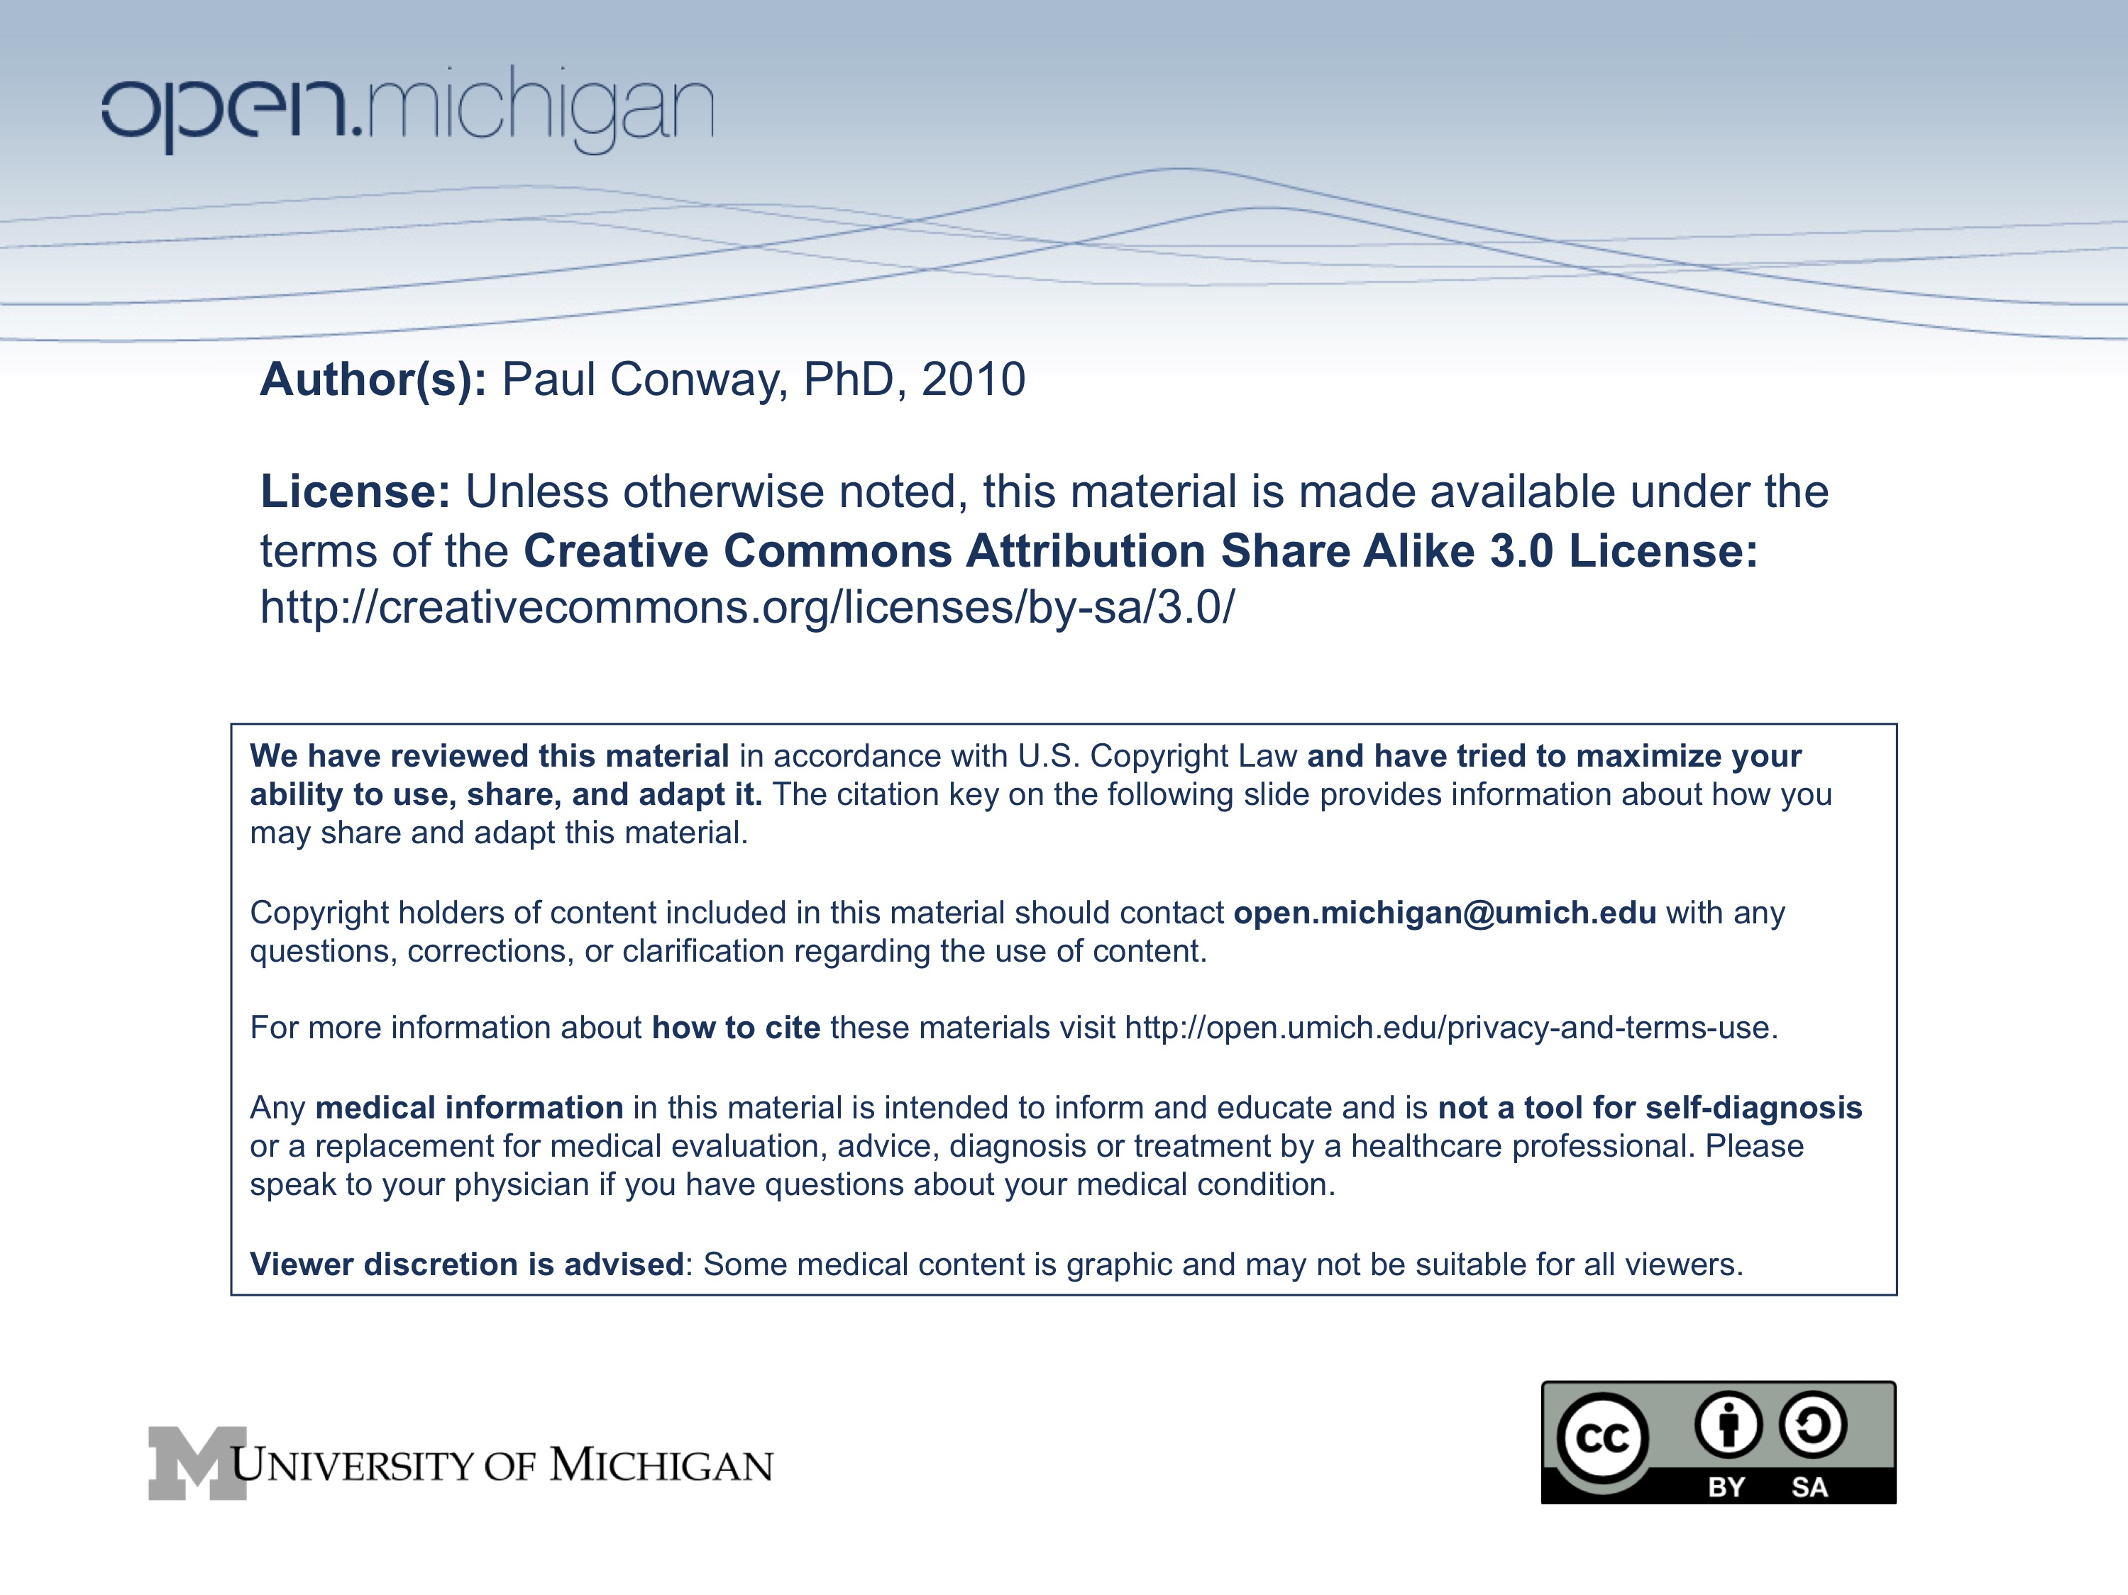


SI 410 Ethics and Information Technology

Schedule

Week 1: Ethics and Information Technology Discussion Guide 1
7 September Course Logistics (+ ethics survey) Essay Assignment
8 September Lab: Using Library Electronic Resources (Scott Dennis, MLibrary)
9 September Computer Ethics

Week 2: Ethics and Information Technology
14 September Models
15 September Lab: Essay Writing Fundamentals (Sweetland Center)
16 September Infosphere Due: Essay Topic (4:00 pm)

Week 3: Ethics and Information Technology
21 September Philosophy and Object Oriented Programming (Guest)
22 September Lab: Personal Ethical Behavior (findings of survey)
23 September Back to the Really Big Picture

Week 4: Information Integrity Discussion Guide 2
28 September Boundaries of Trust Due: 1st Draft of Essay
29 September Lab: Introduction to MediaWiki MediaWiki Assignment
30 September Wikipedia as an Information System

Week 5: Information Integrity
5 October Wikipedia and Trust Management
6 October Lab: Advanced MediaWiki
7 October Wikipedia and Anonymity Due: 1st MediaWiki Entries

Week 6: Information Integrity
12 October Plagiarism in the Online Environment
13 October Discussion: Integrity and Trust
14 October Enforcing Integrity

Week 7: Presentations
19 October Study Break: No Class Today
20 October Lab: Student Presentations on MediaWiki Due: Revised Essay
21 October Student Presentations on MediaWiki

Week 8: Avatars & Identity Discussion Guide 3
26 October What is an avatar?
27 October Lab: Briefing on Assignment and Tools Avatar Assignment
28 October Identity in Cyberspace

Week 9: Avatars & Identity
2 November Avatars: Continuum or Prosthesis
3 November Lab: Avatar Construction
4 November Avatars and Anonymity

Week 10: Avatars & Identity
9 November Privacy Reconsidered
10 November Lab: Unreal Engine Game Scenario Assignment
11 November Synthesis of Identity and Virtuality Due: Avatar Reflection

Week 11: Virtual Environments Discussion Guide 4
16 November Ethics of Game Play
17 November Lab: Unreal Engine
18 November War Gaming

Week 12: Virtual Environments
23 November Gaining Advantage in Virtual Environments
24 November Lab: Bartle Test of Gaming Personality
25 November Thanksgiving Break

Week 13: Virtual Environments
30 November Games and Gender
1 December Lab: Virtual Environments Free Time
2 December Rape in Cyberspace Revisited Due: Game Scenario (Team)

Week 14: Ethics and Information Technology
7 December Team Presentations on Virtual Environments
8 December Lab: Team Presentations on Virtual Environments
9 December Making Sense of Ethics and Information Technology

13 December (11:55 pm) Due: Final MediaWiki Entries + All Excused Late Work

