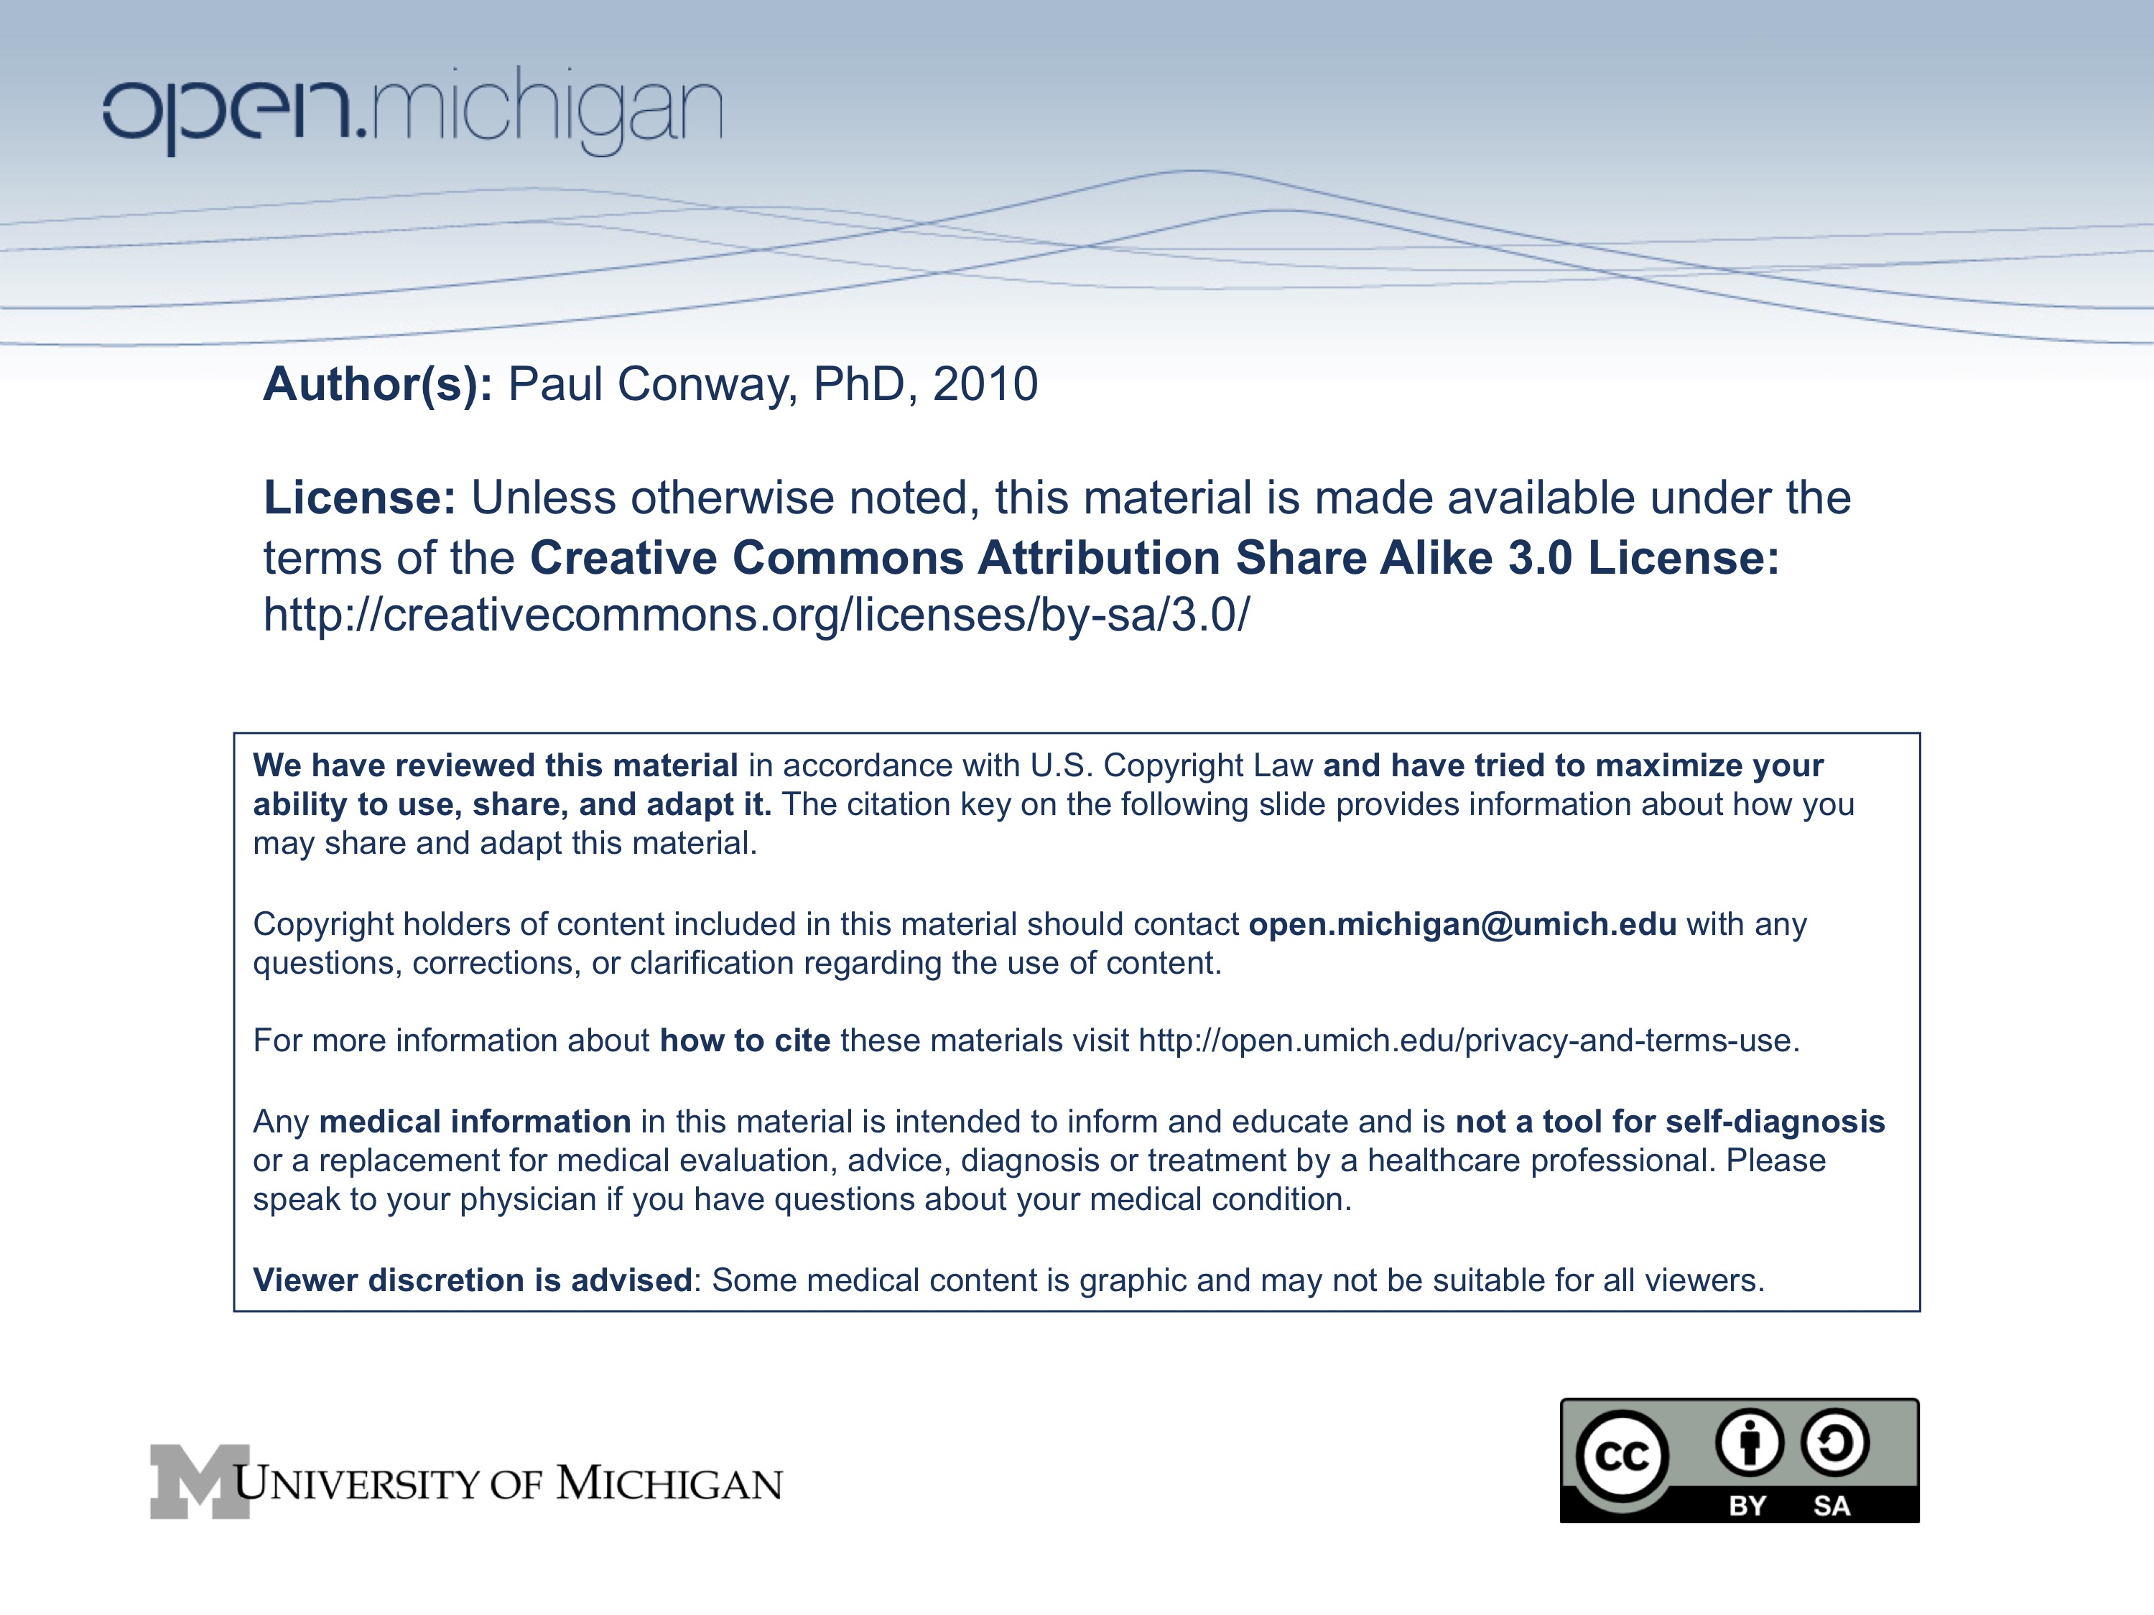



Collaborative Wiki Writing and Editing [25% of total grade]

Concept

This is the second gradable assignment for SI 410 Ethics and Information Technology. The assignment is designed to accomplish four interrelated goals.
- Learn some of the mechanics of writing with the assistance of a collaborative wiki tool.
- Model the writing style and structure of collaboratively developed encyclopedias.
- Expose some of the ethical dilemmas that accompany collaborative writing and editing in a wiki environment.
- Synthesize and extend the philosophical concepts of the course.
Since this assignment contributes toward your satisfaction of the LS&A Upper Level Writing Requirement, the principal focus of the the work is on producing a specific written article for the class wiki and then editing your work and the writing of other students in the class. The net result is a useful compendium of articles on ethics and information technology.

How to Get Started

The class MediaWiki site is the location for all of the writing and editorial work for the assignment. It is accessible through the course CTools site. (“Wiki)

Make sure you are comfortable using the basic writing and editing tools at MediaWiki. An excellent set of help pages is available through MediaWiki [http://www.mediawiki.org/wiki/Help:Contents] and through the “Help” link in the class MediaWiki site.

Procedures

1. Choose a topic and create a stub. Any concept, person, or object covered in the course may be used as the focal point for the article you prepare. You must identify a unique topic; i.e., two students in the class may not draft an initial article on the same topic. Create a stud article and enter the topic on the index page, with a link to your stub article.
Concept. Ideas such as “information integrity,” “privacy in the online environment,” “virtual reality,” “Infosphere,” “digital ontology,” are all drawn from the course readings and discussion. It is also acceptable to extend the course concepts into the realm of new and popular media (e.g., “virtual reality in film,” “rock and roll and technology,” “technology ethics in the movies,”) or to apply the concepts in an international or multicultural setting (e.g., women and new media in China). Follow your own personal interests and apply them to the assignment. Use the syllabus and the reading/discussion guides as a key to identifying concepts. The syllabus and reading guides will also lead you to articles that you can use to both write your draft article and document your ideas. If you choose this option, you must provide a definition of the concept that relates it directly to ethics and information technology.
Person. You may write a biographical article for the author of any of the articles listed on the syllabus. Some people are more well known and “documentable” then others. You may also write a biographical statement for any person who has advanced the understanding of computer ethics or information ethics in the past 50 years. Some of these people are mentioned in assigned articles but are not themselves authors of articles that you read. If you choose this option, you must be sure to explain what the major contribution(s) the person has made to ethics and information technology.
Object. You may write a descriptive article on an information object (or product) that has or transmits ethical properties. “Avatar,” “LambdaMoo,” “Second Life,” “The Matrix,” “Halo:Reach” are all examples of objects with ethical implications. If you choose this option, you must identify in your draft article the ethical issues associated with your object.

2. Find information. Some topics may already have Wikipedia entries and other online encyclopedia entries. It is OK to start with pre-existing information, make major revisions, and then add your own ideas. For example, Luciano Floridi has an entry in Wikipedia that might serve as a point of departure. His entry does not do a very good job describing his ideas, but focuses instead on his biography.

PLAGIARISM ALERT. Do not attempt to pass off Wikipedia entries as our own work. You may start with Wikipedia entries to get ideas, but you must document your starting point. It is extremely easy for the instructor to identify plagiarized content from Wikipedia and other online sources. The opportunity of this assignment is to work with exisiting content as raw material for something you wish to say, while documenting where you got your content and ideas.

3. Write a first draft and submit under your own uniqname. Your first draft should contain between 750 and 1000 words, longer if necessary. Articles that are too short won’t have enough substance to edit. Articles that are too long are hard to read and may require major surgery to make them readable. The technical quality of your initial writing will be stronger if you draft your article in a word processing program and then cut the results into the MediaWiki site. Additionally, if you edit and adapt content that you find in other sources, it will be easier to maintain quality if you paste and edit in a word processing program, then edit and revise within the MediaWiki site.

4. Edit your own work in WikiMedia. Add links, references, illustrations. Add appropriate sub-headings to make the article look and read well. You may undo other student’s editing if you feel that the editing is wrong.

5. Edit someone else’s article with attribution. You may edit the wording to improve the readability. You may correct spelling and punctuation. You may add footnotes, links, illustrations, and even new sections. You may delete portions of the article if you feel that doing so improves understanding. You will not achieve full credit for this assignment without subtantive editorial work on another student’s draft article. Anemic editorial efforts will be penalized up to 5 of 15 grade-points for the assignment.

6. Edit some else’s article anonymously. You will be issued a dummy id and password that will allow you to write and edit in MediaWiki without anyone in the class knowing who you are. Experiment with the use of the power that comes from anonymity. Write about it in the discussion components of one or more articles.

MESSING AROUND ALERT. Sarcasm doesn’t communicate well in a wiki encyclopedia setting. Because this is only an exercise, the instructor is quite tolerant of efforts at humor (lame or not) in this assignment, as long as it is pretty clear what the intent is. Visual puns and humor are easier to grasp than written parody. While we strive for truth in our work here, we have learned that truth is rarely absolute; one person’s truth is another person’s joke. And vice versa.

7. Cross-link articles. Up to five points of extra credit for this assignment will be given to students who create “meta-articles” that pull together two or more individual articles under a broader topic and provide internal links to those individual articles at the WikiMedia site.

Assignment Deadlines

1. [Tues., Sept. 28] Practice logging in; create a stub personal biographical statement; edit a stub; search for a topic.
2. [Wed., Sept. 29] Discussion session on the basics of MediaWiki. Bring your notebook computers to class. Be ready to create a brief biographical statement and create first part of article through a combination of original writing and the editing of already existing content.
3. [Wed., Oct. 6] Discussion session on advanced techniques for MediaWiki, including the use of “Discussion” tabs to identify controversy and conflict surrounding any given article, the addition of illustrations and reference works; combining and massaging groups of articles. Creating “Meta-Articles” with internal cross-links.
4. [Thurs.., Oct. 7] Deadline for submission of your first draft article.
5. [Wed., Nov. 24] Troubleshooting technical aspects.
6. [Mon., Dec. 13] All editorial work complete. At 5:00 pm, the class MediaWiki site will be “frozen” for grading and analysis.

Deliverables

Each student is responsible for making contributions to the collective SI 410 MediaWiki site. Each student must draft and submit one original article on a topic related to Ethics and Information Technology. Each student must edit and improve the work of at least two articles submitted and edited by other students in the class. One editorial exercise must be done for attribution, using your uniqname to log in. One editorial exercise must be done anonymously, using the separate ID/password provided to you. Each student must contribute illustrations to the MediaWiki site. Each student must add at least four references to one or more articles submitted to the MediaWiki site.

Because this assignment is fundamentally about writing and editing in a “wiki mode,” the quality and style of your written contributions and editorial engagement are the most important measure of success. Additionally, because this assignment involves learning how to use a particular software tool in a way that exposes students to the ethical challenges of collaborative authorship, the quantity and variety of your work on the site as a whole is an important measure of success.

Grading

This assignment is worth 25 percent of your total grade (25/100 points) for the class. Grades will be assigned individually, based on the following criteria:
1. Quality of the written article that you submit originally to the MediaWiki course site.
2. Clear evidence of time invested in writing, editing, and adding appropriate illustrations, and other substantive content to the written articles submitted and edited by you and others in the class, as evidenced by your presence in the “History” tabs of multiple article sites.
3. Contributions to the “Discussion” sections of one or more articles, showing where ethical issues arise in the creating or editing of article content.
4. Evidence of ability to describe one or more key ideas covered in the course readings, class lectures, and discussion, in part through the insertion of citations to published readings or links to appropriate websites.
The highest grades for this assignment will go to students who demonstrate a grasp of the distinctive combination of the “wikipedia” style of writing, the acquisition of the technical skills required to display, illustrate, and document the substance of a wiki article, and substantive editorial work on wiki, both anonymously and with attribution.

