Chapter 2

Conference Goals and Results From Needs Assessment

Speakers:
Frank Anderson, University of Michigan
Madeline Taskier, University of Michigan
Gaurang Garg, University of Michigan
Raymond de Vries, University of Michigan

Introduction of the Meeting Framework

Frank Anderson: I’d like everyone to get their folders. I wanted to explain what our meeting framework is like and how we hope to work. From the Call to Action and Way Forward, there were certain categories or buckets that we heard from the participants of the meeting. These are areas that needed to be addressed. And, when all of these areas are addressed, we can come up with a comprehensive training program.

We also tasked a program manager to isolate each one of those areas and that is how we came up with your Needs Assessment. The Needs Assessment form was posted online and we had 100% participation of people filling in that online survey. Madeline and Gaurang are going to give you the results of those Needs Assessments now.

We also took those categories of the Needs Assessment, then we asked for people to submit abstracts in relation to the different categories. We received approximately 25 abstracts, and all of those abstracts are available to you on the Dropbox folder, so you can see what people are doing in the different categories within their projects, so you can learn from that. (See Appendix V.) We wanted to print that, but it is about at least half a cedi to one cedi per page to print here, so it just became too expensive to print. We went green, and it is all available for you online in multiple different places.

So we have the Call to Action, then we have the Needs Assessment. We have abstracts related to those and now we have our agenda set up based on those categories. You can see that our first panel will be on partnership and the partnership development process. That is going to be related to the Charter for Collaboration that is also in your folder. (See Appendix VII.) We'll talk more about that.
Then we are going to talk about models for infrastructure and program design. What does it take to have a department in an African university? What are the physical things that are needed? What are some of the programmatic structures are needed? Another plenary will be tomorrow.

We will talk about curriculum development, clinical teaching, and assessments for OBGYN residencies. We are going to talk about deployment of OBGYNs, working with ministries of health and education, working with communities, other healthcare partners, and faculty development. We will also discuss research, mentoring and evaluation, and quality assessments. We will also talk about certification and accreditation of obstetrician gynecologists. So, those are the main categories, and that is what we are going to hear from people.

Now, if you notice, the last set of pages is a worksheet, and this is called the OBGYN Program Development Worksheet. There are instructions on the worksheet, but basically they are questions that relate to each plenary panel. When you hear a plenary panel, you can look at these questions and you can hear any new ideas that come up from the plenary panels and each plenary panel will also have plenty of time for open mics so people can bring up what has been left out. We can add that to these worksheets and you can go back to your group with your flash drive.

One representative from each group should have a laptop computer so you can start answering these questions for yourselves, figuring out what are the different issues related to the particular topic that we discussed. By the end of the day, you'll have a 5-to-7-page program plan that you will be able to use to keep working with your group to develop, to implement, to look for funding for yourself. You are also invited to submit that to the 1000+ OBGYN Project, and we will put that together as a group. We can approach funders and say, “We as a group of universities and professional societies have all of these people ready.”

There is no RFA for this and no funders are asking us to do this. But here we are together and we have this opportunity to put all of this together and say, “We are here, we are ready to do this”, and I think we will get a response. That is the goal of the meeting, is that we come up as a group with these concrete written plans. Funders want us to have concrete written plans so we can hit the ground running.

The meeting today is not to talk about what we could do, but what we want to do, what we have plans to do. And I would like that by the end of this meeting, we will have a new number. Right now we have 1000+ OBGYNs. The question comes up, how many OBGYNs would we train if we weren’t meeting today and we weren’t going to make these plans? How many would that be in 10 years? And how many versus when we put our minds to it and put our effort to it, how many can we say we can train in 10 years from now? And not just that, but how do we measure the effect, not only in maternal health but also neonatal mortality, especially?

Also, we will have to figure out ways to measure this: case fatality rates, complication rates, and referral rates. We will have a session on monitoring and evaluation and clearly that's an area that still needs to be developed. The way that the conference is set up reflects the Call to Action, reflects our Needs Assessment, and reflects what is in the abstracts. You will all be in the rooms nearby to other countries where you live. There are three breakout rooms where people can work on tables to discuss these issues.

You have visitors from different organizations – ACOG, FIGO, representatives from the Society of Maternal and Fetal Medicine, representatives here from the Association of Professors of Gynecology and Obstetrics, the Council on Resident Education for Obstetrics and Gynecology. And you'll be hearing from them and meeting them all throughout the meeting. There is the capacity and knowledge here to do this, so our job now is to gather that capacity together and shape it in a workable way.

So at this point, let’s move on to Madeline and Gaurang. They have analyzed all the data from the Needs Assessment and have made some beautiful graphs, which are available to you. They will go over the results with you now.

Needs Assessment Results

Madeline Taskier: Hi everyone. We are just going to do a quick presentation. This is Gaurang Garg, by the way.

Gaurang Garg: Hi everyone. Nice meeting you - I’m excited to be here.

Madeline Taskier: We are just going to do a quick presentation on the cross institutional comparisons from the postgraduate training Needs Assessment. The purpose of the assessment is to understand the diverse partnership models. We began assessing interest from the different partnerships who attended the FIGO meeting in Rome, which Gaurang was at as well. The desire to share information and best practices was very clearly expressed. We had a conference call with several of the American representatives who mentioned on the conference call that they really need to understand where we are now and have a baseline that we can talk about during the breakout sessions and during this meeting. The big questions are, “How close are we to the goal of 1000+ OBGYNs, where does each partnership stand, and how best can we pair partnerships together to complement each partner's needs? “.

The method of the survey was helped very much by Joel Segre from the Gates Foundation. We submitted an online survey to all of the partnerships that gathered individual country data which was self-reported by one or two representatives from each country partnership that looked at OBGYN resident rates.

So, how many were in your class – we sort of counted it by class; the department structure; site requirement and capacity – what is your caseload, OR capacity, etc.; curriculum – what is the current curriculum you are operating with now; faculty, faculty development opportunities, research opportunities, certification process – what is your institutional certification process to train OBGYNs; online access to education, research capacity for OBGYNs and faculty members? In many ways the questions were to assist our project with Elevate Health, which you will hear about in a little bit.

Gaurang Garg: Like Frank and Madeline mentioned, we have these really wonderful responses that all of the partnerships gave us. So, thank you first to all of the partnerships for filling the surveys out. After reading through them (they were quite interesting) we had all of them compiled into one document called the Country Report, which is available in Dropbox – that magical thing that Madeline was talking about – and also on your individual flash drives, which you will have during your breakout sessions. For each country – for example, Ghana had three responses, three different medical schools and hospitals that responded – we wanted to put them all together under one country report under Ghana.

The first page of that country report was some basic statistics: some population statistics, economics like GDP and GINI coefficient, and lastly some maternal health statistics from the WHO, just to kind of give an overall profile for the country. You can take a look at what the maternal health care is like currently. There is also a table of all of the medical schools within each country – which we have taken from the Lancet – and whether we have reached out to them through the 2012 FLORA survey that Frank mentioned or this 2014 Needs Assessment. Following that first introductory page is the raw response data from each one of the partnerships. Like I said, if you are in your country teams, you can look at what your colleagues mentioned and wrote, and then if you want, on the flash drive or in Dropbox you can look at what people around sub-Saharan Africa wrote as well.

Current and Aspirational Number of Resident Physicians

One of the first questions that we wanted to ask was, “What are the numbers of residents that you have in your institutions right now, and then what is the cumulative number of residents that you want to train in the next ten years, by 2024?” So here is just a side-by-side comparison of where we are and where we want to be by country. And the next slide is broken down by institution. There were sixteen partners that responded. For each partnership, how many residents do they have right now total between year one and year four or five for some, and then how many do they want to train in total by 2024.

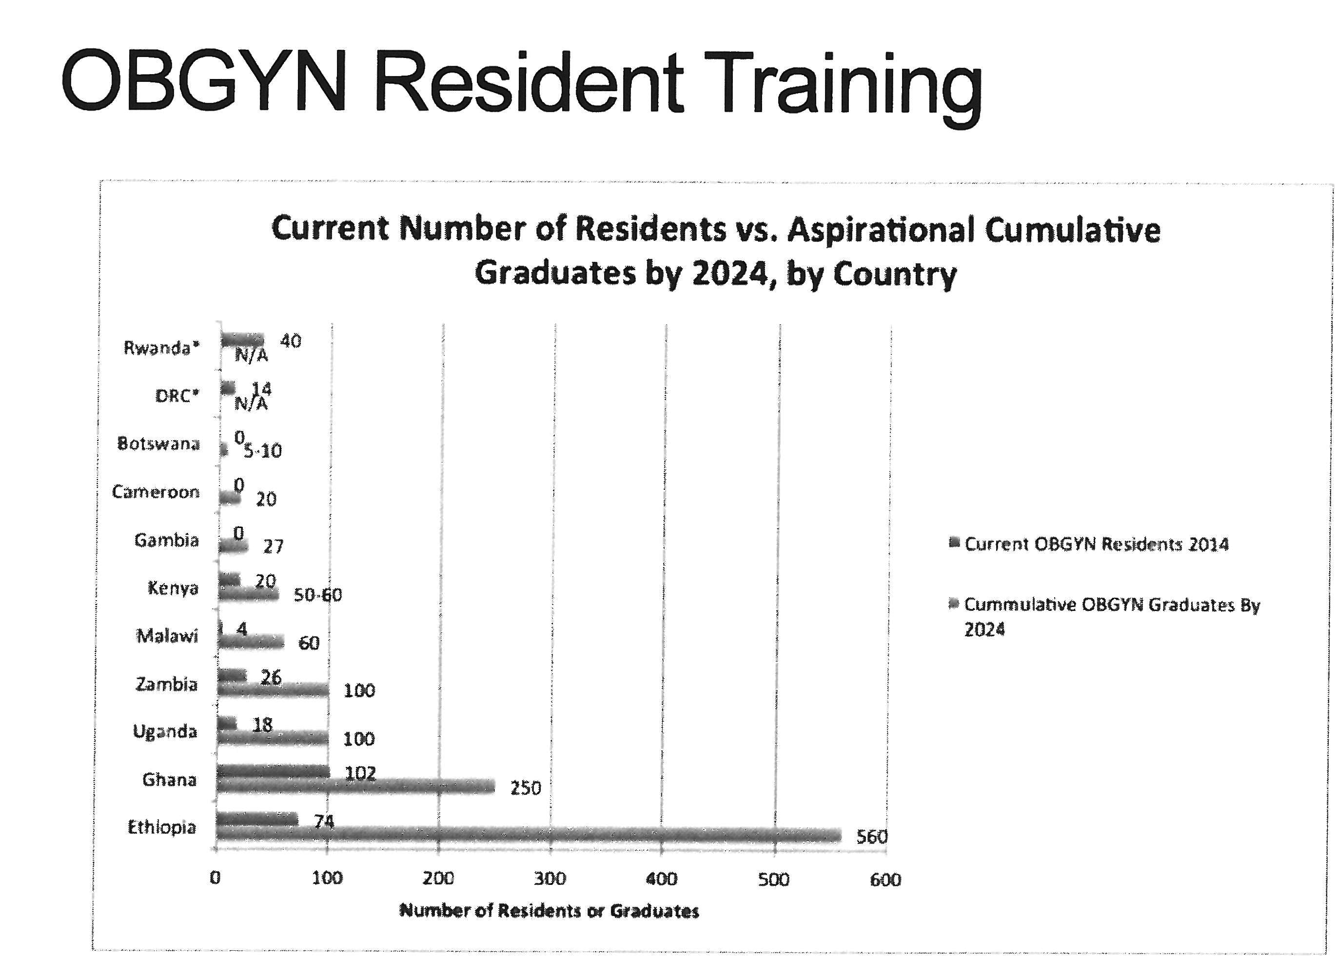

Madeline Taskier: We organized it in ascending order and, as you can see, some of the data shows that there are some program without any residents at this time but they have goals to train over the next several years. If there is no red line, then they do not have current residents – or at least that is how we interpreted the data, please correct us if we are wrong – and you can see how each of the institutional partnerships aspire to train more and scale up. As you can see, if you count the whole total which have on the Country Report but not on this presentation, but it exceeds 1000+ OBGYNs. So the aspirational goal in 10 years from each institution definitely exceeds our proposed number.

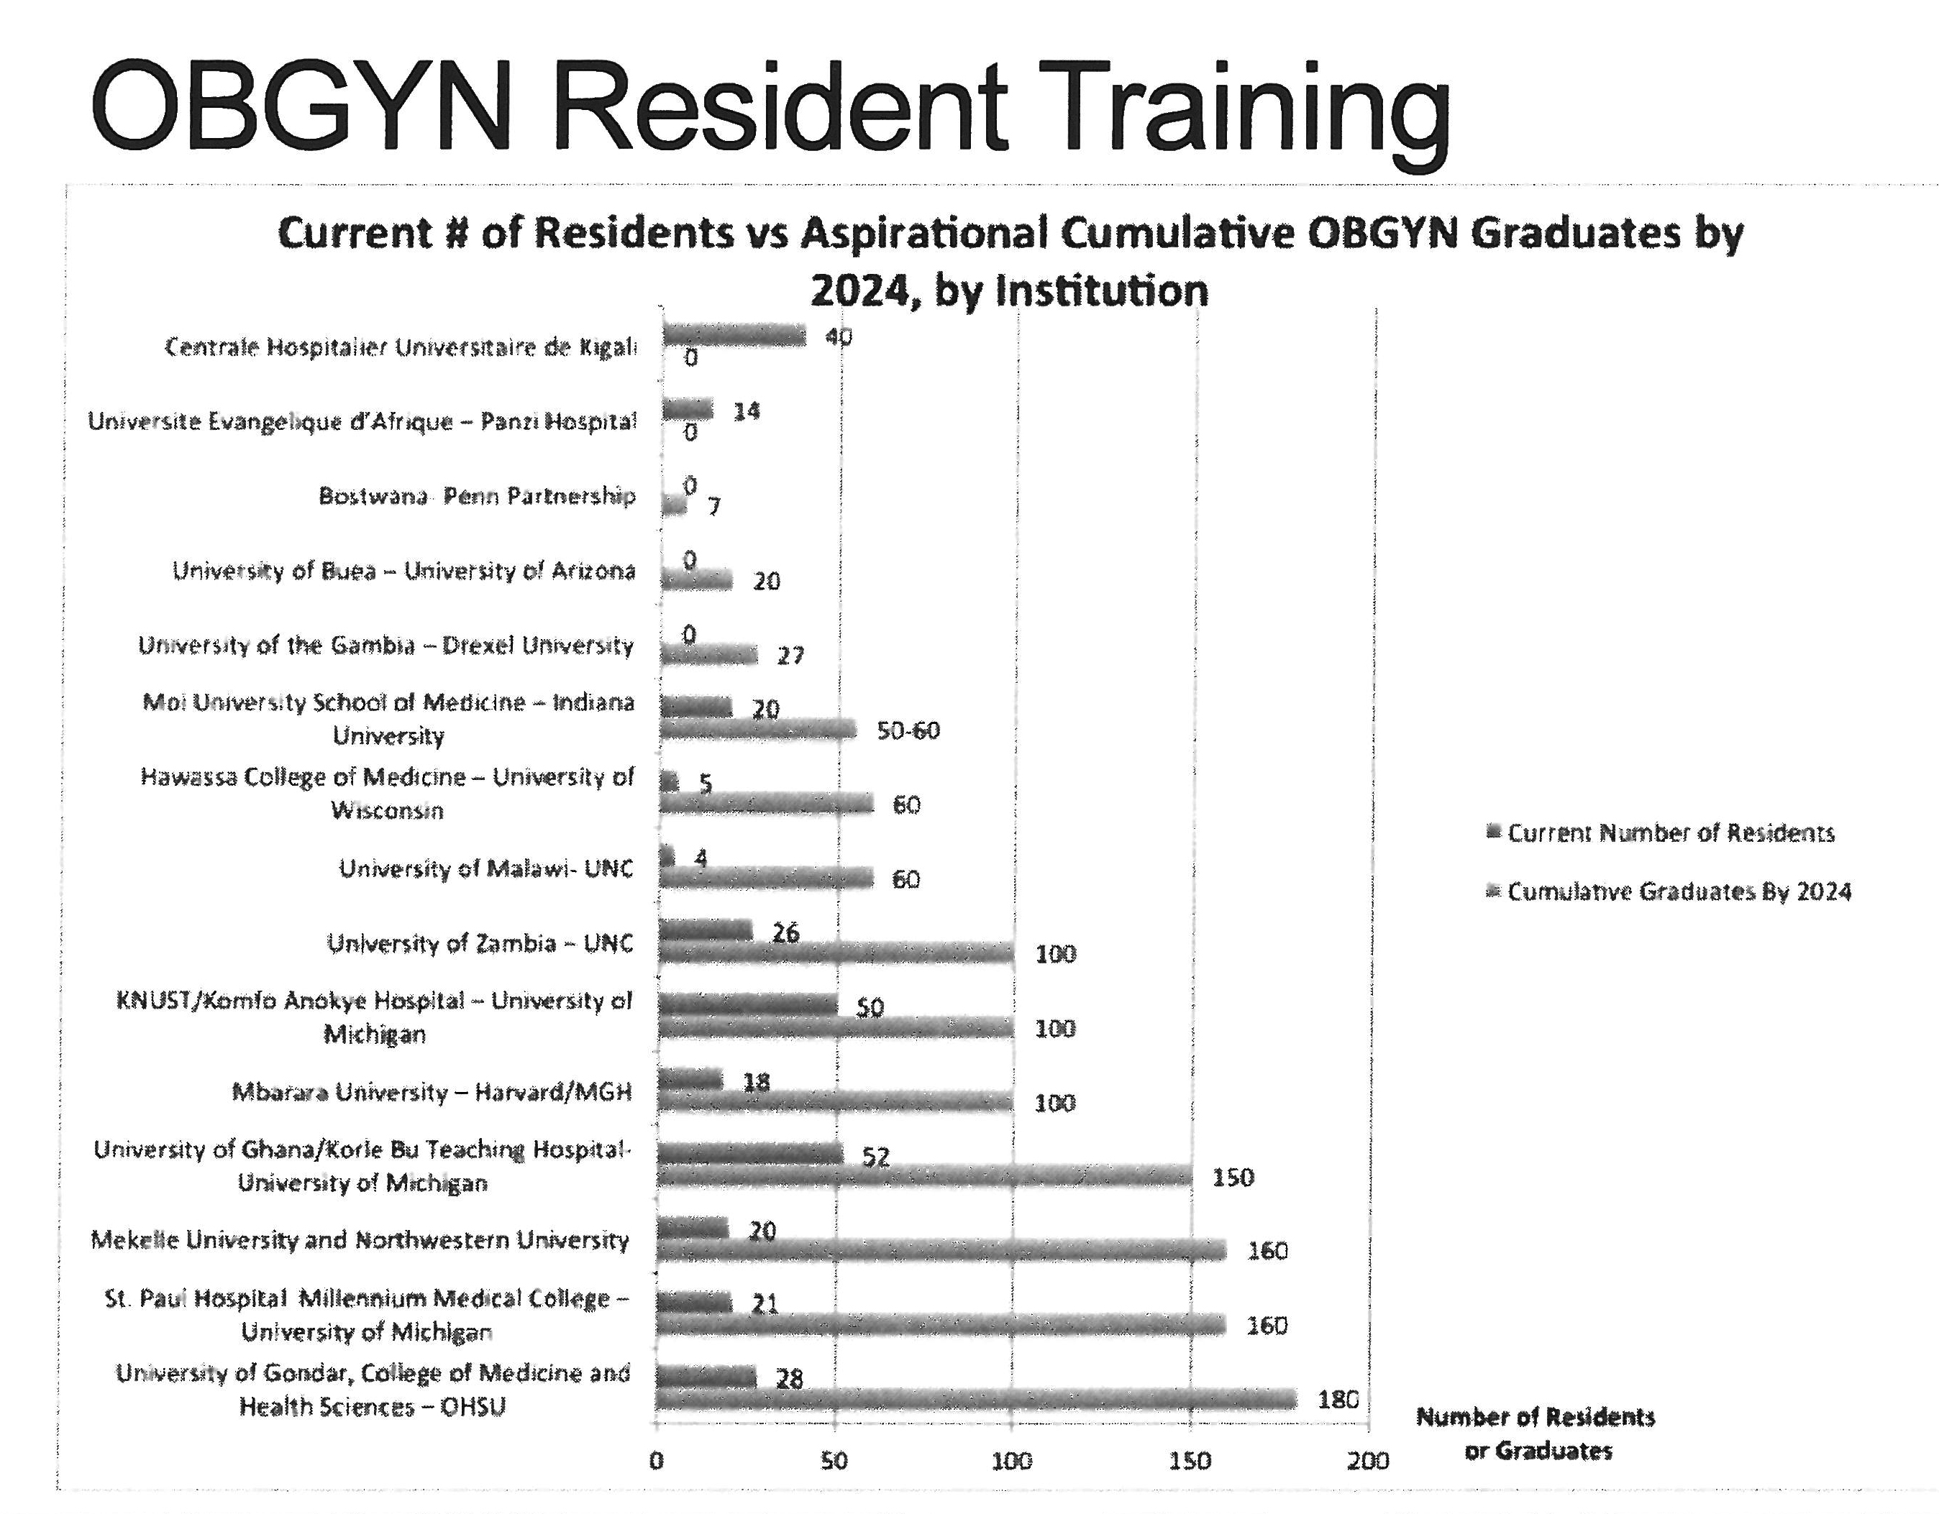

This is another graph looking at the projection of residents in each incoming class. 2014 is in yellow, where we are now; in five years, 2019 is in the red: and in 10 years, 2024 is in the blue. You can see that each program has sort of a gradual scale up.

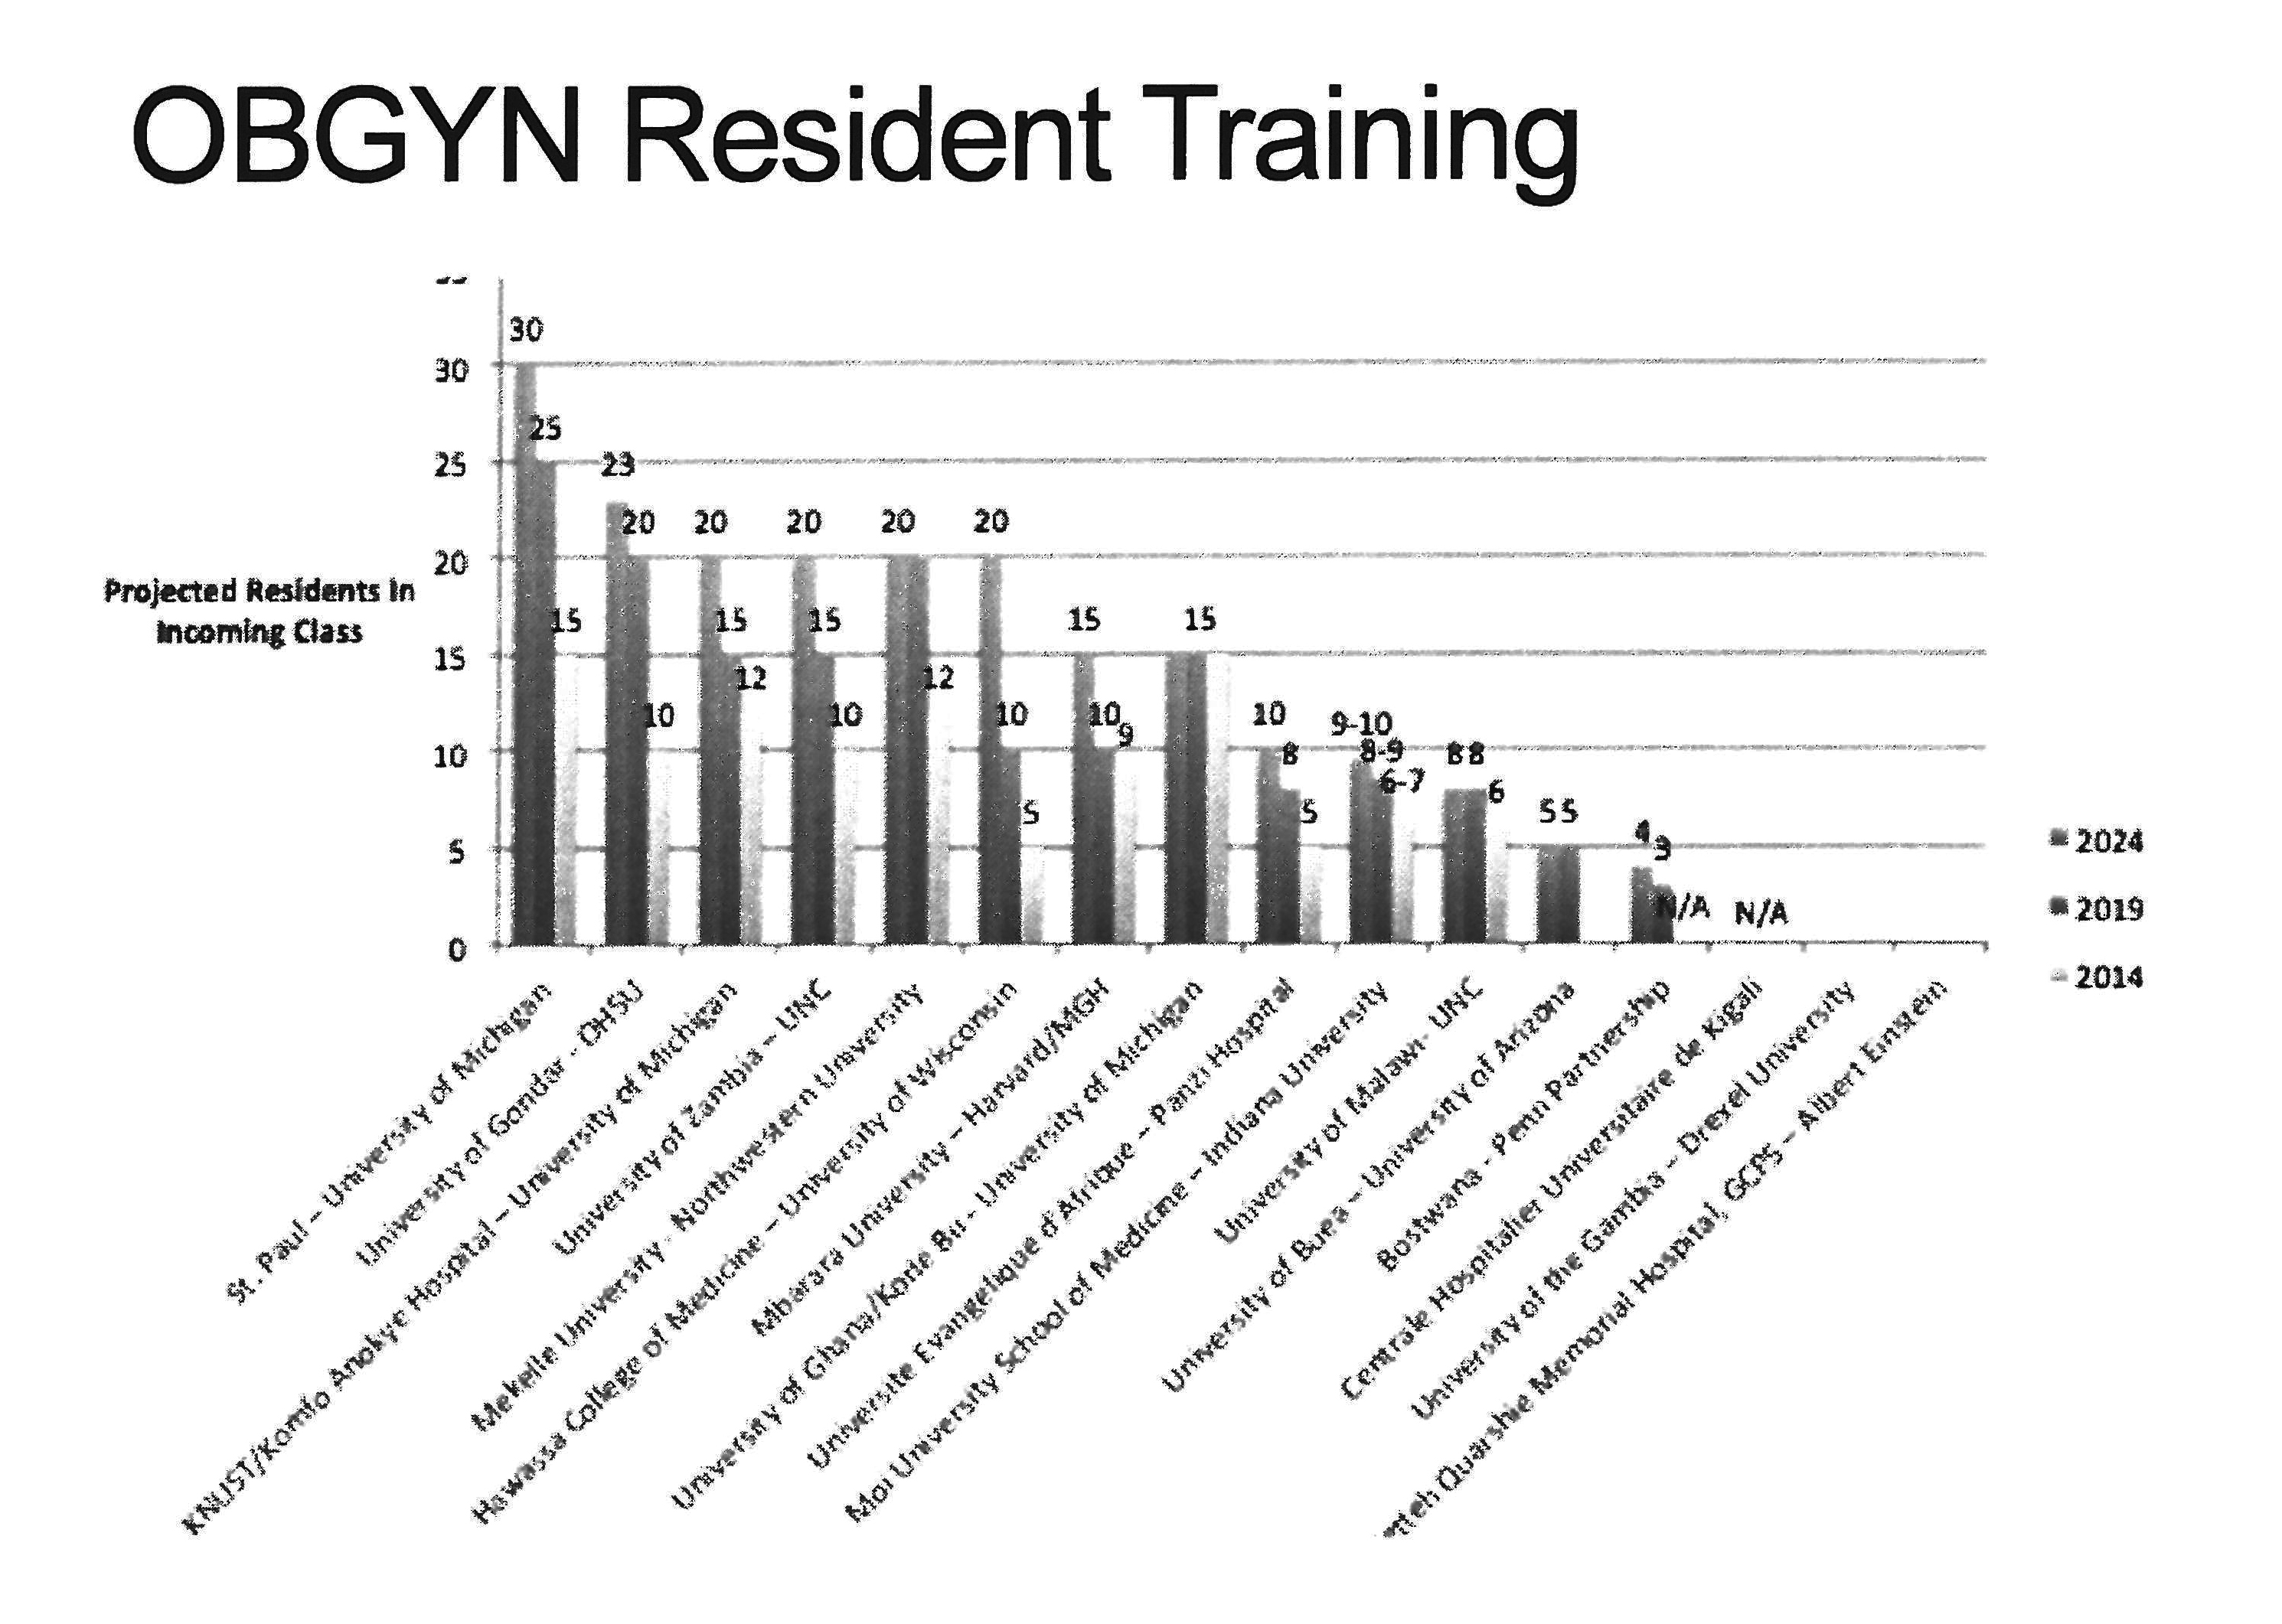

Gaurang Garg: One other interesting aspect is that when you are looking at all of the responses, some partnerships do not have a program right now or they are planning on starting one by 2016 or 2017 (to be decided), so it is interesting to see the scaling progression for all of these institutions.
Case Evaluation

The next phase of questions that we had were related to the number of cases that each institution saw per year. By ‘cases’ we mean deliveries and C-sections. And other questions were, “What is the current capacity in your operating rooms and in your OBGYN clinics?”

Curriculum source

We have a graph that is available to you on your flash drives. What we analyzed was the total number of cases per faculty member per institution. You are able to see this really interesting analysis of the caseload per faculty member in each institution. The departments that have more faculty members - even if they have more cases - seemed to have an easier time of managing it, as is represented by having a lower ratio.

Madeline Taskier: We asked each partnership what the source of their curriculum was, how often it was reviewed, and then a qualitative question on what are their needs overall. We asked each partnership to check off whether there were additional modules included in the curriculum that have been shown to help support and supplement OBGYN resident training, including a management module, research capacity, community rotations, respectful care, and quality improvement. I would say that the majority of responses have research capacity and management modules inserted. Quality improvement and respectful care were about two-thirds, or one-to-two-thirds of all responses.

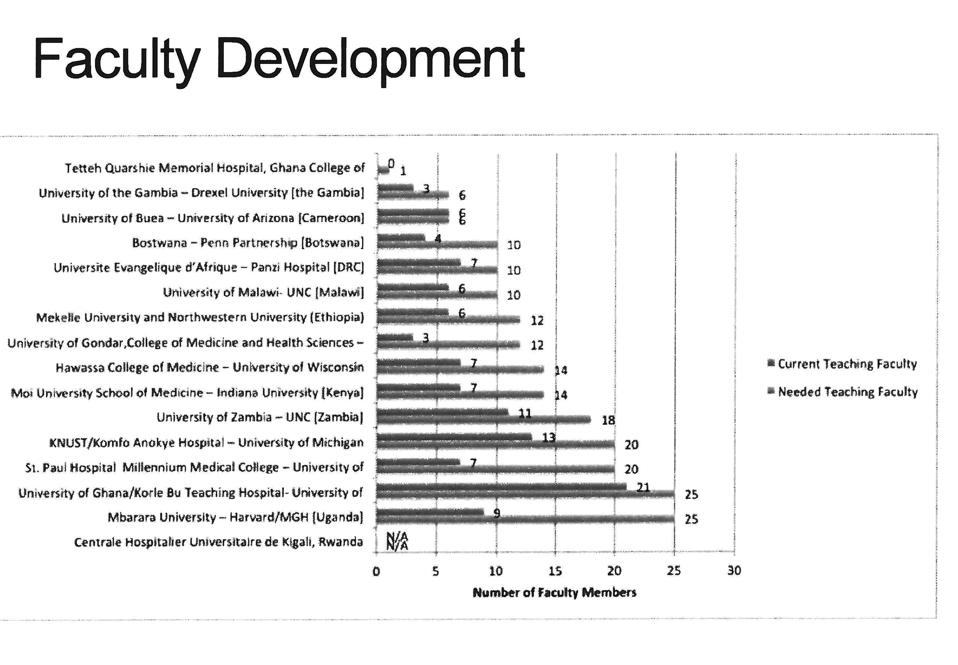

Faculty development
Gaurang Garg: One basic question that we wanted to ask in terms of faculty was if there were any room for faculty development in terms of research and other activities that they could take to become more proactive in their own careers. This first slide is our first question, “Can you give us a little more information on how many faculty you currently have”, which is in red, and then the blue bar represents how many they need, or how many they aspire to have over the next few years, and whether that is coming from the classes that they are training or other people that are coming and working for the institutions and staying as long-term solutions for training residents.

Certification
Madeline Taskier: There are a variety of certification methods that we have come across for OBGYN training, and we tried to show them on the map of Africa and the concentration of where they are geographically.

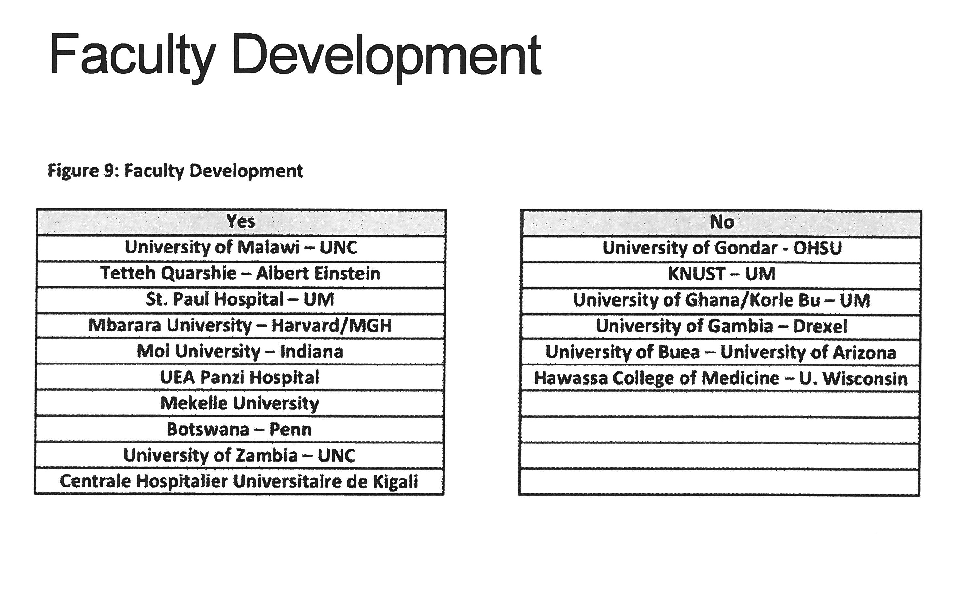

The countries highlighted in blue have a national body of certified OBGYNs. Ethiopia also has certain universities that do certification as well. The MMED program is quite popular as well, as you can see in eastern and southern regions. There are the national and super-national bodies like the Ghana College of Physicians and Surgeons but also the West African College of Physicians and the West African College of Surgeons. And these were the general responses that we received. So you can see, it is sort of a mix. Of the 16 responses, here is the percentage breakdown:
- 31% were in MMED programs,
- 25% were by national body,
- 13% by super-national body.
That sort of gives us a sense of how we can align certification methods and make them more uniform.

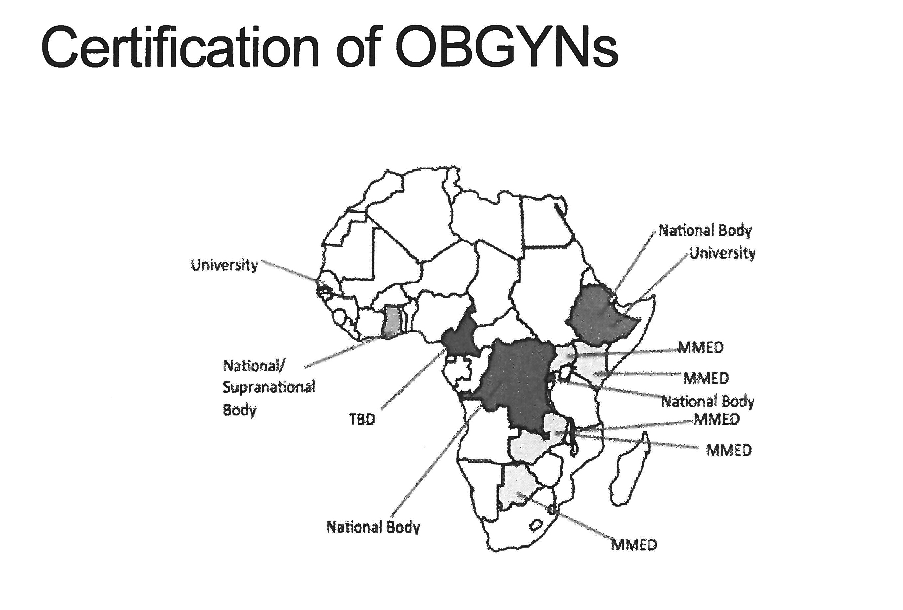

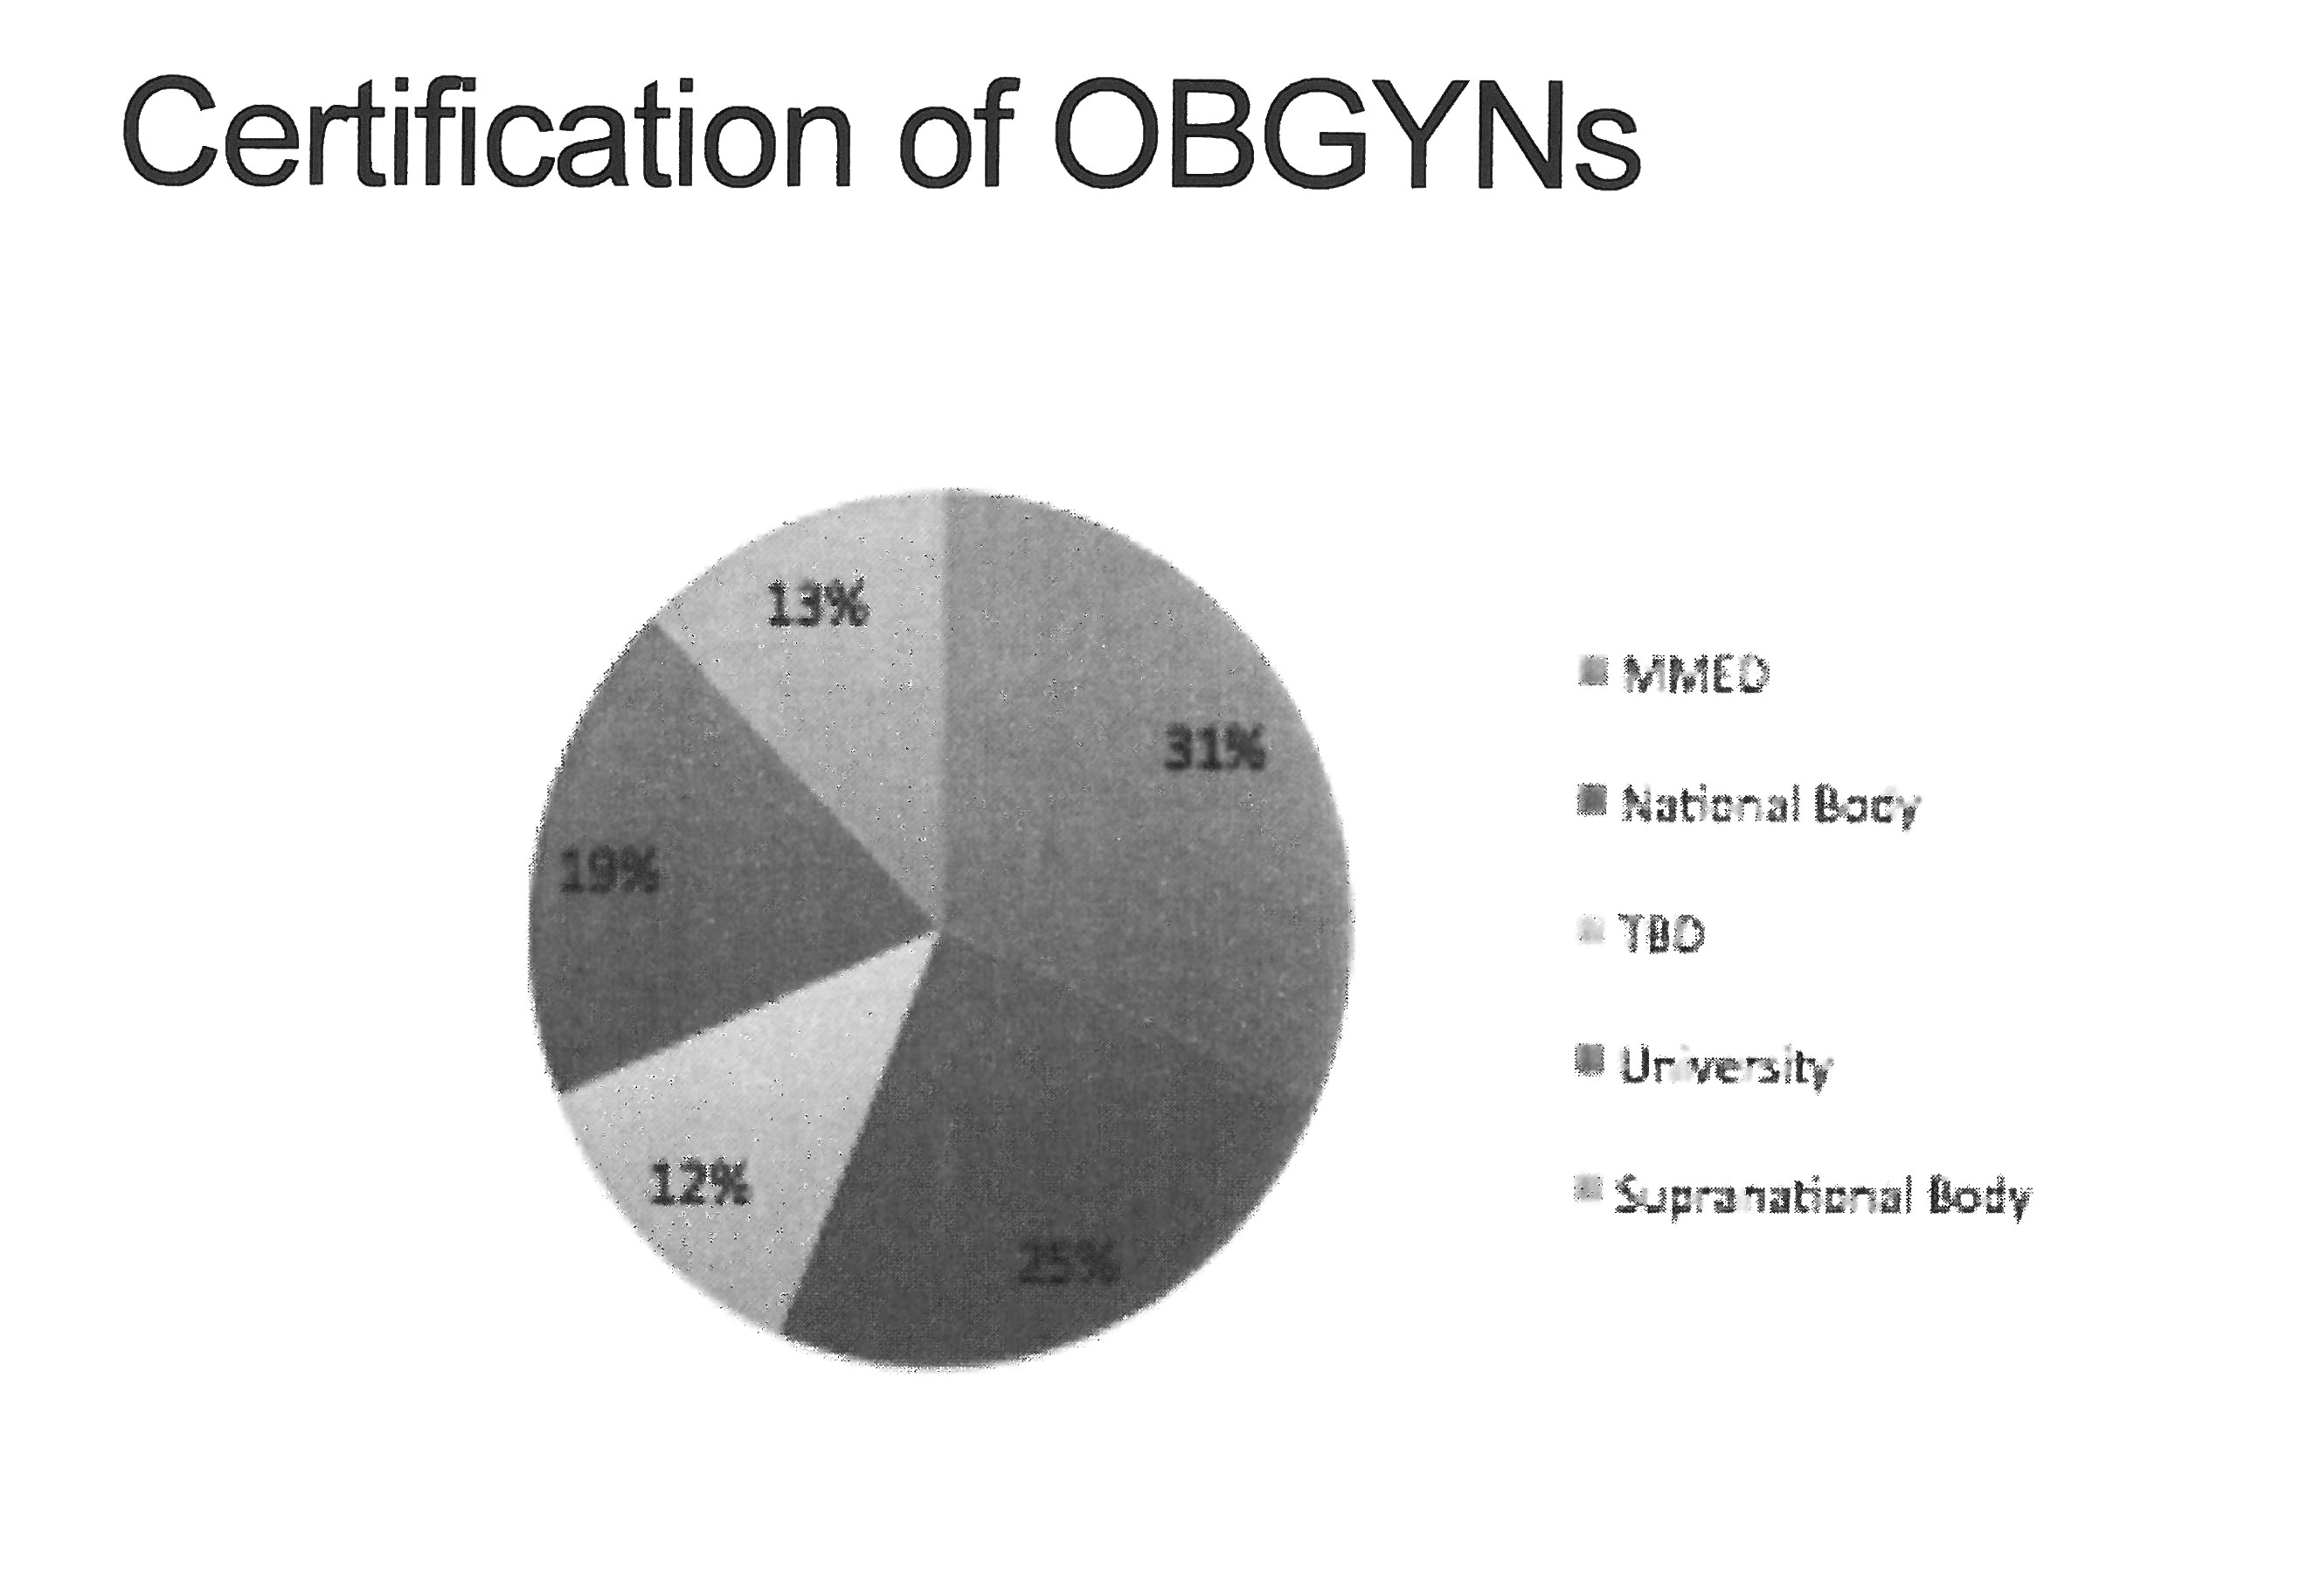

Internet access

Gaurang Garg: The next section of the response dealt with the current infrastructure for Internet. Part of this deals with the Elevate team and their goal of adding online medical education, and this is also just in terms of just basic resources that are available to all of the residents. We asked, “Do you have access to Internet?” The follow-up question was if they had access to high bandwidth?

The vast majority said that they had it sometimes, and then a few institutions also said, “Often,” for both. Only one of the partnerships said, “Always,” that they had it pretty consistently and pretty regularly, which naturally will be a concern that you will have to deal with it in terms of implementing online education or even other forms of communication for the residents than what they have available.

Research capacity

The last section asked, “Are residents trained in doing research, becoming inquisitive thinkers, and going on to lead their own projects in the future?” The nice thing is that the vast majority (14/16) said that they do train the residents in some way. What we did was compile a few of the methods they use in terms of giving their residents the skills to become researchers in the future. There was a pretty good mix; some are really creative.

I think Dr. Wilkinson said that his team does weekly journal clubs, which I thought was very interesting. Other institutions do things like having public health teams come in and offer some type of seminars or some type of courses. We would like to see these continue.

I think that one of the main feedbacks that we got in the responses was that every institution thought it was really important, that research training and going along that line was something critical that all residents should learn.

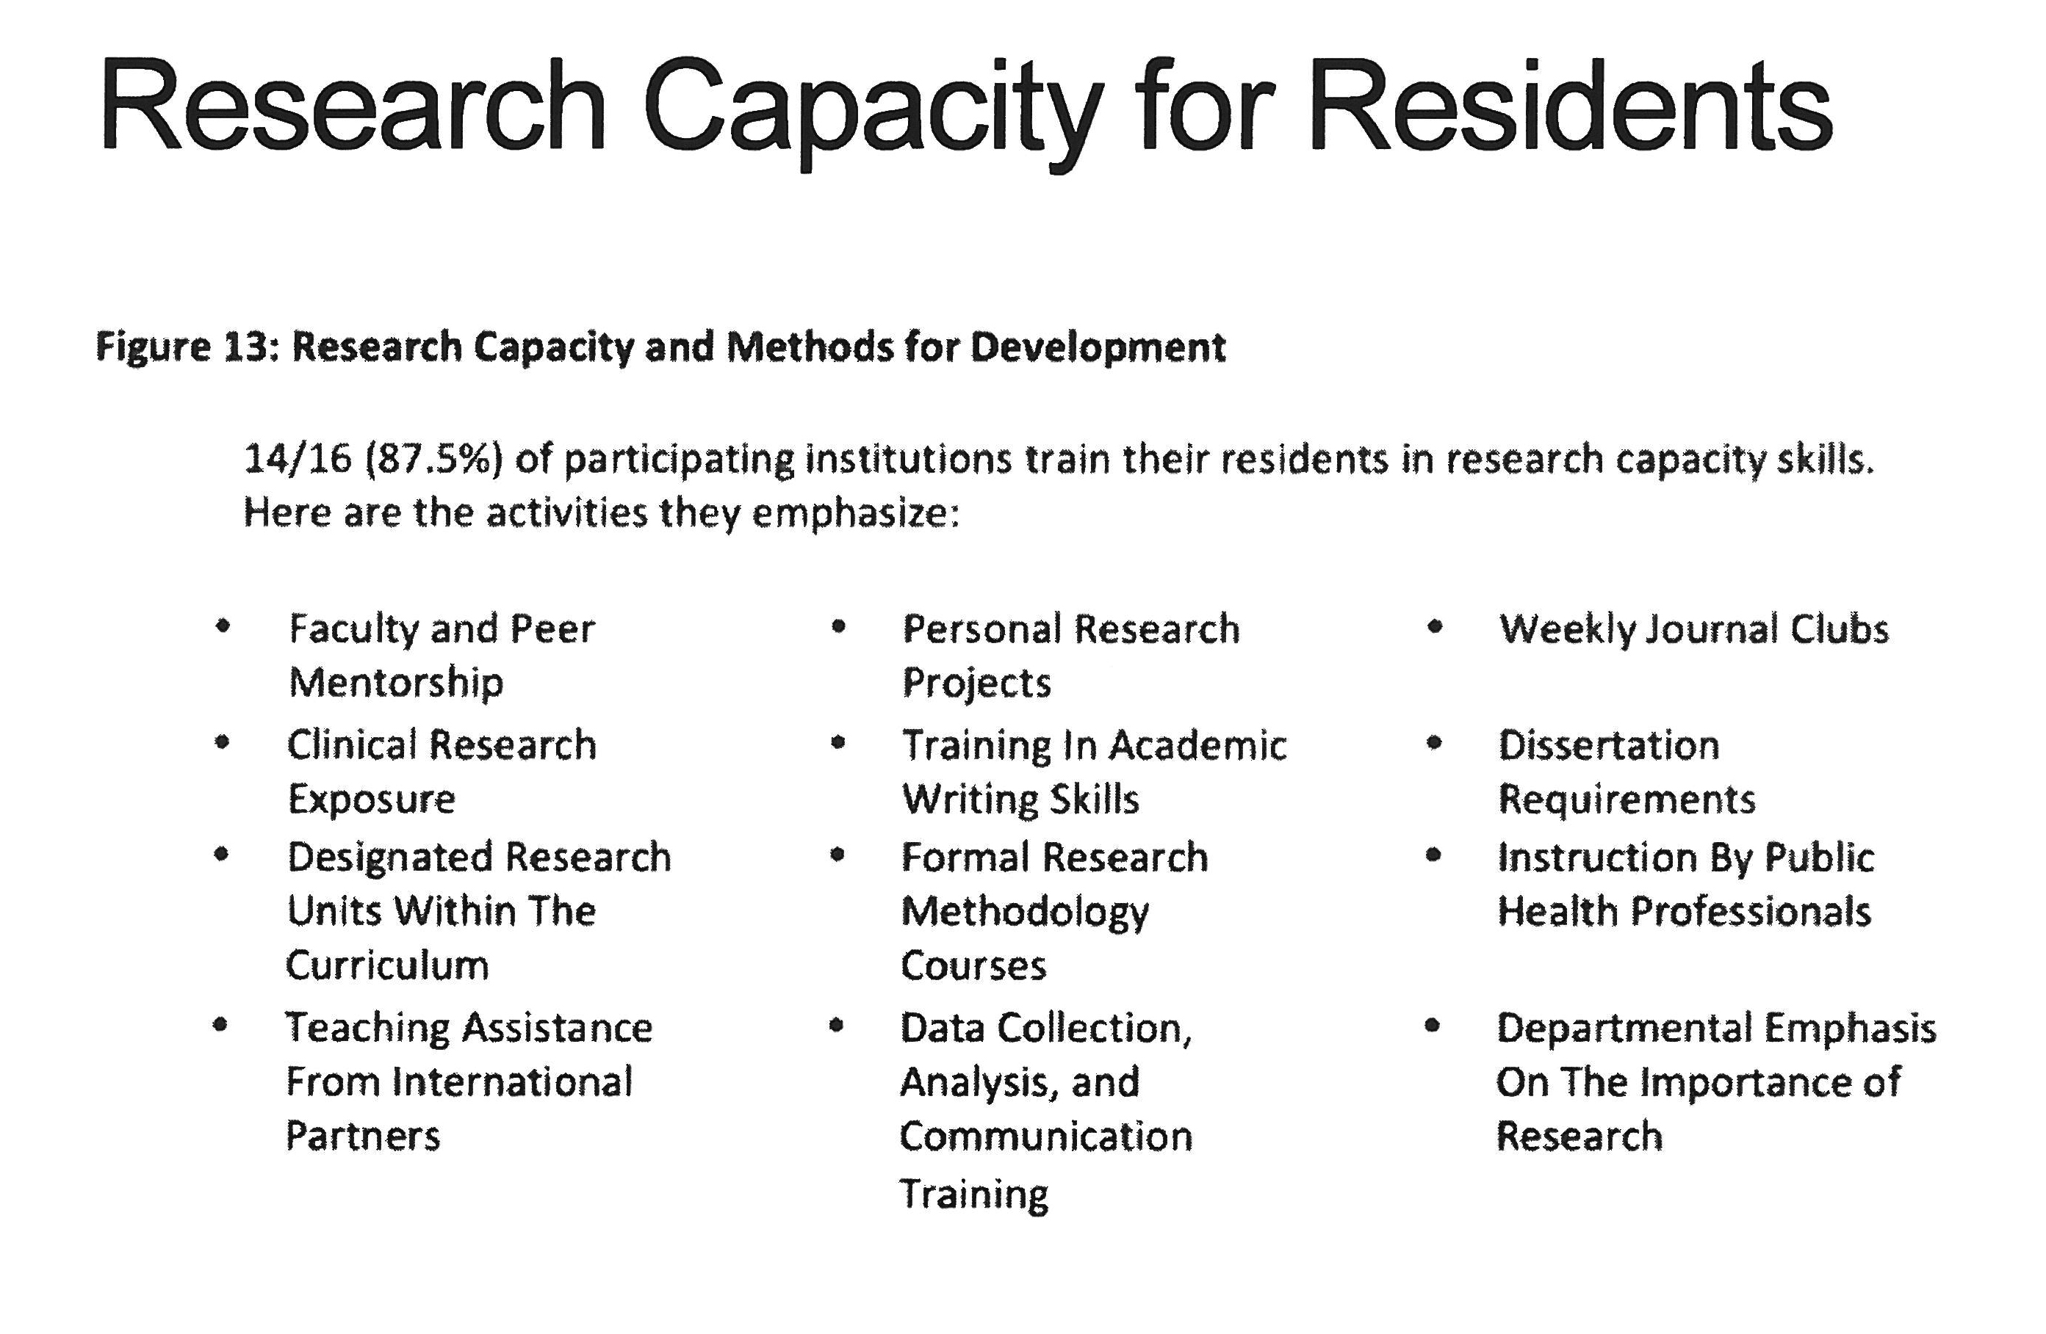

Madeline Taskier: And that is everything. If you have any questions on how the data was analyzed or if your team didn't get the chance to fill out the Needs Assessment, it is still an open form and we are going to update it as the week goes on and upload a more recent version into the Dropbox. Does anyone have any questions?

Jeffrey Wilkinson: I wonder if we can explore further the distinction between certification and training, because there is the training body, which you would get in an MMED, but the certification might be through the Council of Physicians.
Madeline Taskier: Dr. Wilkinson’s question was to distinguish the difference between training and certification, because the training may be the MMED degree but what is the larger body that is certifying? I think that distinction is something that will definitely brought up during the certification panel and can be discussed among the breakout groups, but we are going to have a certification discussion and panel later in the program. Any other questions? We will actually hand you the microphone.

Thank you so much!

Gaurang Garg: Thank you!

Frank Anderson: So that is the data we collected from all of the participants. As you look at that data, if you want to adjust that data, please let us know. That’s a great place to start and a great baseline. Now that you see it up there and you see your partnership response, you may want to adjust that a little bit. As you go into your small groups, this country report will be on your disk. Your individual country data will be on the disk as well as the compilation. And you can absolutely update the information.

Thinking about a proposal development process or a project plan, you can use the first few pages of your own country report as kind of a baseline data and update it as you will. I think the plan is that you will have your own Needs Assessment already done for your country and for your program as you move forward.

Does anyone have any questions about the worksheet and the process of the meeting? Any comments or feedback? Could I hear some feedback from the audience about this process and how they think it might work?

