Surgical Repair of Vesico-Vaginal Fistulae (VVF)
Dr Aldo Marchesini, Mozambique



Surgical Repair of Vesico-Vaginal Fistulae (VVF)
Dr Aldo Marchesini, Mozambique

South African Institute for Distance Education
P O Box 31822
Braamfontein
2017
South Africa
Tel: +27 11 403 2813
Fax: +27 11 403 2814
http://www.saide.org.za

© South African Institute for Distance Education and Dr Aldo Marchesini, 2011
Permission is granted under a Creative Commons Attribution license to replicate, copy, distribute, transmit, or adapt this work freely provided that attribution is provided as illustrated in the citation below. To view a copy of this licence visit http://creativecommons.org/licenses/by/3.0/ or send a letter to Creative Commons, 559 Nathan Abbott Way, Stanford, California,94305, USA.
Citation:
Marchesini, A. 2011. Surgical Report of Vesico-Vaginal Fistulae. (VVF). Johannesburg: Saide

ISBN:978-0-9869837-6-4

This project was funded by

Table of Contents
Chapter 1: Examination and Classification of Fistulae 7
1. How is a fistula formed 7
2. How to stabilise a fistula 7
3. How to examine a fistula 8
3.1 Site 8
3.2 Size 8
3.3 Nature of the margins 9
3.4 Size of the Vagina 9
3.5 Recto-Vaginal Fistulae (RVF) 9
4. Pre-operative examination 9
5. Classification of the VVF 10
5.1 Site on the vesico-vaginal wall 10
5.2 Sizes of VVF 13
5.3 Miscellaneous VVF 14
Chapter 2: Repair of VVF 16
1. Position of the patient 16
2. Improving the exposure 17
3. Reducing the possibility of bleeding 18
4. Separate the vagina from the bladder 19
5. Surgical Repair of VVF 20
6. Final test 21
7. The fatty flap of the labium majora 21
8. Completion of the operation 24
Chapter 3: Surgical Repair of Recto-Vaginal Fistulae (RVF) 26
1. High RVF 26
2. Low RVF 28
3. Postoperative Care 32
4. Other surgeries 32
4.1 Correction of incontinence 32
4.2 Ureterosigmoidostomy 32

List of Figures
Fig 1: Tissue with necrosis, and Necrotic tissues becoming detached
Fig 2: Vaginal stenosis, posterior band
Fig 3: Severe vaginal narrowing and vaginal atresia
Fig 4: The continence mechanism is located in the urethral sphincter and the bladder base
Fig 5: VVF not affecting the continence mechanism 11
Fig 6: VVF affecting only the vaginal wall 12
Fig 7: Circumferential VVF 12
Fig 8: Urethral Meatus on view – its characterisation 13
Fig 9: Micro VVF, viewed by injecting gentian violet 13
Fig 10: Large VVF, with bladder base prolapse 13
Fig 11: Destruction of anterior urethral wall 14
Fig 12: Destruction of circumferential urethra 15
Fig 13: Destruction of the anterior urethral wall 15
Fig 14: Vesico-uterine fistulae 15
Fig 15: Hyper lithotomy position 16
Fig 16: In this position, the assistant may comfortably assist 16
Fig 17: Labia minora open and valve in position 17
Fig 18: Ventral decubitus position 17
Fig 19: View before the episiotomy 18
Fig 20: View after the episiotomy 18
Fig 21: View after the episiotomy and placing the valve 18
Fig 22: Separating the bladder epithelium and the vagina epithelium 19
Fig 23: Vesical plane with introverting suture, without perforating the mucosa 19
Fig 24: How to begin the separation of the planes 19
Fig 25: Opening the labium majora and isolating the fatty flap 21
Fig 26: Tunnelling the flap 22
Fig 27: Extracting the flap on the vaginal side. 23
Fig 28: Fixing the flap over the VVF suture 23
Fig 29: Another example of the Martius flap technique 24
Fig 30: Vaginal plasty with flaps of the labia minora 25
Fig 31: Traction with finger in rectum 26
Fig 32: Traction with small retractor 27
Fig 33: Opening of Douglas 27
Fig 34: Traction to the bottom of the rectal wall and suture 28
Fig 35: Vaginal margins sutured to rectal wall 28
Fig 36: A probe is passed through the RVF 29
Fig 37: Probe on tension and incision of the septum 29
Fig 38: RVF converted to a 3rd degree perineal laceration 29
Fig 39: Recto-vaginal mobilisation 30
Fig 40: North-south suture of anal canal 30
Fig 41: Completed suture 30
Fig 42: Sphincter suture 31
Fig 43: Isolation of the cut sphincter ends 31
Fig 44: Sutured sphinter ends 31
Fig 45: Retro-pubic colpo-urethral suspension of the passage area of the urethra to the bladder 32

Acknowledgements
This English translation was prepared by Maria Teixeira Translations cc.
Dr. K. Lalloo, a specialist obstetrician and gynaecologist, checked the accuracy of the translation, and inserted five clarificatory sentences.

A note from the author
The aim of this document is to introduce vesico-vaginal fistulae (VVF) and the guiding principles associated with its surgical repair.

I am happy to have found such an opportunity to release my work on surgical repair of Vesico-Recto Vaginal fistulas under a Creative Commons licence. This work is meant for all surgeons who decide to restore to dignity these unfortunate patients in resource-poor settings.
The booklet was developed over the years in which I worked in Mozambique and was met with the appalling number of fistula patients being generally neglected. Slowly a small group of surgeons started dedicating some of their time to the problem and it appeared that there was a need for a hand-out publication showing in detail the steps in surgical repair.
Later on the Ministry of Health supported special training sessions in major Mozambican Hospitals and a number of surgeons were trained in fistula repair techniques. Now fistulas are repaired in Maputo, Beira, Tete, Chimoio, Buzi, Quelimane, and other centres in Mozambique. The bi-annual training sessions in Beira involve eight surgeons and the number of patients treated and restored to dignity is steadily increasing.

Dr Aldo Marchesini, 26 November 2010

Chapter 1: Examination and Classification of Fistulae

How is a fistula formed
A fistula is, by definition, an abnormal opening between two organs that no longer closes spontaneously. In our case, it is an opening which forms between the bladder and the vagina.
During prolonged obstructed labour, the head of the foetus becomes stuck in the birth canal and presses the soft parts of the vagina and the bladder against the pubic symphysis, and sometimes the vagina and the rectum against the sacral promontory. Should this compression last several hours, the tissues become deprived of blood circulation and oxygen, thus producing an area of necrotic tissue. When the necrosis detaches from the adjacent tissues, an orifice opens between organs involved, which will no longer close, thus forming a fistula.
It will either be a vesico-vaginal fistula (VVF) or a recto-vaginal fistula (RVF), depending on its location.
There are other consequences: the foetus may die and, at times, the uterus can rupture because of hypertonic contractions, with serious life-threatening consequences for the mother. Cephalo-pelvic disproportion is the main cause of obstructed labour. Consequently, sufferers of VVF/RVF are normally young primiparous women, of small stature (< m.1,50). Some of these women no longer have a uterus and, thus, are doubly discriminated due to incontinence of urine and /or faeces and residual permanent infertility.

How to stabilise a fistula
Following a prolonged obstructed labour, the vaginal tissues become traumatised, oedematous and, in many cases, necrotic at various sites of the vaginal canal. The necrotic tissue become detached and scar retraction processes begin which may reduce the vagina to a narrow, distorted, canal presenting bands of scar tissue which profoundly alter the architecture of the vagina. The processes of retraction and repair may take several weeks to heal. Surgical repair should therefore be considered two months after initial injury.

Fig 1: Tissue with necrosis, and Necrotic tissues becoming detached
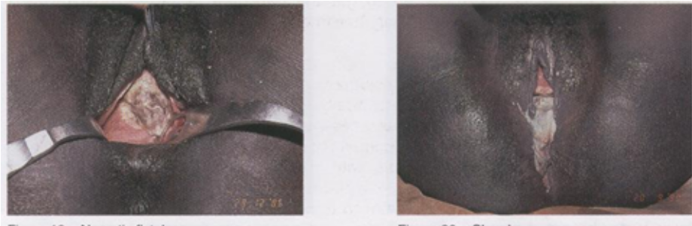

Fig 2: Vaginal stenosis, posterior band
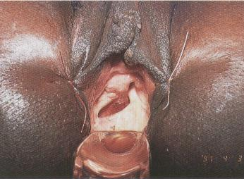

Fig 3: Severe vaginal narrowing and vaginal atresia
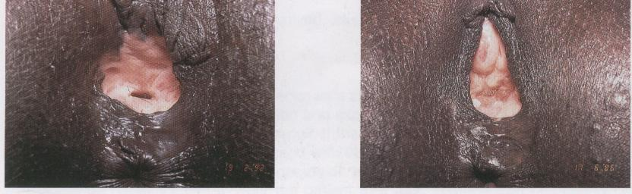

How to examine a fistula
The first examination simply involves the digital examination of the vagina. Use two fingers to determine the form, size and elasticity of the vagina, and with the tip of the forefinger or the middle finger try to locate the orifice of the fistula. In most cases, it is simple to detect the site, form, size and nature of the margins, the elasticity and thickness of the tissues, etc. The various characteristics are presented below.

3.1 Site
- Close to the pubis, mid-vaginal, close to the cervix, or even in the vaginal vault in the case of a hysterectomy due to a uterine rupture.
- May or may not occur in the bladder base (the urethra passage to the bladder). This is important in the event of urethral sphincter destruction, and once the VVF has been repaired, incontinence may continue due to sphincter incompetence.
- Whether or not circumferential, i.e. if it involves the entire bladder, leaving a separation between the proximal urethral orifice and the vesical fistula orifice.

3.2 Size
The correct assessment of the size is done with the tip of the finger over the entire circumference of the VVF. This is the only way to determine the real size of large fistulae and of those that present as a cystocele.
Greater care should be taken with small fistulae to distinguish its presence and size in the anterior vaginal wall. Often the finger is unable to recognise the fistula. In this case, examine the patient in the lithotomy position, with good lighting, with the assistance of retractors, and by introducing a solution dyed with methylene blue or gentian violet via a catheter and syringe, to observe where the liquid leaks into the vagina, thus allowing identification of the VVF.

3.3 Nature of the margins
This is an important aspect because it reveals the scar thickness, elasticity or rigidity of the margins. If the margins are thick, fatty and well vascularised, the VVF suture will hold with greater ease, but if the margins are thin, scarred or adhering to the ascending border of the pubis without a cleavage plane, then the closure will be laborious with a high probability of dehiscence and failure of repair surgery.
- Carefully examine the upper margin, especially when it is in contact with the symphysis pubis. If the soft parts are very thin or reduced to a simple layer of scar tissue on the lower horizontal border of the pubis, then the closure will present severe difficulties and post-repair residual urinary incontinence will almost inevitably occur.
- In examining this margin, care should be taken to detect if this is a circumferential fistula, characterised by the circular destruction of the bladder base. More concretely, by palpation it is possible to detect the presence of two separate orifices: the proximal urethra and the neck of the bladder.
- Another important detail worth recording is the length of the urethra. If it is less than 1 cm, then part of the urethra was destroyed and the VVF repair will result in a probability of urinary incontinence.

3.4 Size of the Vagina
Assess the size of the vagina as it may have serious implications in the closure of the VVF.
- Narrow, short and scarred vagina. It may also have horizontal bands on the lower wall which limit access and may impede visualisation of VVF.
- Excessively large and deep vagina. It may be very difficult to view the opening of the VVF. Inventive solutions and techniques will be required to improve the visibility and accessibility of the VVF.

3.5 Recto-Vaginal Fistulae (RVF)
Before completing the examination, always ask the patient if she experiences faecal incontinence. This will assist in suspecting the RVF.
It is worth recalling that RVF are formed due to the compression of the soft tissue between the head of the foetus and the sacral promontory, which normally occurs in the upper part of the vagina. However, lower RVF and even third-degree perineal lacerations also result in faecal incontinence.
It is not always easy to visualise a RVF. These are frequently located behind a scar band which may conceal the opening of the RVF. RVF have an elliptic shape on a large horizontal transverse axis. The lower margin tends to be more rigid and fixed.
RVF may not always be detected by digital examination. Therefore, insert a long and thin Kelly forceps in the orifice and then introduce a finger in the rectum to detect where the forceps enters the rectal canal and thus locate the VVF.

Pre-operative examination
In most cases, vaginal palpation is sufficient to make the diagnosis. However, often the golden rule is an examination under anaesthetic, with excellent lighting, in the hyper lithotomy position, as to be used during repair surgery. It is not uncommon to discover details which were not detected by palpation.
The examination in theatre is indispensable to discover the site of smaller VVF which were not located by palpation.
For this purpose, a catheter is inserted into the bladder and naso-gastric syringe (or another large syringe, adapted with a rubber of a solution system) is used to inject a saline solution dyed with methylene blue or gentian violet. The VVF orifice will be easily detected, even if it is small. Up to 200 ml might need to be inserted into the bladder to detect VVF.
If no liquid leaks into vagina, it is possible to conclude there is no VVF.
In the event of no leakage, two possibilities exist, which might explain the uncontrolled loss of urine.

Urinary incontinence.
This may be easily demonstrated by removing the catheter leaving a full bladder. There may be an immediate leakage of urine from the urethral meatus. If the urine does not exit spontaneously, first place pressure suprapubically or ask the patient to cough to demonstrate stress incontinence.

Ureterol-vaginal fistula
There is no exit of urine when removing the catheter, nor during coughing, suprapubic pressure. As you continue to observe the vagina, you will note that after a few minutes, a small amount of liquid collects in the posterior fornix. Dry with a swab and observe if the liquid collects once again. If the liquid which collects is transparent and clear, and not blue or violet, it is possible to conclude it is an uretero-vaginal fistula because the urine has not come from the bladder but directly from the ureters. Every effort should be made to detect whether it is the right or the left ureter. Where facilities are available one can confirm this by doing a retrograde pyelogram.

Classification of the VVF
The two main parameters to be considered when classifying the VVF are the following:

Site on the vesico-vaginal wall
The basic marker is the continence mechanism, i.e. the integrity of the bladder base and the urethral sphincter.

Fig 4: The continence mechanism is located in the urethral sphincter and the bladder base
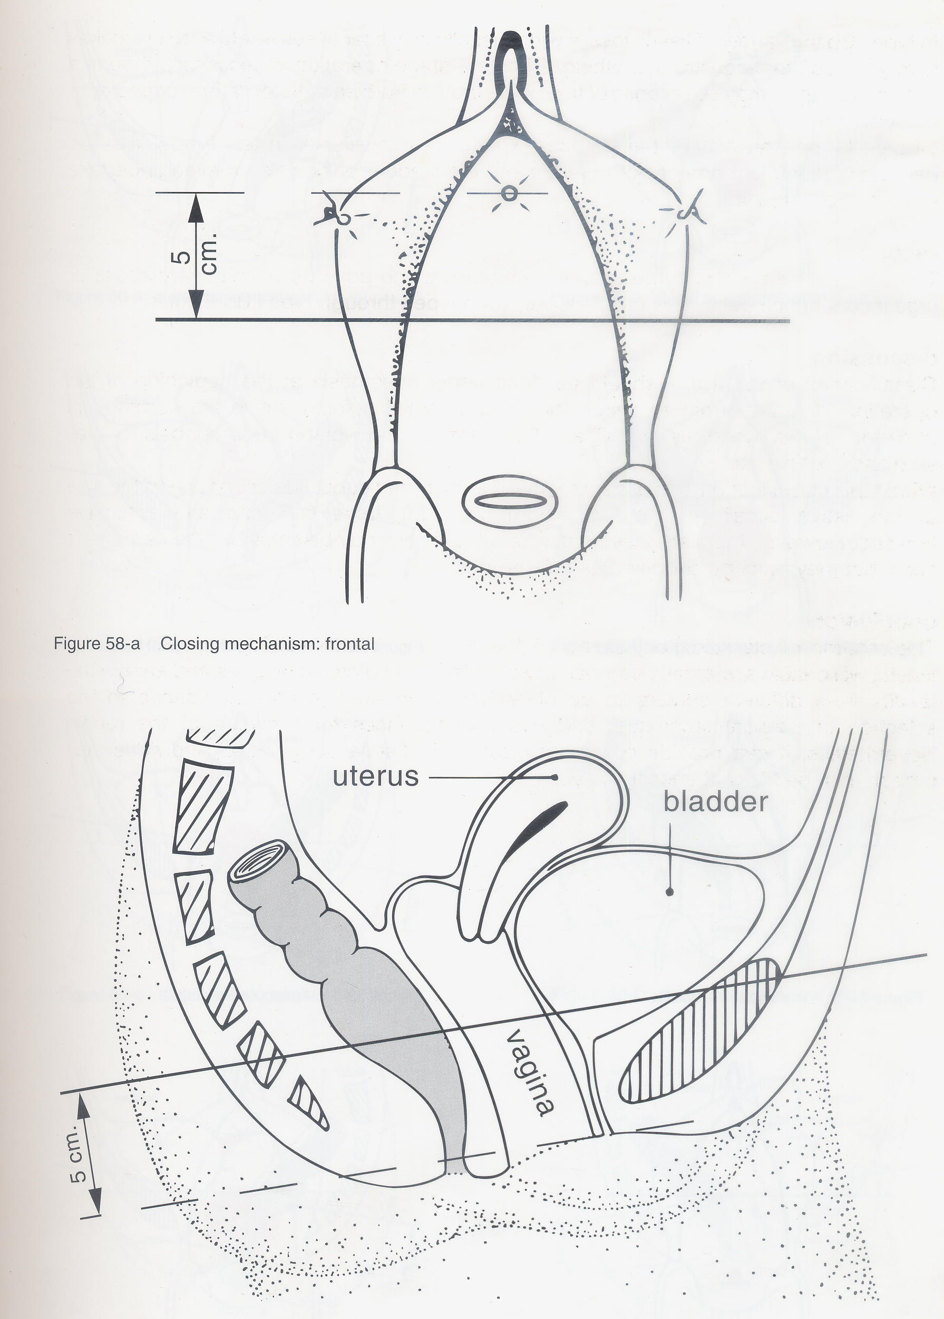

In VVF that does not affect the continence mechanism: successful repair of VVF will result in complete cure and continence.
Fig 5: VVF not affecting the continence mechanism
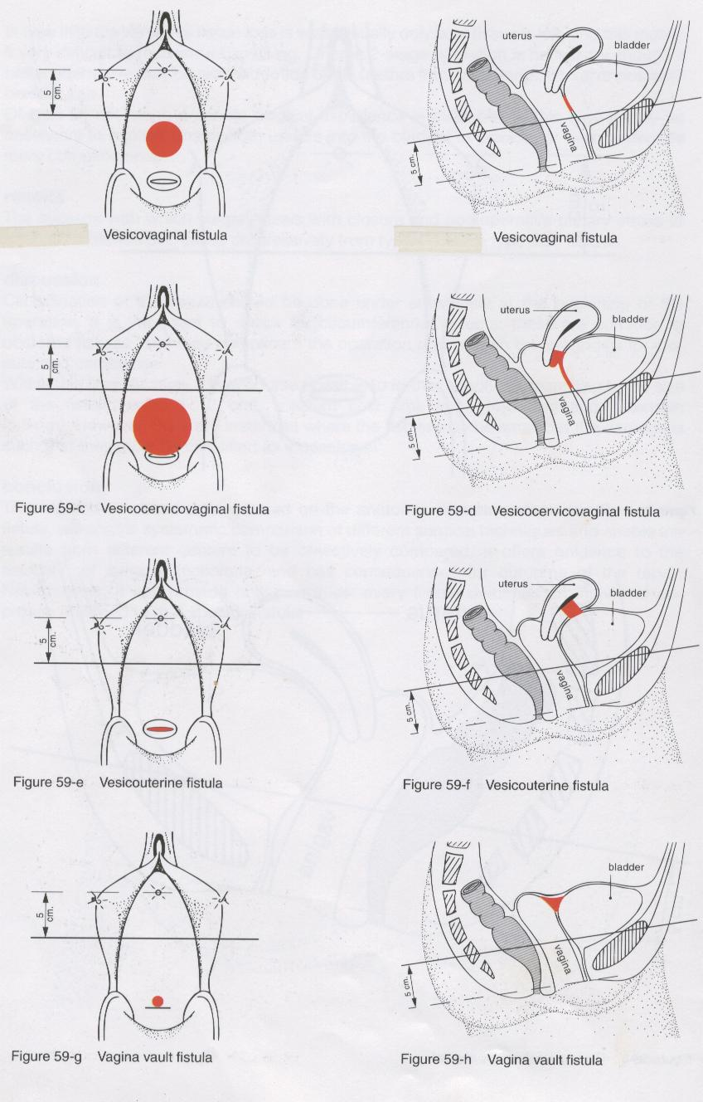
VVF affecting the continence mechanism, i.e. those whose upper margin is related to the bladder base and the sphincter.

Fig 6: VVF affecting only the vaginal wall
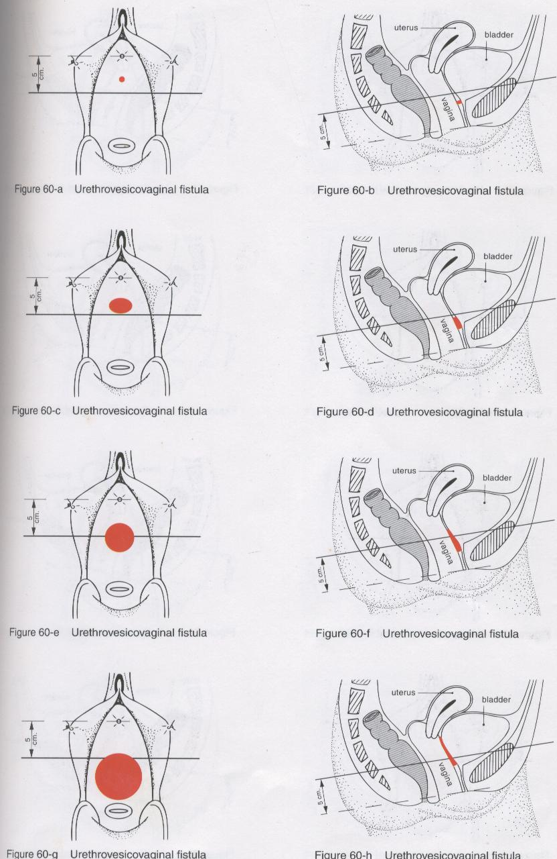
Fig 7: Circumferential VVF
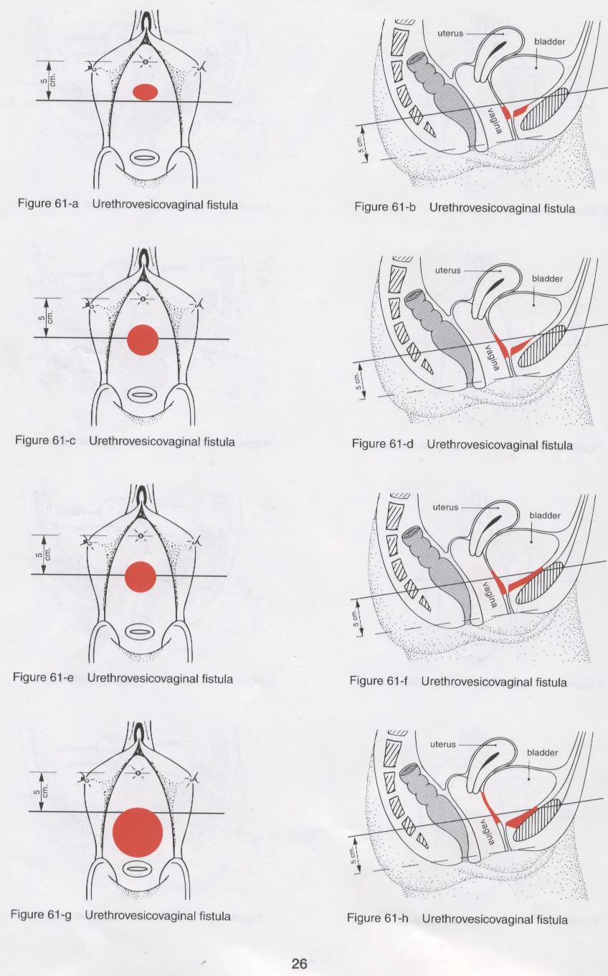

VVF whose upper margin presents the urethral meatus visible in the margin. These VVF may or may not affect the continence mechanism.

Fig 8: Urethral Meatus on view – its characterisation
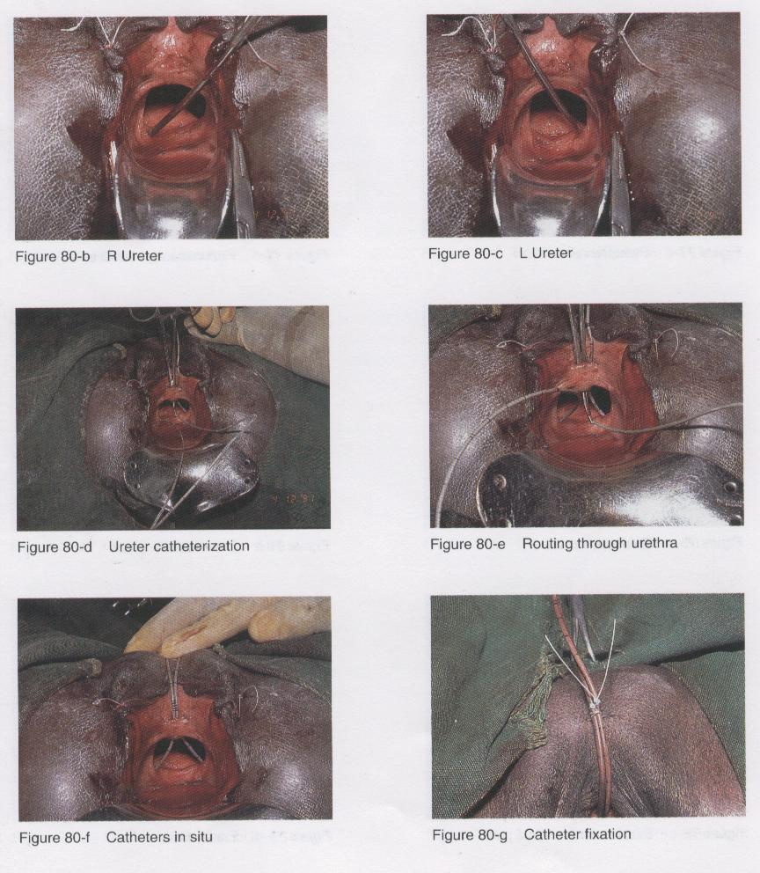

5.2 Sizes of VVF
Microscopic: need to be located with blue or violet solution through a catheter.

Fig 9: Micro VVF, viewed by injecting gentian violet
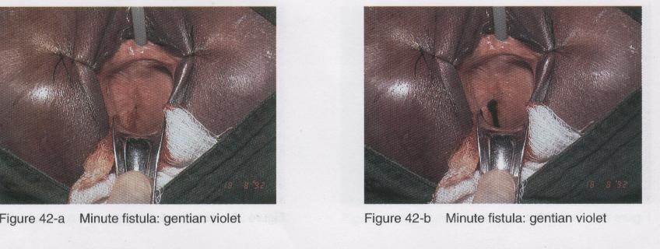

Small: up to 2 cm in diameter
Medium: larger than 2 cm, but with fatty and elastic margins
Large: whose margins are against the ascending borders of the pubis.

Fig 10: Large VVF, with bladder base prolapse
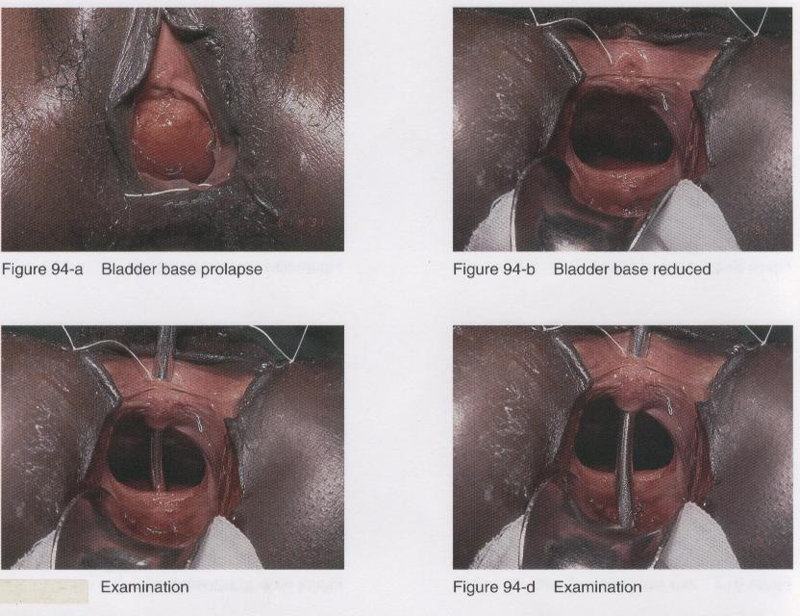

5.3 Miscellaneous VVF
Urethro-vaginal fistulae
Fistulae with the destruction of a considerable portion of the urethra
Fig 11: Destruction of anterior urethral wall
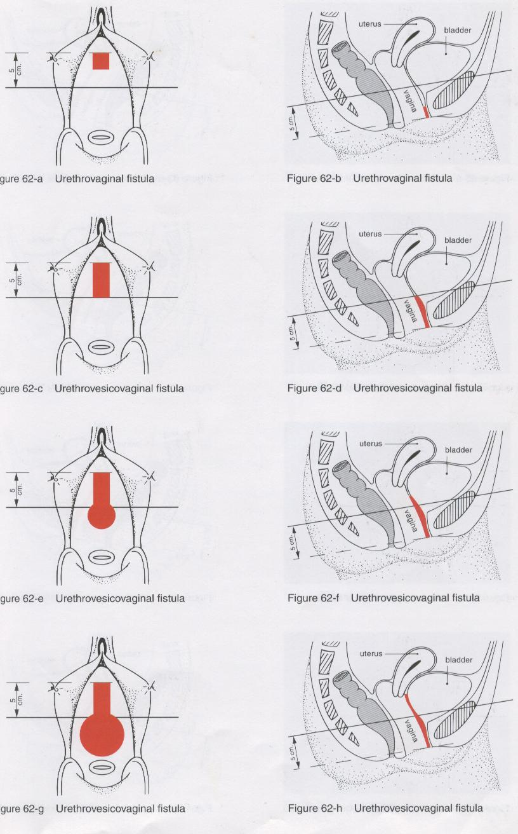

Fig 12: Destruction of circumferential urethra
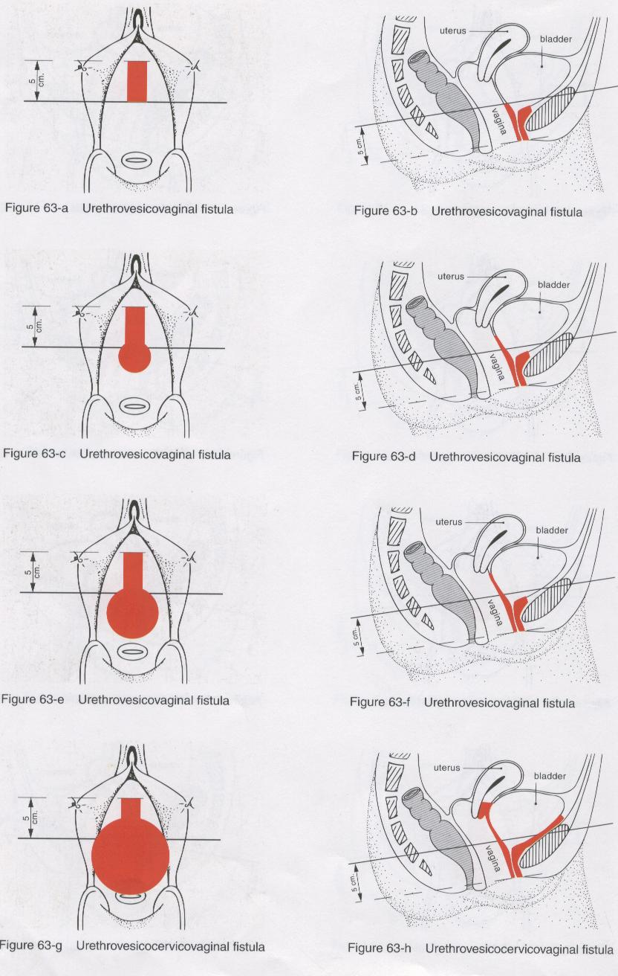

Fig 13: Destruction of the anterior urethral wall
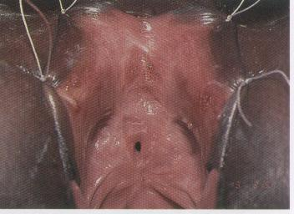

Fistulae which open into the cervical canal of the uterus or into the uterus \

Fig 14: Vesico-uterine fistulae
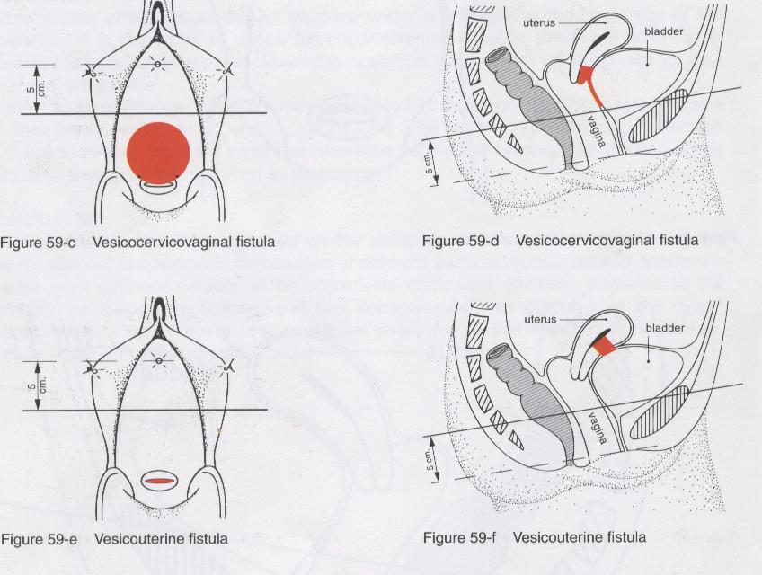
Chapter 2: Repair of VVF
The surgical repair of VVF is based on two basic principles:
- The separation and mobilisation of the vaginal and bladder planes;
- Suture for opposing edges without tension of the bladder wall, without perforating the bladder mucosa.
The aim of the VVF surgery is to apply these two principles correctly. There are various solutions and, at times, a creative initiative is required to overcome an impediment to the application of the two principles. Therefore, there is always a margin for innovation when operating on VVF and you never stop learning and inventing, and tailor making appropriate procedures.

Position of the patient
The normal position is the hyper lithotomy position, with the buttocks extending beyond the theatre table, the thighs flexed against the abdominal wall and abductors, the theatre table plane inclined in the Trendelemburg position.
Fig 15: Hyper lithotomy position
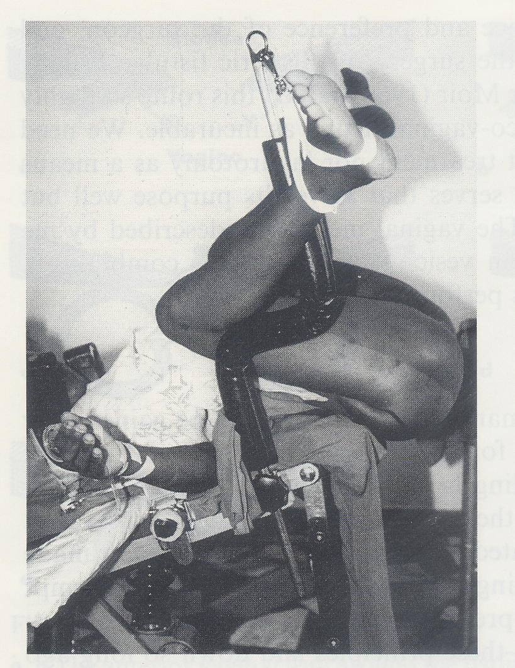
The visibility of the field is good in this position and the assistants may easily assist, seeing sufficiently well and without having to submit to uncomfortable positions.
Fig 16: In this position, the assistant may comfortably assist
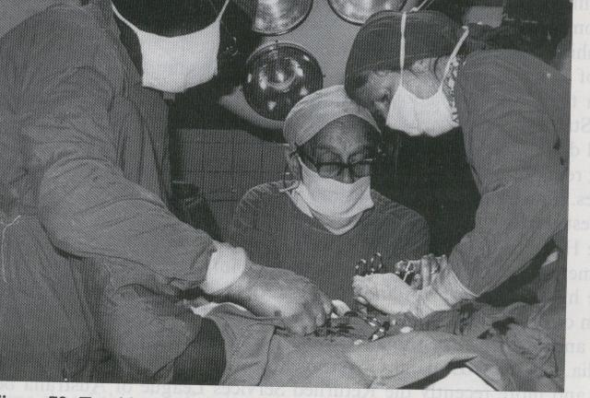
For a clear view of the interior of the vagina, you need to fix the labia minora with silk sutures on the top and on the bottom and introduce a retractor, possibly the heavy weighted type that does not require an assistant.
Fig 17: Labia minora open and valve in position
However, there are cases where the position of the VVF is against the pubic bone or have other characteristics which make it practically inaccessible in the hyper lithotomy position.
These difficulties can be overcome by turning the patient onto her stomach, in a ventral decubitus position.
Fig 18: Ventral decubitus position
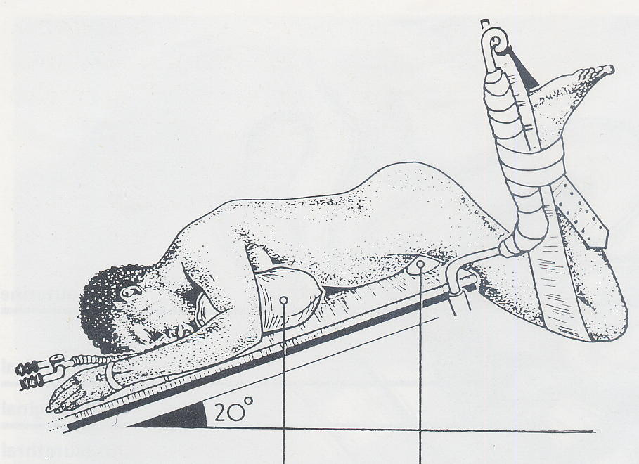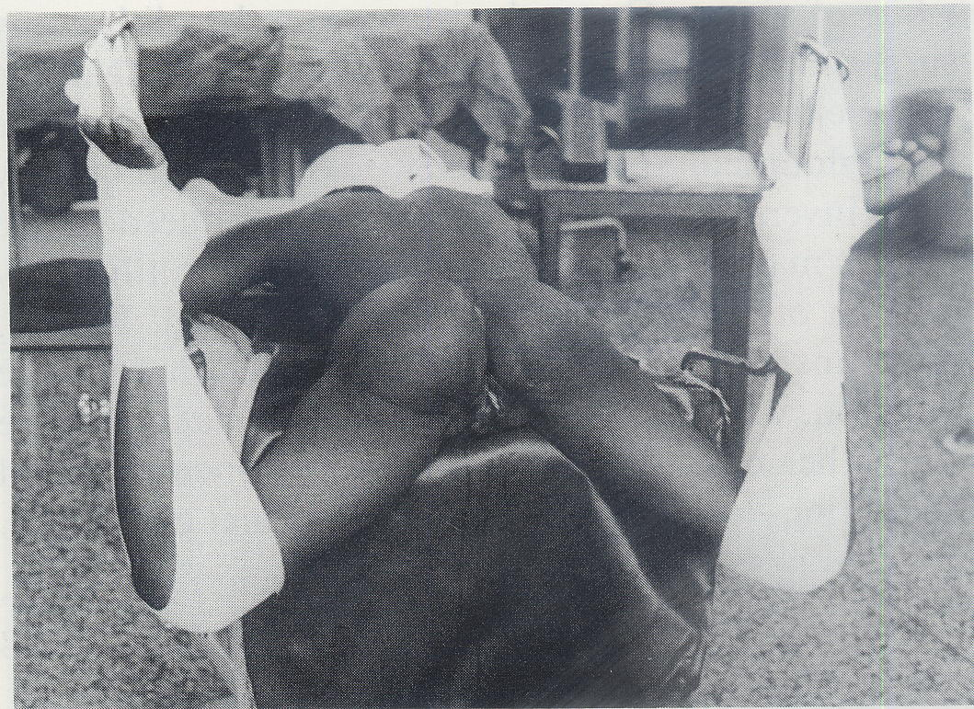

The assistants obviously cannot see as well and work in uncomfortable positions.

Improving the exposure
To operate properly, firstly you need to see clearly, i.e. you need to adopt all these skills or techniques which bring the VVF into view in a position accessible to the scalpel, scissors and needle holder.
It is useful to raise the upper part of the vagina, placing two Allis forceps to the sub-urethral portion: this brings the VVF orifice easily within sight.
When the vagina is tight or has horizontal scar bands in the posterior vagina wall, do not hesitate to perform one or two generous episiotomies. These will radically improve the view and are easily repaired at the end of the procedure.

Fig 19: View before the episiotomy
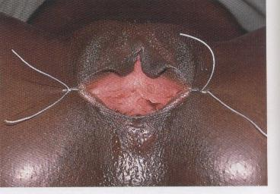
Fig 20: View after the episiotomy
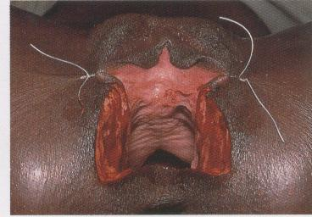
Fig 21: View after the episiotomy and placing the valve
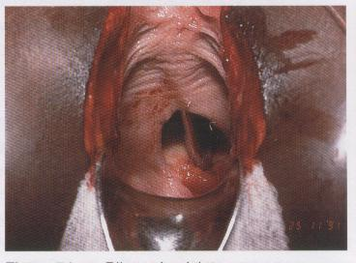
Two instruments are particularly useful in improving the exposure: the metal speculum and the thin and narrow malleable blades, which assist in retracting the side and upper vaginal walls.
In the case of the interior wall prolapse of the bladder, it is useful to introduce a swab in the bladder via the VVF. Naturally, do not forget to remove it before tightening the orifice too much.

Reducing the possibility of bleeding
It is convenient to infiltrate the tissues which are to be dissected to improve the separation of tissue planes and reduce bleeding during dissection. With a 20 ml syringe, aspirate an adrenaline ampoule, and wet the entire internal surface of the syringe. The adrenaline is then emptied once again in the ampoule and with the same syringe aspirate 10-15 ml of saline solution, thus, obtaining the lowest concentration adrenaline solution. Use this solution to infiltrate the peri-fistulous tissues, targeting the vesico-vaginal tissue plane.

Separate the vagina from the bladder
In a VVF, the vesical epithelium edge heals continuously with the vaginal epithelium.
The bladder epithelium continues in the vagina epithelium. These need to be separated.
Fig 22: Separating the bladder epithelium and the vagina epithelium
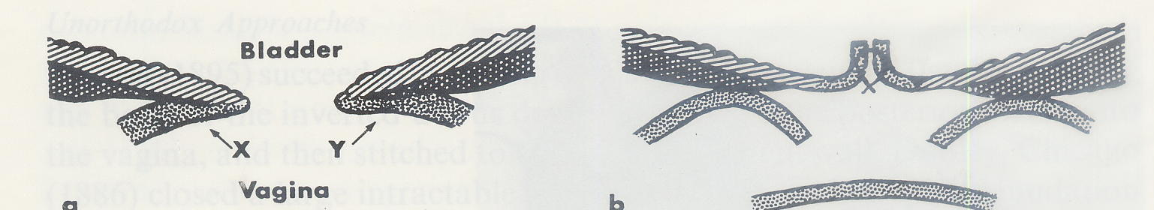

The separation is the first step in suturing the two surfaces separately further on. Thus, after repairing the two epithelia will constitute two completely separate and independent layers, without any connection.
Fig 23: Vesical plane with introverting suture, without perforating the mucosa
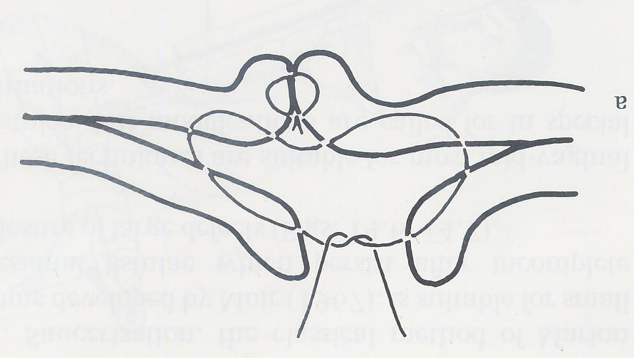
More concretely, the technique used to easily find the cleavage plane between the bladder and the vagina, is to make an incision in the vaginal wall, calibrating the depth to reach the exact cleavage plane. Begin by making a north-south incision, from the inferior margin, to keep the field free of blood as well as to improve the mobilisation of the interior margin.
Fig 24: How to begin the separation of the planes
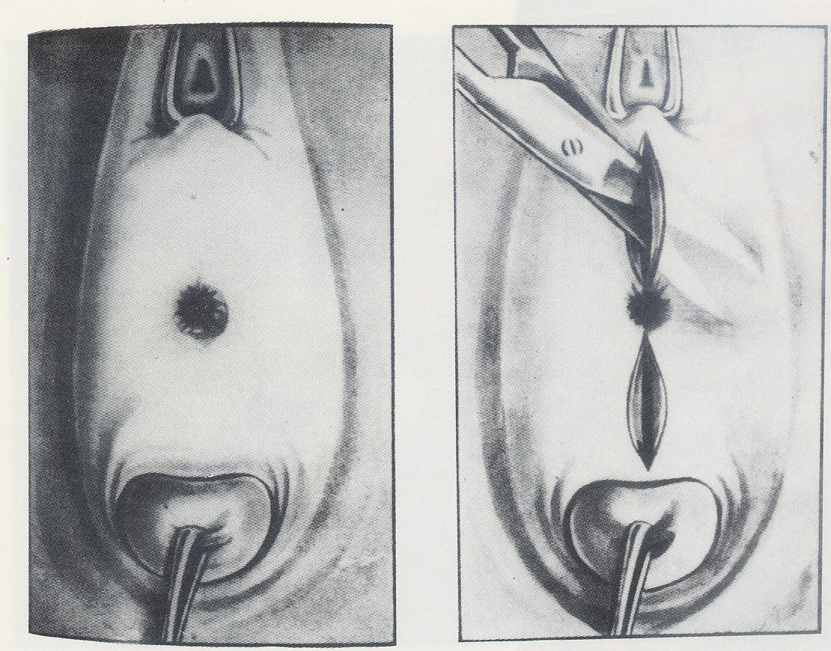
Subsequently, prolong the incision following the line of passage of the vaginal epithelium to the vesical epithelium, until the west to east points of the circumference of the VVF orifice. With a surgical scalpel blade No. 12 or with the point of a thin dissecting scissors) deepen the separation of the planes, lifting as if it were two petals. It is very important to separate at the cleavage plane, to keep bleeding to a minimum. If an arterial bleed occurs, use electrocoagulation. Alternatively, make a haemostatic stitch in the shape of an 8, in chrome 3/0 or 2/0. The extent of the dissection depends on the resistance offered by the tissues to the approximation of the VVF margins without any tension.
At this point make two incisions on the vaginal plane in a horizontal east-west direction, allowing for the more efficient lifting of the vaginal wall in relation to the bladder. This incision allows the beginning and completion of the bladder mobilisation in relation to the deeper and quite often intervening scar tissues between the bladder and the ascending borders of the pubis.
Once these regions have been mobilised, then proceed with the separation of the vaginal and vesical (or urethral) planes, beginning at the upper margin. Once again, use the south-north incision technique and the incision in the line of passage between the two walls, vaginal and urethral. At the end of the dissection, four petals should be formed between the four incisions which form a cross as from the margin. These are fixed with chrome 2/0 or 3/0, in extroversion, to allow for the best possible reconstructive surgical field of vision without the assistant having to constantly hold forceps to keep tissue apart.

Surgical Repair of VVF
Once the separation appears to be good, proceed with a test by taking the margins with the Allis forceps and approximating them to see if they may be sutured without any tension.
Four criteria govern the suture of the VVF margins, namely:
- Introverting, i.e. the vesical mucosa must remain in the interior of the suture and the same cannot be perforated by the suture thread;
- Tension-free repair;
- Begin at the edges;
- Separate sutures of vicryl 3/0 or 2/0 or chrome 2/0; ie NOT continuous sutures.
The most comfortable and convenient line of suture is the horizontal one, traditionally called east-west. There are, however, VVF which close with greater ease in the longitudinal direction of north-south.
Suturing in separate stitches allows for greater safety and firmness in the approximation of the margins, and therefore, it is preferred. However, there are surgeons who use two continuous sutures, beginning at the ends and joining at the middle.
The best thread is the vicryl (or other polyglycolic thread) 3/0 or 2/0, to be selected as appropriate according to the nature of the tissues. Where there is a need for stronger sutures in resistant tissues, select the 2/0, where there is a need to respect the fine and delicate structures, use the 3/0. Vicryl has the advantage of being extremely resistant to slipping of the knot and lasts approximately 6 weeks. In the absence of vicryl, chrome 2/0 may be used, which is also very resistant and maintains the knot well.
The needle must be appropriate to the space available to make a suture. It is possible to mould the needles of the atraumatic threads using the tip of the needle holder and the fingers. It is also very useful to increase the curvature of the tip, thereby reducing the radius.
Given that each stitch is introverted and tension-free, the success of the suture depends on the place where the needle passes in the lower half and the upper half.
The most difficult suture is the first one on each end. It should be made in a way that will reduce the possibility of urine leaking between the suture and the lateral extremity of the VVF.
Sutures should be placed close enough to avoid leakage of urine. If there is any doubt, you can always make another stitch in the middle.
The last stitches are the ones located in the middle. These may present some difficulty due to the low thickness of the upper wall, close to the urethra. This margin may not provide more mobility. It is the lower margin, by contrast, that may be mobilised a little more, to more easily place the stitch with its greater mobility.
When the orifice to be closed is small, it may be difficult to maintain a clear view of the margins to be sutured. In this case, apply the technique of first placing the stitches and keeping them untied on hold with mosquito/ small forceps and tying them one by one at the end.

Final test
The VVF cannot be considered to be properly closed without submitting the sutures to an intravesical liquid pressure test. To do this, inject the solution dyed methylene blue or gentian violet via a catheter using a 50 or 100 ml syringe, with a wide tip, the type used for naso-gastric feeding. In its absence, a 20 ml syringe adapted with a rubber of a solution system may be used.
In general, 100 ml is sufficient, given that there may also be some residual urine which would have accumulated in the bladder during the repair procedure.

The fatty flap of the labium majora
If the suture presents scarce tissue consistency or insufficient vascularisation, it is very useful to use the additional thickness and vascularisation offered by the flap around the fatty tissue, mobilised by opening one of the labia majora longitudinally. This technique is known as the Martius flap, after the name of the Austrian author who proposed it for the first time, or bulbo-cavernous graft.
Select the labium majora in the best position to transfer the fatty flap.
Make a longitudinal incision and with a hand forceps and scissors isolate a cylinder of fatty tissue, the size of the small finger. Achieve haemostasis. Cut the upper part and mobilise the flap to its base. Open a tunnel with a long and thin Kelly forceps, entering from the side of the vagina and exiting on the side of the labium majora. With the Kelly forceps take the edge of the flap and pull, through the tunnel, towards the detached vaginal space. The flap is fixed with chrome 2/0 suture on the line of suture of the VVF with a few stitches.
Then cover the flap with the vaginal wall detached previously. If it is not sufficient, cover it with a flap of tissue surrounding the wall of the labium minora.
Lastly, close the gap of the labium majora, joining the subcutaneous in chromic suture and close the skin with simple silk sutures, without much tension because there is a tendency to oedema formation a which will result in tearing of tissue by the tight stitches resulting in breakdown of the repair. The stitches may be removed on the 3rd or 4th day. This repaired area heals rapidly due to the excellent vascularisation.

Fig 25: Opening the labium majora and isolating the fatty flap
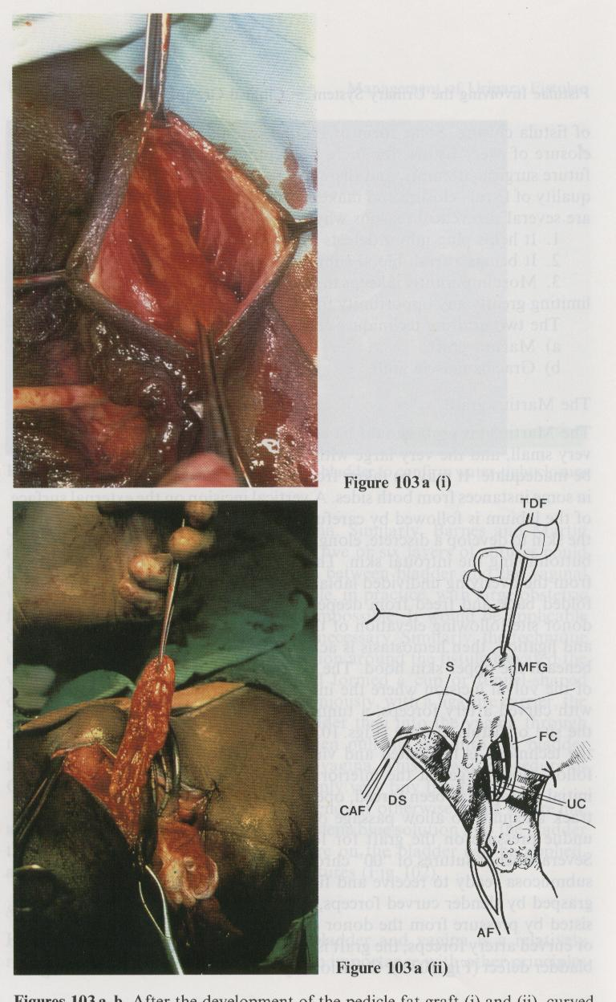
Fig 26: Tunnelling the flap
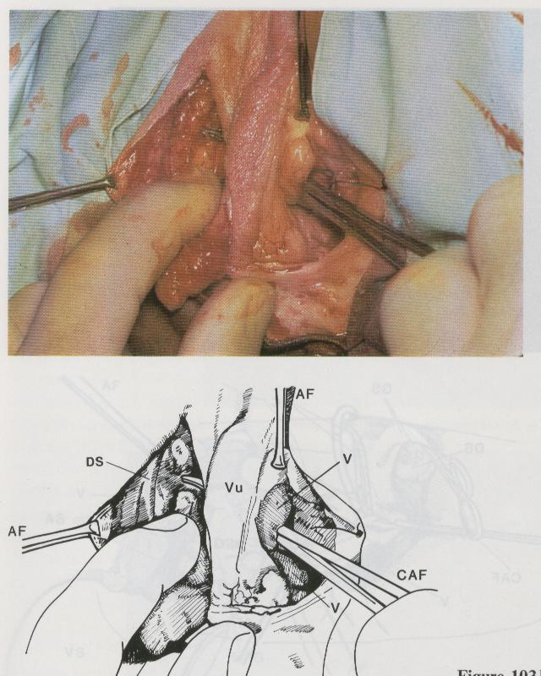

Fig 27: Extracting the flap on the vaginal side.
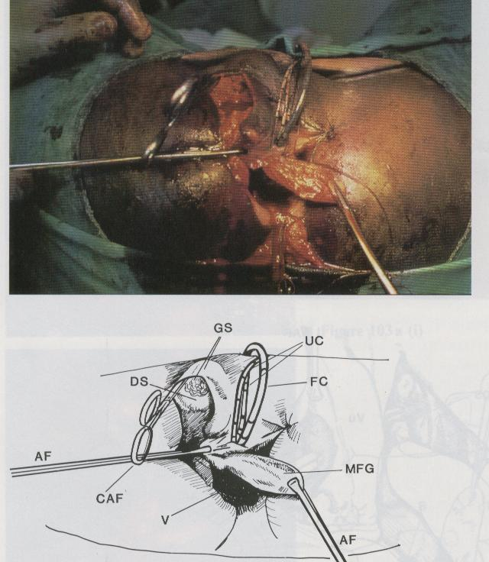
Fig 28: Fixing the flap over the VVF suture
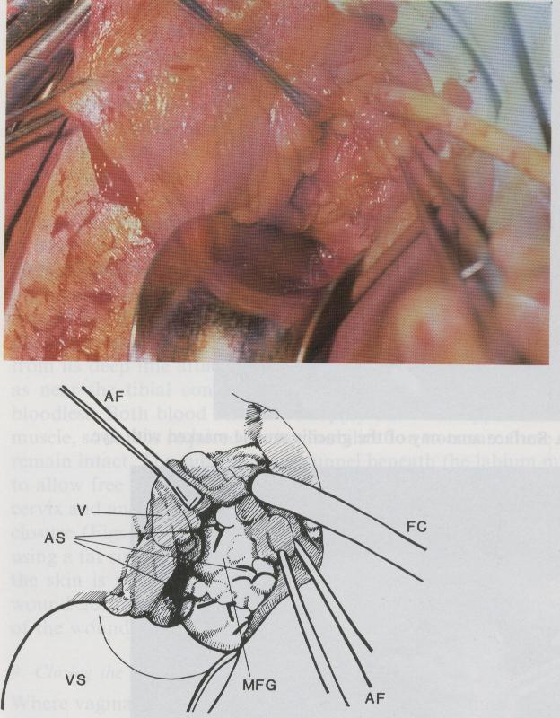

Fig 29: Another example of the Martius flap technique
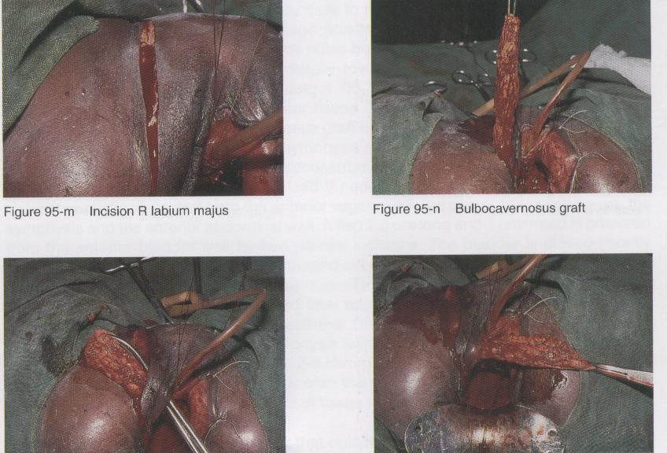

Completion of the operation
Once the VVF suture is completed, and possibly the fatty flap done, the vaginal plane is reconstructed in chrome 2/0. Sometimes there is a lack of tissue. If the skin edges are not excessively wide, you can leave it like this: it will reepithelise by secondary intention. If it is wide, you will need to cover with flaps from the labia minora or perineal skin.
If episiotomies were done, these need to be sutured.
At times the vagina may become too narrow. In this case, it is necessary to replace the episiotomies with a few flaps of the labia minora or the perineum.

Fig 30: Vaginal plasty with flaps of the labia minora
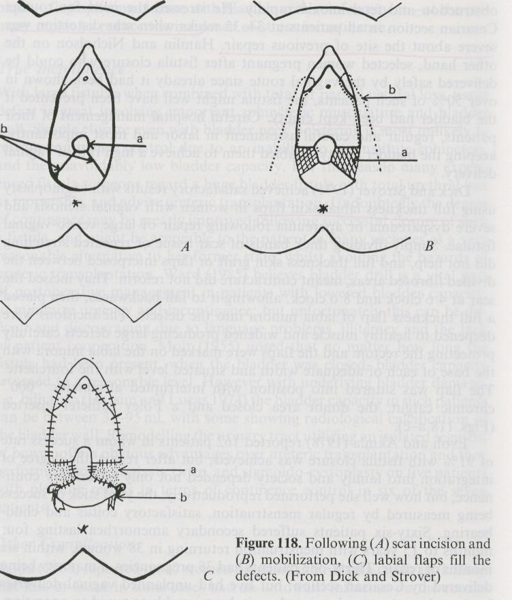

After suturing the vaginal plane, wash the vagina with saline solution and place a tamponade with some swabs or vaginal plug to control the residual haemorrhage and to compress the amply dissected tissues and cover swab over vaginal and vulvar stitches. The swabs must be removed the next day. A good rule is to confirm complete removal of all swabs by digital examination to avoid the possibility of any forgotten swabs which will result in severe infection and breakdown of repair.
The patient should remain with an indwelling catheter for 14 days (two weeks) post operatively. If it becomes blocked, it should be replaced immediately to avoid filling of bladder and damage to repair. It is best if the patient remains in hospital during this period to protect the operated area against pressure and infections.
Normally an antibiotic is administered such as amoxicillin or cotrimoxazol during one week to prevent infections.
When the patient is discharged, she is advised not to have sexual intercourse during a period of 2 months. Should the patient become pregnant, she should organise to be taken to a hospital where the baby can be delivered via a caesarean section to avoid damage to repair and recurrence of VVF.

Chapter 3: Surgical Repair of Recto-Vaginal Fistulae (RVF)
As mentioned before, RVF tend to form fairly high in vagina, since these are caused by the compression of the soft parts between the head of the foetus and the sacral promontory. There can be RVF formation in the lower half of the vagina and even third-degree perineal lacerations, generally due to tears in the soft tissue caused by the passage of the head or caused by extraction manoeuvres.
Its repair cannot be carried out without first clearing the RVF of the faecal bacterial contamination. To achieve this, a colostomy must be performed beforehand in the left transverse colon or in the sigmoid colon. The easiest and fastest is the left transverse colon.
Once the vagina is cleaned, a RVF repair may be scheduled.
It is advisable to conduct the closure of the RVF and the VVF during the same operating session. Normally we begin with the RVF, because the prior dissection of the lower vaginal plane, to mobilise the vaginal and rectal walls of the RVF, creates the most beneficial condition of viewing the operating field, as well as in the region of the VVF.
However, it is best to begin with the recto-vaginal mobilisation, to benefit from the good visibility to repair the VVF and, thereafter, complete the operation with the repair of the RVF. Other times it is more convenient to close the RVF completely before proceeding to the VVF.
The basic principles are the same:
- Introverting suture;
- Suture without tension.

High RVF
High RVF present the difficulty of mobilisation of the vaginal plane. Begin with a distal north-south incision that reaches the vaginal-rectral cleavage plane and has a length of approximately 2 cm. In the lower part of the incision it is easier to enter the cleavage plane with the tip of the scissors and, gradually separate the two planes in the entire circumference of the RVF. The electrocoagulator must always be on hand to maintain an efficient haemostasis.
Once the rectal orifice has been separated in its entire circumference, continue the separation on the cleavage plane, until the margins of the rectal wall may be approximated without any tension.
At times, some skills or “tricks” may be used to facilitate the mobilisation.
- The distal margin of the RVF may be retracted with a finger inserted in the rectum or by means of a small Farabeuf retractor.

Fig 31: Traction with finger in rectum
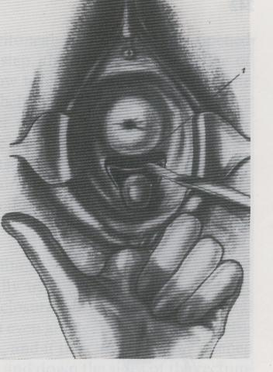
Fig 32: Traction with small retractor
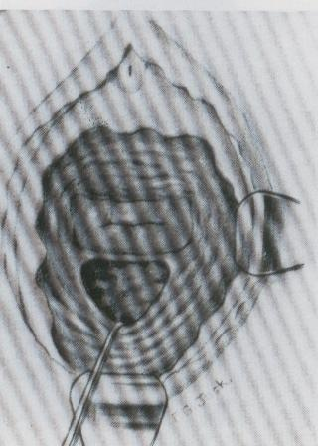

The margin between the RVF and the posterior fornix may be opened by deliberately entering in the end of the pouch of Douglas, to retract down the rectal wall without obstacles.
Fig 33: Opening of Douglas
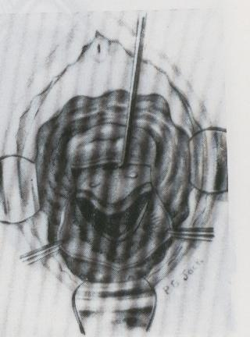

Fig 34: Traction to the bottom of the rectal wall and suture
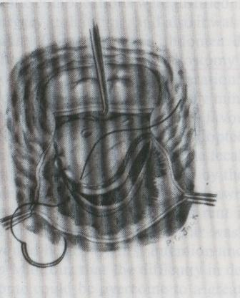

The rectal wall may be fixed to the vaginal margins in such a way as to substitute the vaginal wall when the latter is not enough.
Fig 35: Vaginal margins sutured to rectal wall
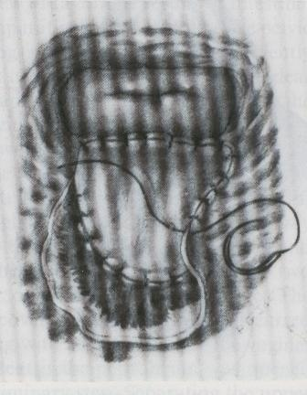

The vaginal margins are sutured to the rectal wall, which constitute the new vaginal plane.

Low RVF
The low RVF may be treated by separating the vaginal and rectal walls, following north-south incisions that reach the cleavage plane and continuing with the introverting suture and without tension.
In certain cases close to the anus it may be easier to convert the RVF into a third-degree perineal laceration and proceed with its repair with the well exposed tissues in front.

Fig 36: A probe is passed through the RVF
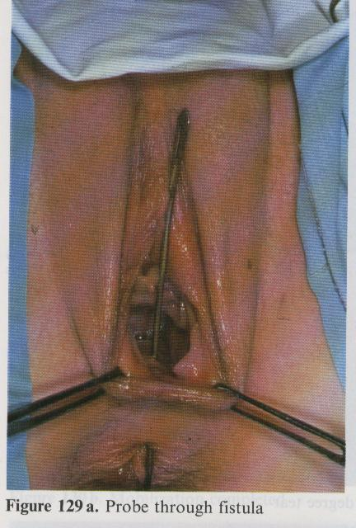
Fig 37: Probe on tension and incision of the septum
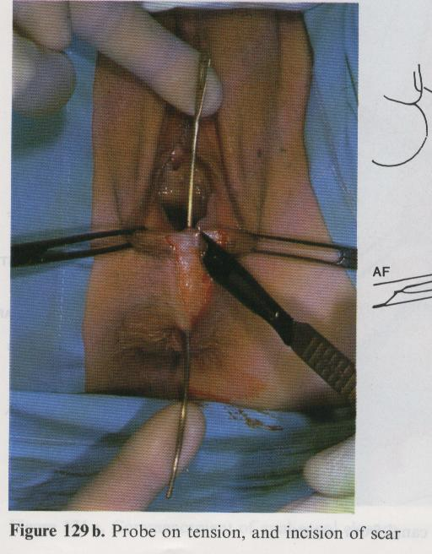
Fig 38: RVF converted to a 3rd degree perineal laceration
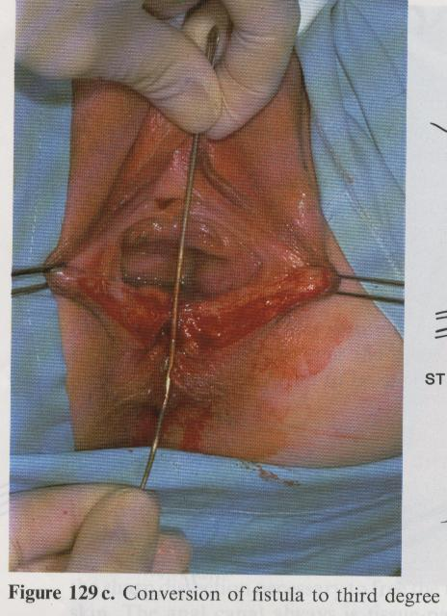

Fig 39: Recto-vaginal mobilisation
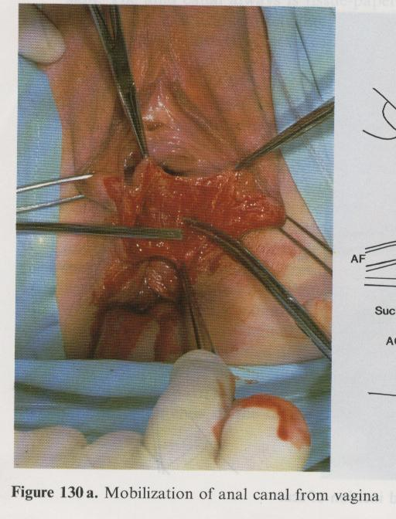
Fig 40: North-south suture of anal canal
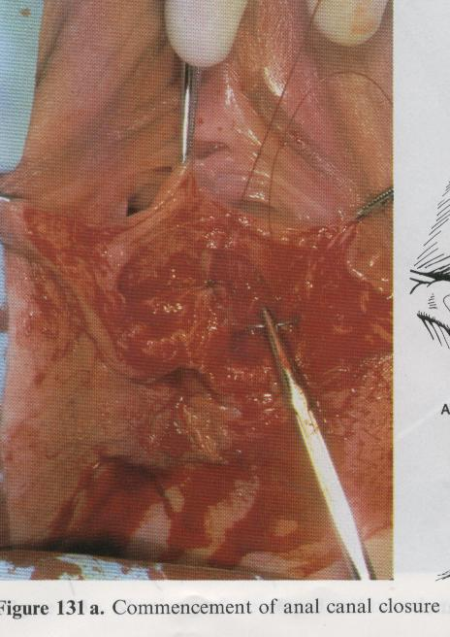
Fig 41: Completed suture
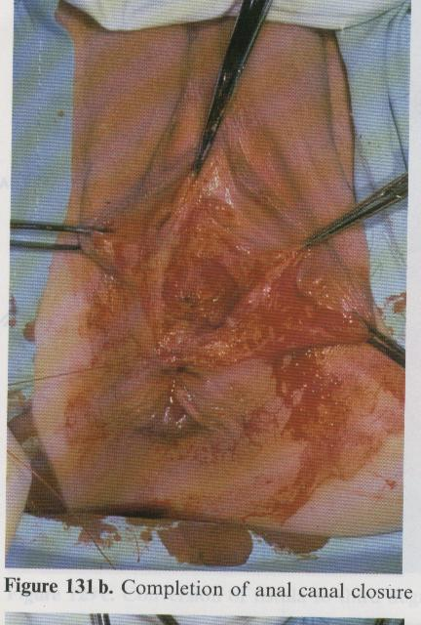
Fig 42: Sphincter suture
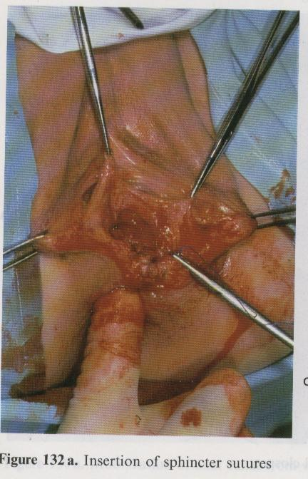
Fig 43: Isolation of the cut sphincter ends
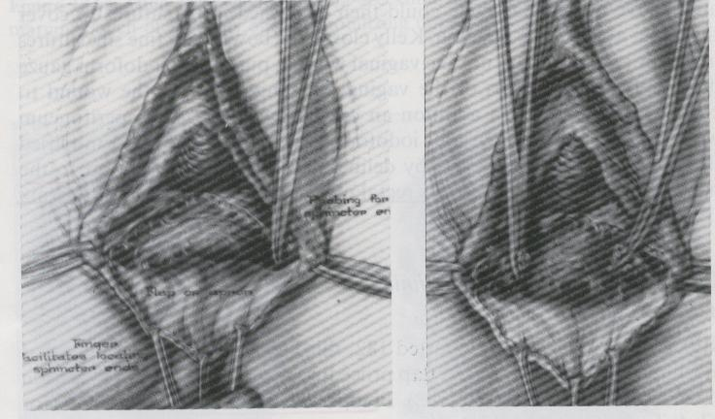
Fig 44: Sutured sphinter ends
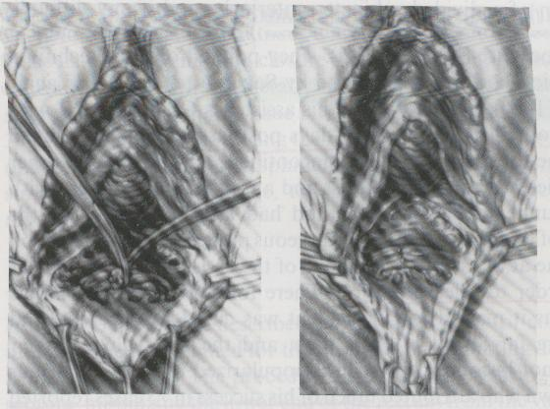

Finally, proceed with the closure with a suture on the vaginal plane. It is often useful to reinforce the rectal suture with a Martius fatty flap of the labium majora. Place a tamponade.

Postoperative Care
The following day remove the tamponade. Careful vaginal hygiene is recommended.
After a month, the patient is taken to theatre to examine if the suture of the RVF was successful.
Introduce a probe in the rectum and fill the balloon. Inject 100 to 200 ml of saline solution dyed methylene blue or gentian violet. If no colour exits the vagina, it can be concluded that the RVF has closed and you may proceed with the closure of the colostomy.

Other surgeries

4.1 Correction of incontinence
Following the successful repair of the VVF, the patient may remain incontinent due to the general loss of tissues in the bladder base and the urethral sphincter. The most current operation is, with a strip of fascia lata, to suspend retropubically, above the fascia of the rectus abdominal muscles, the proximal part of the urethra at the entrance to the bladder. This is a sling procedure that can also be done using many sling grafts now available. For example, TVT tape or obturator tape.
Fig 45: Retro-pubic colpo-urethral suspension of the passage area of the urethra to the bladder
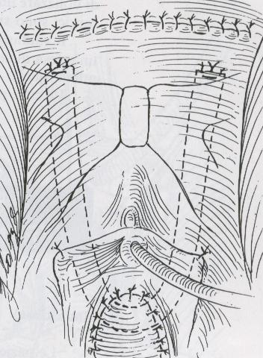
Results can be mediocre, and in the best cases, the patient is only continent when lying on a bed or sitting. Good results seen with newer sling tapes.

4.2 Ureterosigmoidostomy
No reconstructive surgery is possible in cases of extreme loss of vital tissues of the vagina and bladder. In these cases, the solution is to divert the urine into the rectosigmoid. Although this operation carries the risks of ascending urinary infection, it is sufficiently well tolerated and preferable to the ureterocutaneostomy which would burden the patient for the rest of her life to the use of collection bags on the abdominal wall.

