Surgical Repair of Vesico-Vaginal Fistulae (VVF)

Operar Fístulas Vesico-Vaginais (FFV)

Dr Aldo Marchesini, Mozambique

Bilingual Edition: English and Portuguese



Section Page
Surgical Repair of Vesico-Vaginal Fistulae (VVF) – English i
Operar Fístulas Vesico-Vaginais (FFV) – Português 33

Surgical Repair of Vesico-Vaginal Fistulae (VVF)
Dr Aldo Marchesini, Mozambique

South African Institute for Distance Education
P O Box 31822
Braamfontein
2017
South Africa
Tel: +27 11 403 2813
Fax: +27 11 403 2814
http://www.saide.org.za

© South African Institute for Distance Education and Dr Aldo Marchesini, 2011
Permission is granted under a Creative Commons Attribution license to replicate, copy, distribute, transmit, or adapt this work freely provided that attribution is provided as illustrated in the citation below. To view a copy of this licence visit http://creativecommons.org/licenses/by/3.0/ or send a letter to Creative Commons, 559 Nathan Abbott Way, Stanford, California,94305, USA.
Citation:
Marchesini, A. 2011. Surgical Report of Vesico-Vaginal Fistulae. (VVF). Johannesburg: Saide

ISBN:978-0-9869837-6-4

This project was funded by

Table of Contents
Chapter 1: Examination and Classification of Fistulae 1
1. How is a fistula formed 1
2. How to stabilise a fistula 1
3. How to examine a fistula 2
3.1 Site 2
3.2 Size 2
3.3 Nature of the margins 3
3.4 Size of the Vagina 3
3.5 Recto-Vaginal Fistulae (RVF) 3
4. Pre-operative examination 4
5. Classification of the VVF 4
5.1 Site on the vesico-vaginal wall 4
5.2 Sizes of VVF 7
5.3 Miscellaneous VVF 8
Chapter 2: Repair of VVF 11
1. Position of the patient 11
2. Improving the exposure 13
3. Reducing the possibility of bleeding 14
4. Separate the vagina from the bladder 14
5. Surgical Repair of VVF 15
6. Final test 16
7. The fatty flap of the labium majora 17
8. Completion of the operation 20
Chapter 3: Surgical Repair of Recto-Vaginal Fistulae (RVF) 22
1. High RVF 22
2. Low RVF 25
3. Postoperative Care 29
4. Other surgeries 29
4.1 Correction of incontinence 29
4.2 Ureterosigmoidostomy 30

List of Figures
Fig 1: Tissue with necrosis, and Necrotic tissues becoming detached
Fig 2: Vaginal stenosis, posterior band
Fig 3: Severe vaginal narrowing and vaginal atresia
Fig 4: The continence mechanism is located in the urethral sphincter and the bladder base
Fig 5: VVF not affecting the continence mechanism 6
Fig 6: VVF affecting only the vaginal wall 7
Fig 7: Circumferential VVF 7
Fig 8: Urethral Meatus on view – its characterisation 8
Fig 9: Micro VVF, viewed by injecting gentian violet 8
Fig 10: Large VVF, with bladder base prolapse 9
Fig 11: Destruction of anterior urethral wall 9
Fig 12: Destruction of circumferential urethra 10
Fig 13: Destruction of the anterior urethral wall 10
Fig 14: Vesico-uterine fistulae 10
Fig 15: Hyper lithotomy position 11
Fig 16: In this position, the assistant may comfortably assist 11
Fig 17: Labia minora open and valve in position 12
Fig 18: Ventral decubitus position 12
Fig 19: View before the episiotomy 13
Fig 20: View after the episiotomy 13
Fig 21: View after the episiotomy and placing the valve 13
Fig 22: Separating the bladder epithelium and the vagina epithelium 14
Fig 23: Vesical plane with introverting suture, without perforating the mucosa 14
Fig 24: How to begin the separation of the planes 14
Fig 25: Opening the labium majora and isolating the fatty flap 17
Fig 26: Tunnelling the flap 17
Fig 27: Extracting the flap on the vaginal side. 18
Fig 28: Fixing the flap over the VVF suture 18
Fig 29: Another example of the Martius flap technique 19
Fig 30: Vaginal plasty with flaps of the labia minora 20
Fig 31: Traction with finger in rectum 22
Fig 32: Traction with small retractor 22
Fig 33: Opening of Douglas 22
Fig 34: Traction to the bottom of the rectal wall and suture 23
Fig 35: Vaginal margins sutured to rectal wall 23
Fig 36: A probe is passed through the RVF 24
Fig 37: Probe on tension and incision of the septum 24
Fig 38: RVF converted to a 3rd degree perineal laceration 25
Fig 39: Recto-vaginal mobilisation 25
Fig 40: North-south suture of anal canal 26
Fig 41: Completed suture 26
Fig 42: Sphincter suture 26
Fig 43: Isolation of the cut sphincter ends 27
Fig 44: Sutured sphinter ends 27
Fig 45: Retro-pubic colpo-urethral suspension of the passage area of the urethra to the bladder 28

Acknowledgements
This English translation was prepared by Maria Teixeira Translations cc.
Dr. K. Lalloo, a specialist obstetrician and gynaecologist, checked the accuracy of the translation, and inserted five clarificatory sentences.

A note from the author
The aim of this document is to introduce vesico-vaginal fistulae (VVF) and the guiding principles associated with its surgical repair.

I am happy to have found such an opportunity to release my work on surgical repair of Vesico-Recto Vaginal fistulas under a Creative Commons licence. This work is meant for all surgeons who decide to restore to dignity these unfortunate patients in resource-poor settings.
The booklet was developed over the years in which I worked in Mozambique and was met with the appalling number of fistula patients being generally neglected. Slowly a small group of surgeons started dedicating some of their time to the problem and it appeared that there was a need for a hand-out publication showing in detail the steps in surgical repair.
Later on the Ministry of Health supported special training sessions in major Mozambican Hospitals and a number of surgeons were trained in fistula repair techniques. Now fistulas are repaired in Maputo, Beira, Tete, Chimoio, Buzi, Quelimane, and other centres in Mozambique. The bi-annual training sessions in Beira involve eight surgeons and the number of patients treated and restored to dignity is steadily increasing.

Dr Aldo Marchesini, 26 November 2010

Chapter 1: Examination and Classification of Fistulae

How is a fistula formed
A fistula is, by definition, an abnormal opening between two organs that no longer closes spontaneously. In our case, it is an opening which forms between the bladder and the vagina.
During prolonged obstructed labour, the head of the foetus becomes stuck in the birth canal and presses the soft parts of the vagina and the bladder against the pubic symphysis, and sometimes the vagina and the rectum against the sacral promontory. Should this compression last several hours, the tissues become deprived of blood circulation and oxygen, thus producing an area of necrotic tissue. When the necrosis detaches from the adjacent tissues, an orifice opens between organs involved, which will no longer close, thus forming a fistula.
It will either be a vesico-vaginal fistula (VVF) or a recto-vaginal fistula (RVF), depending on its location.
There are other consequences: the foetus may die and, at times, the uterus can rupture because of hypertonic contractions, with serious life-threatening consequences for the mother. Cephalo-pelvic disproportion is the main cause of obstructed labour. Consequently, sufferers of VVF/RVF are normally young primiparous women, of small stature (< m.1,50). Some of these women no longer have a uterus and, thus, are doubly discriminated due to incontinence of urine and /or faeces and residual permanent infertility.

How to stabilise a fistula
Following a prolonged obstructed labour, the vaginal tissues become traumatised, oedematous and, in many cases, necrotic at various sites of the vaginal canal. The necrotic tissue become detached and scar retraction processes begin which may reduce the vagina to a narrow, distorted, canal presenting bands of scar tissue which profoundly alter the architecture of the vagina. The processes of retraction and repair may take several weeks to heal. Surgical repair should therefore be considered two months after initial injury.

Fig 1: Tissue with necrosis, and Necrotic tissues becoming detached

Fig 2: Vaginal stenosis, posterior band
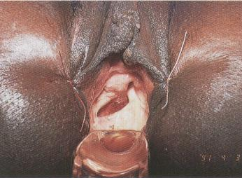

Fig 3: Severe vaginal narrowing and vaginal atresia
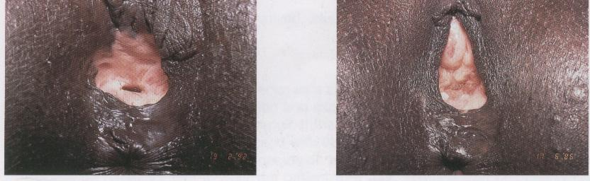

How to examine a fistula
The first examination simply involves the digital examination of the vagina. Use two fingers to determine the form, size and elasticity of the vagina, and with the tip of the forefinger or the middle finger try to locate the orifice of the fistula. In most cases, it is simple to detect the site, form, size and nature of the margins, the elasticity and thickness of the tissues, etc. The various characteristics are presented below.

3.1 Site
- Close to the pubis, mid-vaginal, close to the cervix, or even in the vaginal vault in the case of a hysterectomy due to a uterine rupture.
- May or may not occur in the bladder base (the urethra passage to the bladder). This is important in the event of urethral sphincter destruction, and once the VVF has been repaired, incontinence may continue due to sphincter incompetence.
- Whether or not circumferential, i.e. if it involves the entire bladder, leaving a separation between the proximal urethral orifice and the vesical fistula orifice.

3.2 Size
The correct assessment of the size is done with the tip of the finger over the entire circumference of the VVF. This is the only way to determine the real size of large fistulae and of those that present as a cystocele.
Greater care should be taken with small fistulae to distinguish its presence and size in the anterior vaginal wall. Often the finger is unable to recognise the fistula. In this case, examine the patient in the lithotomy position, with good lighting, with the assistance of retractors, and by introducing a solution dyed with methylene blue or gentian violet via a catheter and syringe, to observe where the liquid leaks into the vagina, thus allowing identification of the VVF.

3.3 Nature of the margins
This is an important aspect because it reveals the scar thickness, elasticity or rigidity of the margins. If the margins are thick, fatty and well vascularised, the VVF suture will hold with greater ease, but if the margins are thin, scarred or adhering to the ascending border of the pubis without a cleavage plane, then the closure will be laborious with a high probability of dehiscence and failure of repair surgery.
- Carefully examine the upper margin, especially when it is in contact with the symphysis pubis. If the soft parts are very thin or reduced to a simple layer of scar tissue on the lower horizontal border of the pubis, then the closure will present severe difficulties and post-repair residual urinary incontinence will almost inevitably occur.
- In examining this margin, care should be taken to detect if this is a circumferential fistula, characterised by the circular destruction of the bladder base. More concretely, by palpation it is possible to detect the presence of two separate orifices: the proximal urethra and the neck of the bladder.
- Another important detail worth recording is the length of the urethra. If it is less than 1 cm, then part of the urethra was destroyed and the VVF repair will result in a probability of urinary incontinence.

3.4 Size of the Vagina
Assess the size of the vagina as it may have serious implications in the closure of the VVF.
- Narrow, short and scarred vagina. It may also have horizontal bands on the lower wall which limit access and may impede visualisation of VVF.
- Excessively large and deep vagina. It may be very difficult to view the opening of the VVF. Inventive solutions and techniques will be required to improve the visibility and accessibility of the VVF.

3.5 Recto-Vaginal Fistulae (RVF)
Before completing the examination, always ask the patient if she experiences faecal incontinence. This will assist in suspecting the RVF.
It is worth recalling that RVF are formed due to the compression of the soft tissue between the head of the foetus and the sacral promontory, which normally occurs in the upper part of the vagina. However, lower RVF and even third-degree perineal lacerations also result in faecal incontinence.
It is not always easy to visualise a RVF. These are frequently located behind a scar band which may conceal the opening of the RVF. RVF have an elliptic shape on a large horizontal transverse axis. The lower margin tends to be more rigid and fixed.
RVF may not always be detected by digital examination. Therefore, insert a long and thin Kelly forceps in the orifice and then introduce a finger in the rectum to detect where the forceps enters the rectal canal and thus locate the VVF.

Pre-operative examination
In most cases, vaginal palpation is sufficient to make the diagnosis. However, often the golden rule is an examination under anaesthetic, with excellent lighting, in the hyper lithotomy position, as to be used during repair surgery. It is not uncommon to discover details which were not detected by palpation.
The examination in theatre is indispensable to discover the site of smaller VVF which were not located by palpation.
For this purpose, a catheter is inserted into the bladder and naso-gastric syringe (or another large syringe, adapted with a rubber of a solution system) is used to inject a saline solution dyed with methylene blue or gentian violet. The VVF orifice will be easily detected, even if it is small. Up to 200 ml might need to be inserted into the bladder to detect VVF.
If no liquid leaks into vagina, it is possible to conclude there is no VVF.
In the event of no leakage, two possibilities exist, which might explain the uncontrolled loss of urine.

Urinary incontinence.
This may be easily demonstrated by removing the catheter leaving a full bladder. There may be an immediate leakage of urine from the urethral meatus. If the urine does not exit spontaneously, first place pressure suprapubically or ask the patient to cough to demonstrate stress incontinence.

Ureterol-vaginal fistula
There is no exit of urine when removing the catheter, nor during coughing, suprapubic pressure. As you continue to observe the vagina, you will note that after a few minutes, a small amount of liquid collects in the posterior fornix. Dry with a swab and observe if the liquid collects once again. If the liquid which collects is transparent and clear, and not blue or violet, it is possible to conclude it is an uretero-vaginal fistula because the urine has not come from the bladder but directly from the ureters. Every effort should be made to detect whether it is the right or the left ureter. Where facilities are available one can confirm this by doing a retrograde pyelogram.

Classification of the VVF
The two main parameters to be considered when classifying the VVF are the following:

Site on the vesico-vaginal wall
The basic marker is the continence mechanism, i.e. the integrity of the bladder base and the urethral sphincter.

Fig 4: The continence mechanism is located in the urethral sphincter and the bladder base
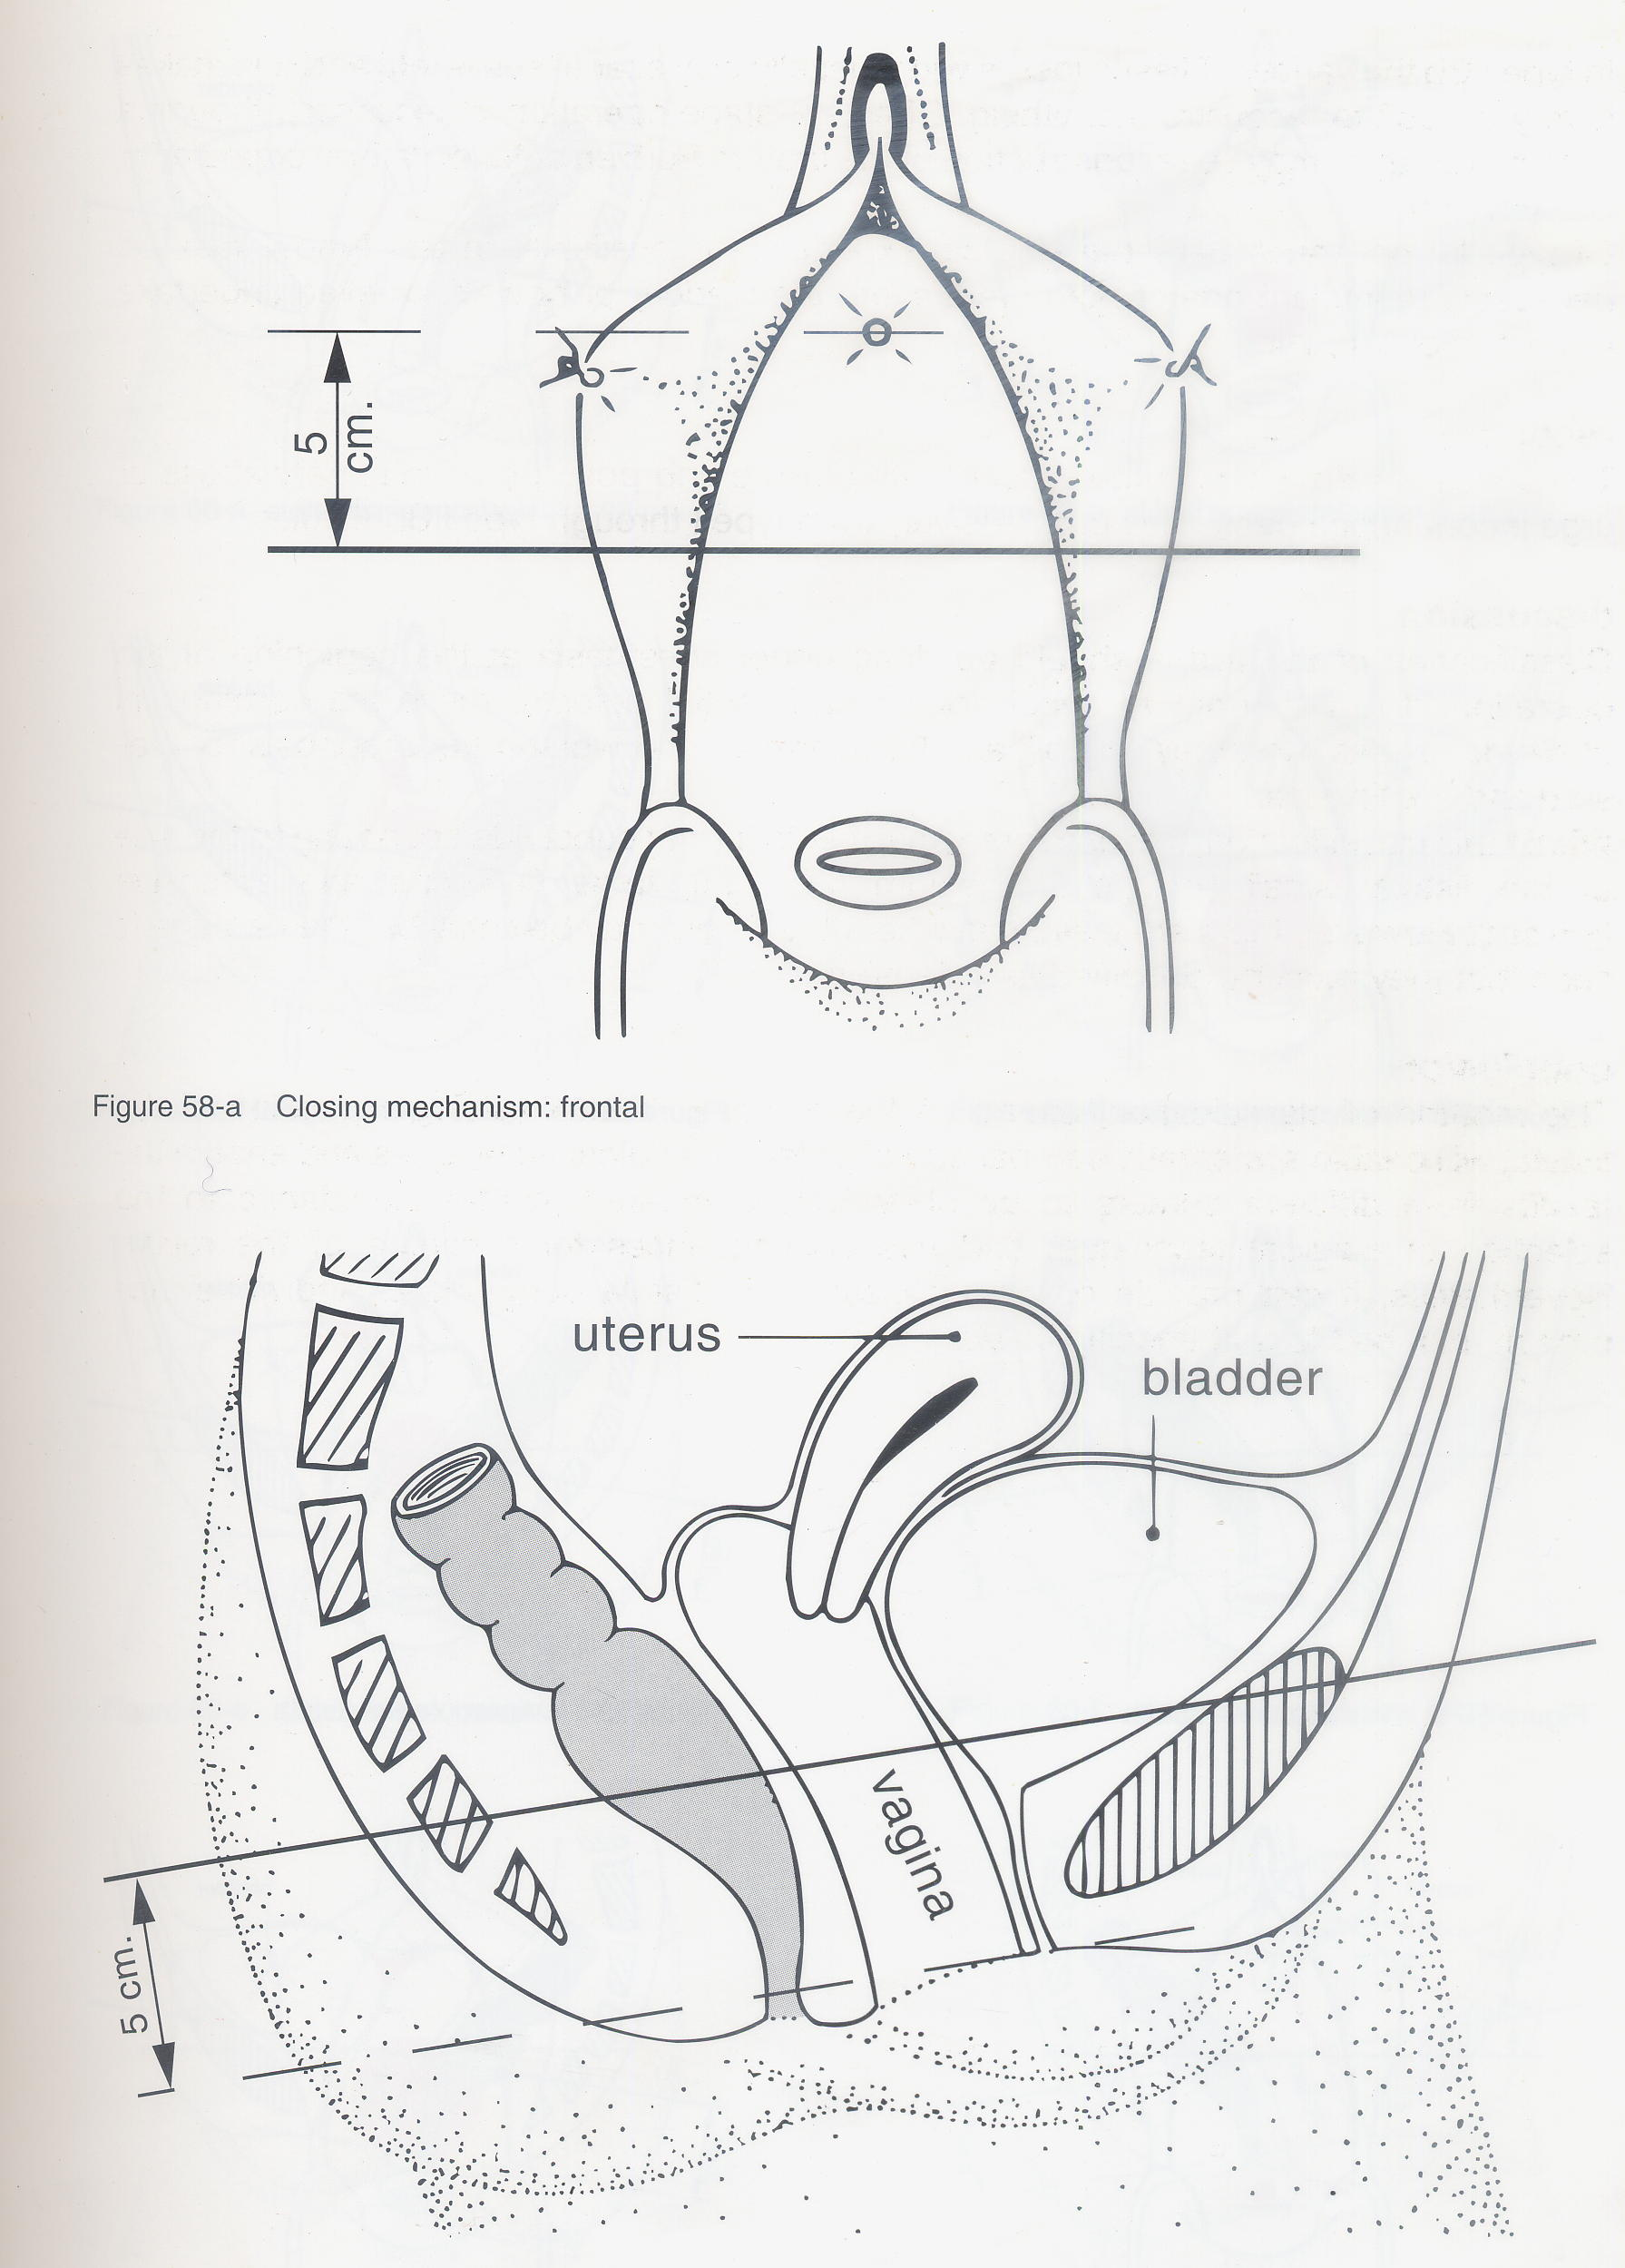

In VVF that does not affect the continence mechanism: successful repair of VVF will result in complete cure and continence.
Fig 5: VVF not affecting the continence mechanism
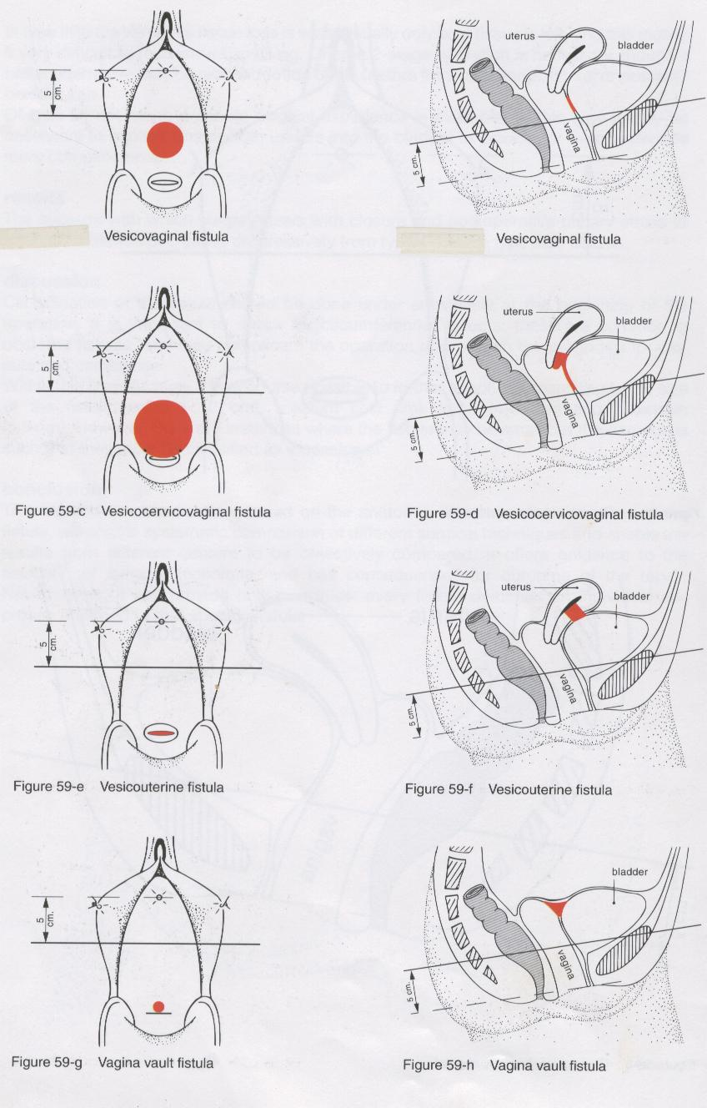
VVF affecting the continence mechanism, i.e. those whose upper margin is related to the bladder base and the sphincter.

Fig 6: VVF affecting only the vaginal wall
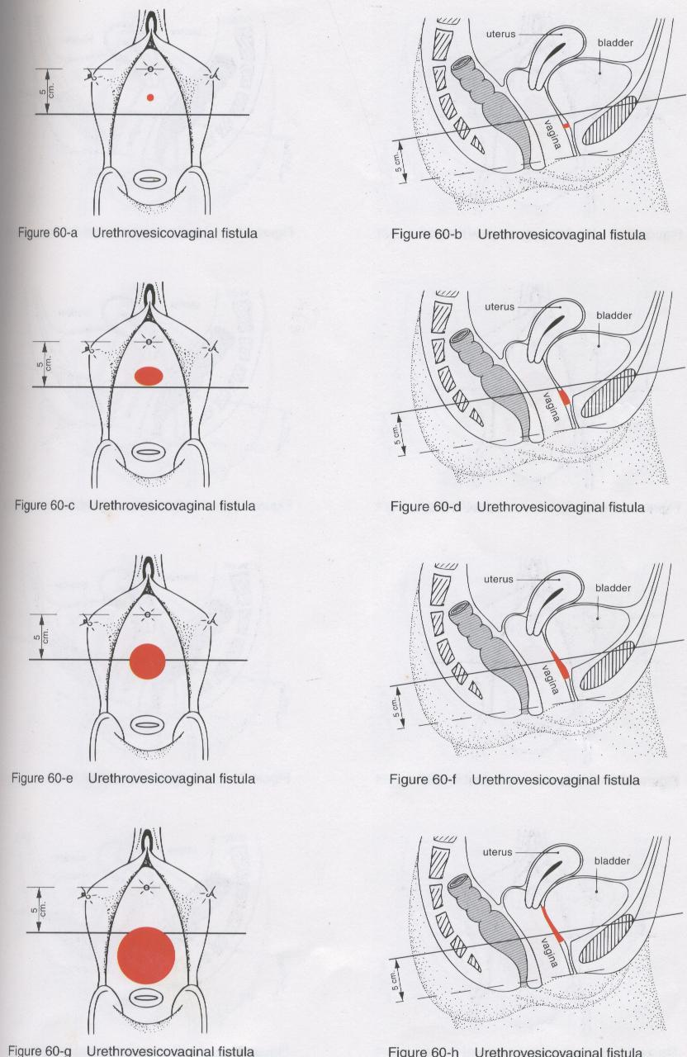
Fig 7: Circumferential VVF
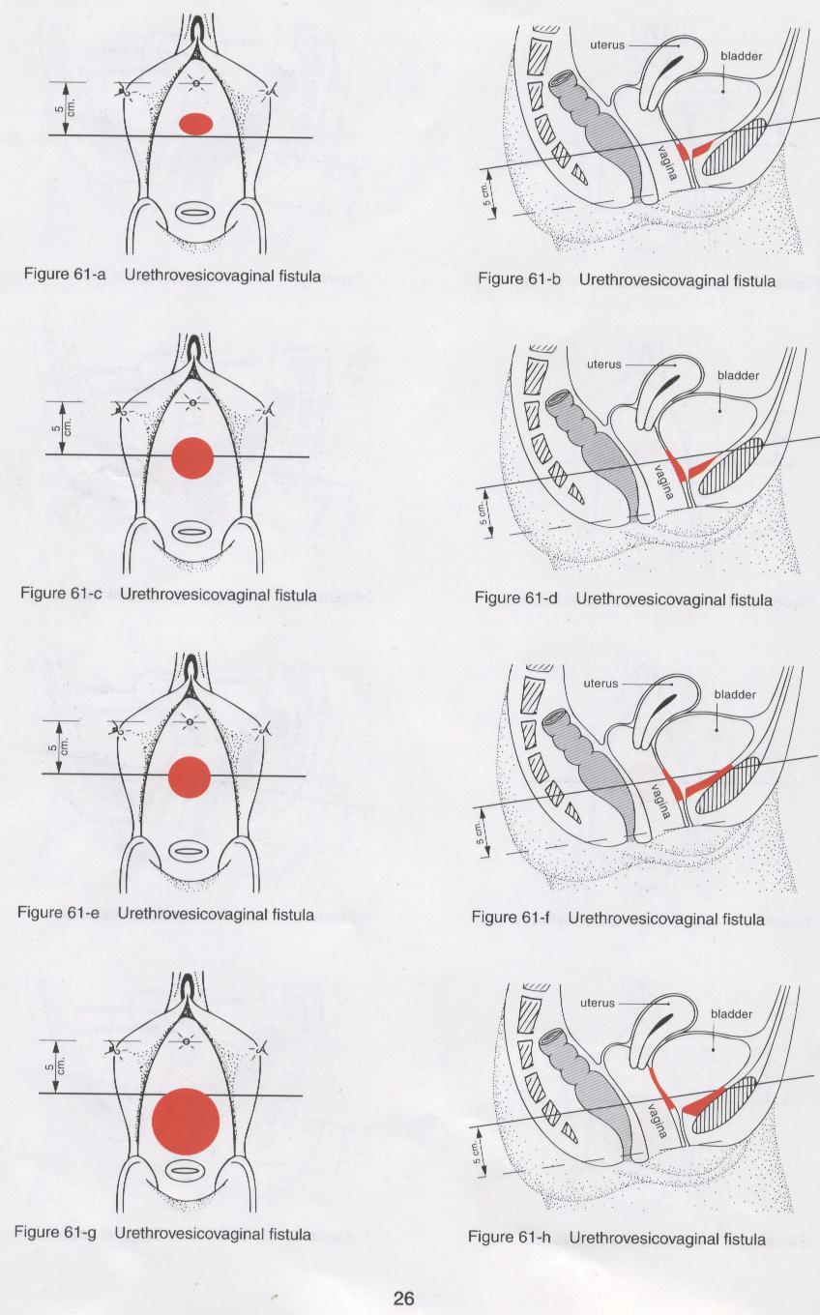

VVF whose upper margin presents the urethral meatus visible in the margin. These VVF may or may not affect the continence mechanism.

Fig 8: Urethral Meatus on view – its characterisation
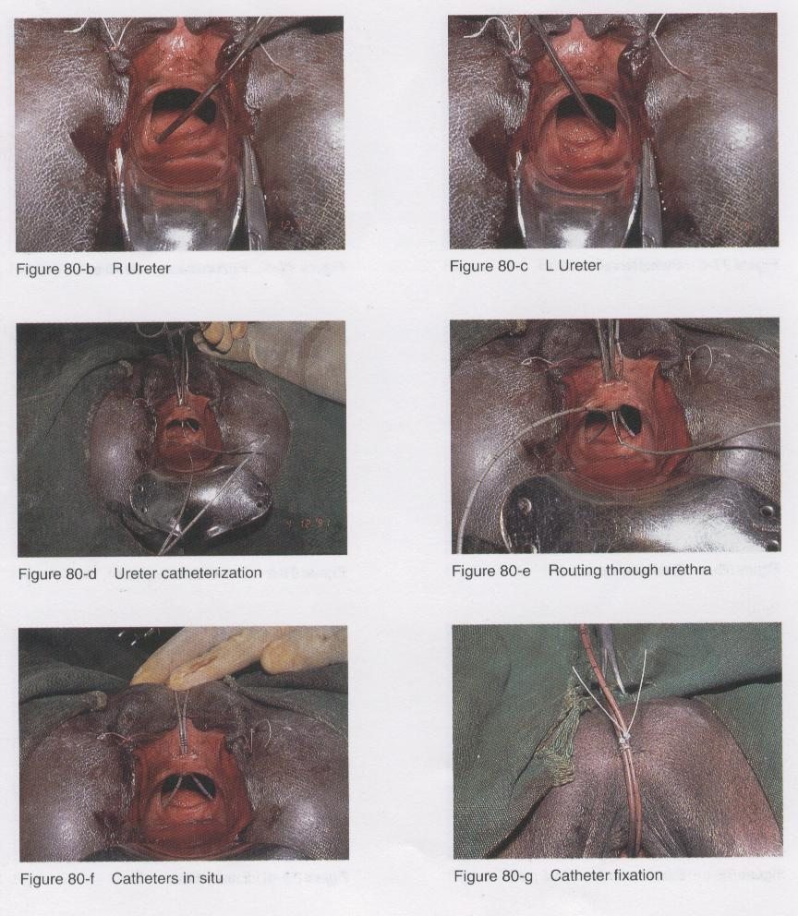

5.2 Sizes of VVF
Microscopic: need to be located with blue or violet solution through a catheter.

Fig 9: Micro VVF, viewed by injecting gentian violet
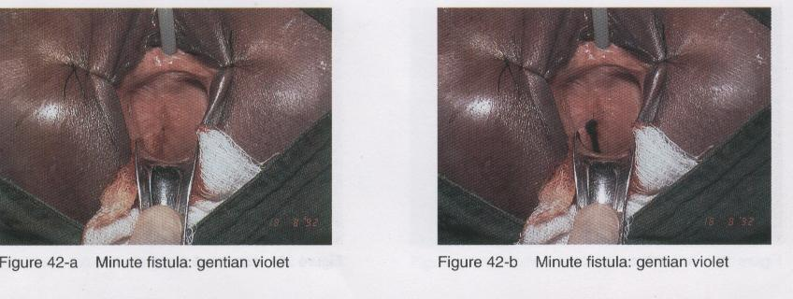

Small: up to 2 cm in diameter
Medium: larger than 2 cm, but with fatty and elastic margins
Large: whose margins are against the ascending borders of the pubis.

Fig 10: Large VVF, with bladder base prolapse
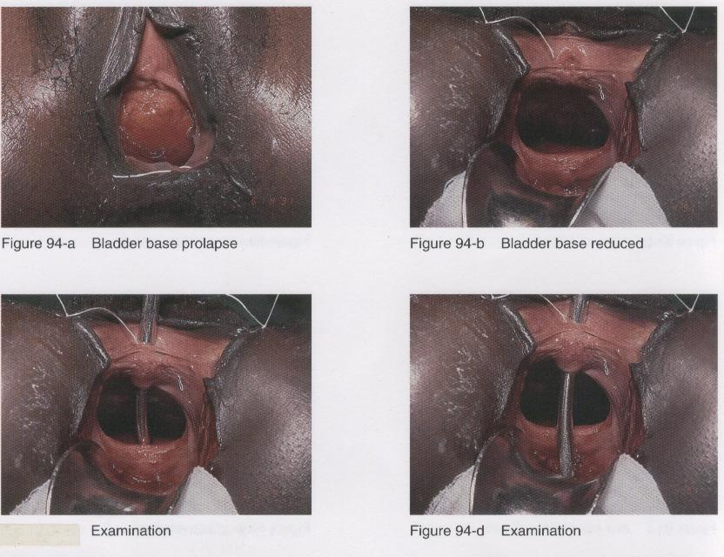

5.3 Miscellaneous VVF
Urethro-vaginal fistulae
Fistulae with the destruction of a considerable portion of the urethra
Fig 11: Destruction of anterior urethral wall
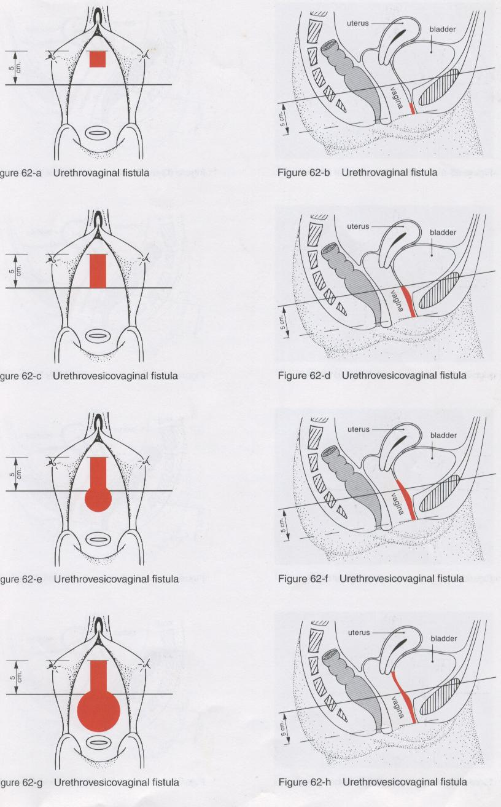

Fig 12: Destruction of circumferential urethra
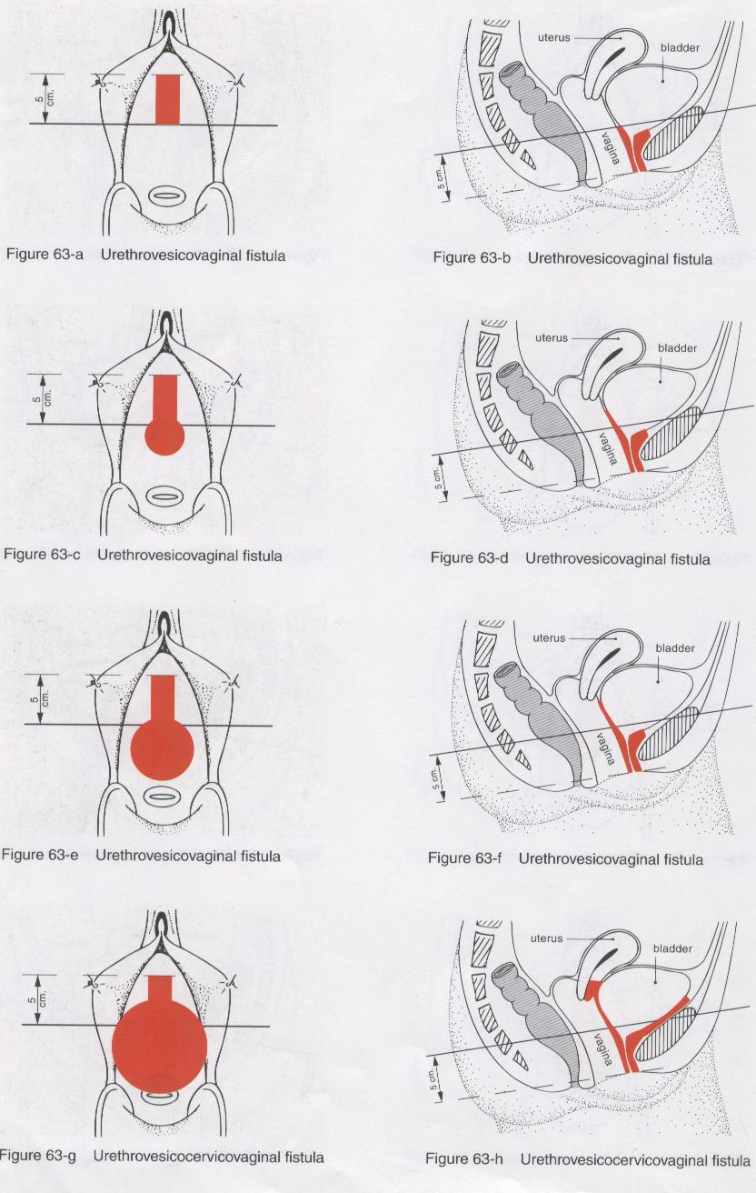

Fig 13: Destruction of the anterior urethral wall
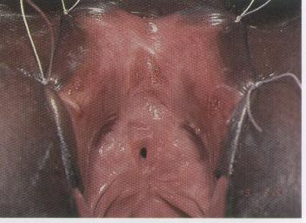

Fistulae which open into the cervical canal of the uterus or into the uterus \

Fig 14: Vesico-uterine fistulae
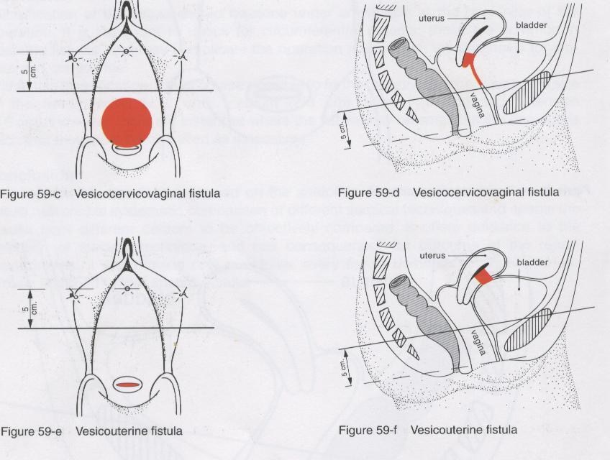
Chapter 2: Repair of VVF
The surgical repair of VVF is based on two basic principles:
- The separation and mobilisation of the vaginal and bladder planes;
- Suture for opposing edges without tension of the bladder wall, without perforating the bladder mucosa.
The aim of the VVF surgery is to apply these two principles correctly. There are various solutions and, at times, a creative initiative is required to overcome an impediment to the application of the two principles. Therefore, there is always a margin for innovation when operating on VVF and you never stop learning and inventing, and tailor making appropriate procedures.

Position of the patient
The normal position is the hyper lithotomy position, with the buttocks extending beyond the theatre table, the thighs flexed against the abdominal wall and abductors, the theatre table plane inclined in the Trendelemburg position.
Fig 15: Hyper lithotomy position
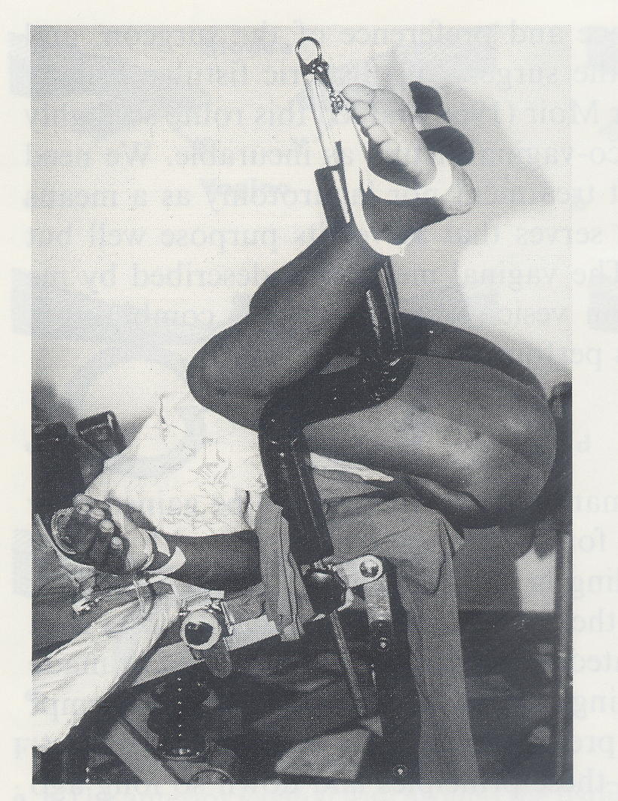
The visibility of the field is good in this position and the assistants may easily assist, seeing sufficiently well and without having to submit to uncomfortable positions.
Fig 16: In this position, the assistant may comfortably assist
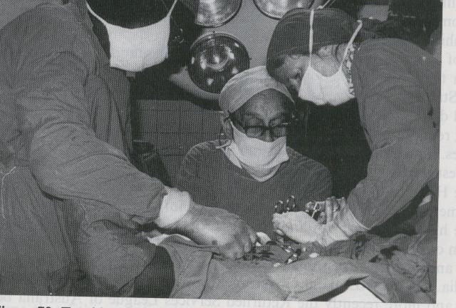
For a clear view of the interior of the vagina, you need to fix the labia minora with silk sutures on the top and on the bottom and introduce a retractor, possibly the heavy weighted type that does not require an assistant.
Fig 17: Labia minora open and valve in position
However, there are cases where the position of the VVF is against the pubic bone or have other characteristics which make it practically inaccessible in the hyper lithotomy position.
These difficulties can be overcome by turning the patient onto her stomach, in a ventral decubitus position.
Fig 18: Ventral decubitus position
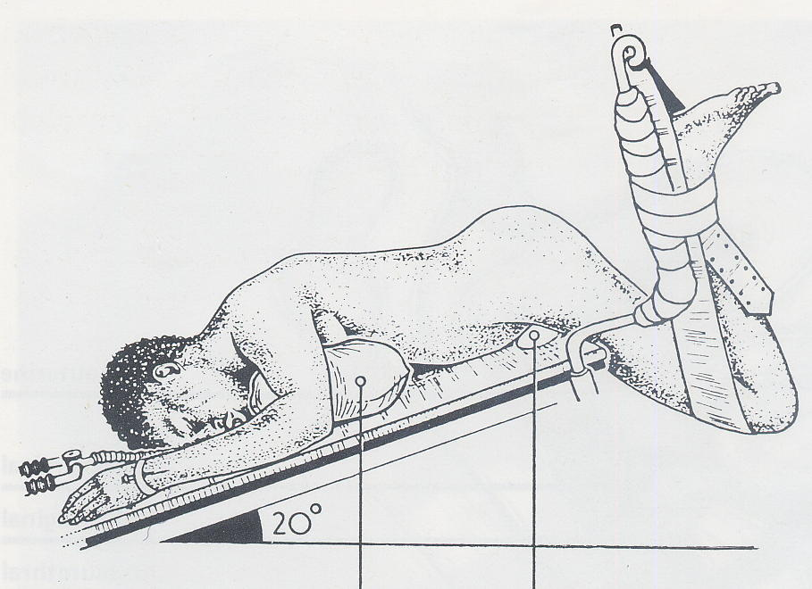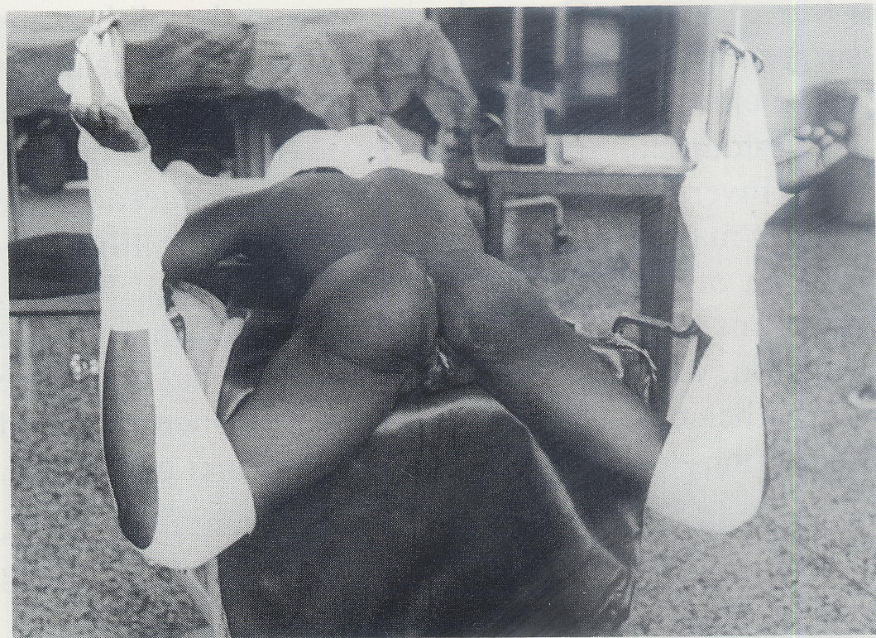

The assistants obviously cannot see as well and work in uncomfortable positions.

Improving the exposure
To operate properly, firstly you need to see clearly, i.e. you need to adopt all these skills or techniques which bring the VVF into view in a position accessible to the scalpel, scissors and needle holder.
It is useful to raise the upper part of the vagina, placing two Allis forceps to the sub-urethral portion: this brings the VVF orifice easily within sight.
When the vagina is tight or has horizontal scar bands in the posterior vagina wall, do not hesitate to perform one or two generous episiotomies. These will radically improve the view and are easily repaired at the end of the procedure.

Fig 19: View before the episiotomy
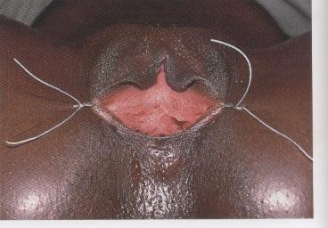
Fig 20: View after the episiotomy
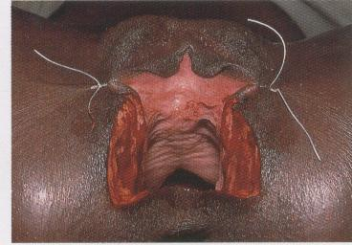
Fig 21: View after the episiotomy and placing the valve
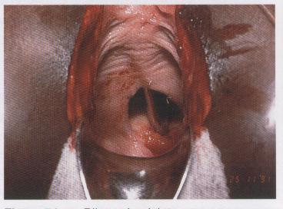
Two instruments are particularly useful in improving the exposure: the metal speculum and the thin and narrow malleable blades, which assist in retracting the side and upper vaginal walls.
In the case of the interior wall prolapse of the bladder, it is useful to introduce a swab in the bladder via the VVF. Naturally, do not forget to remove it before tightening the orifice too much.

Reducing the possibility of bleeding
It is convenient to infiltrate the tissues which are to be dissected to improve the separation of tissue planes and reduce bleeding during dissection. With a 20 ml syringe, aspirate an adrenaline ampoule, and wet the entire internal surface of the syringe. The adrenaline is then emptied once again in the ampoule and with the same syringe aspirate 10-15 ml of saline solution, thus, obtaining the lowest concentration adrenaline solution. Use this solution to infiltrate the peri-fistulous tissues, targeting the vesico-vaginal tissue plane.

Separate the vagina from the bladder
In a VVF, the vesical epithelium edge heals continuously with the vaginal epithelium.
The bladder epithelium continues in the vagina epithelium. These need to be separated.
Fig 22: Separating the bladder epithelium and the vagina epithelium
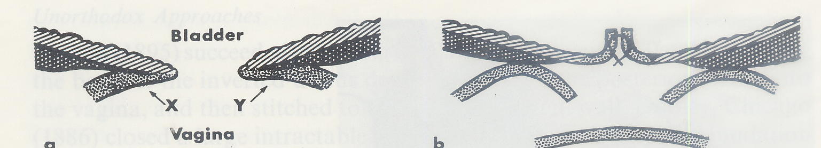

The separation is the first step in suturing the two surfaces separately further on. Thus, after repairing the two epithelia will constitute two completely separate and independent layers, without any connection.
Fig 23: Vesical plane with introverting suture, without perforating the mucosa
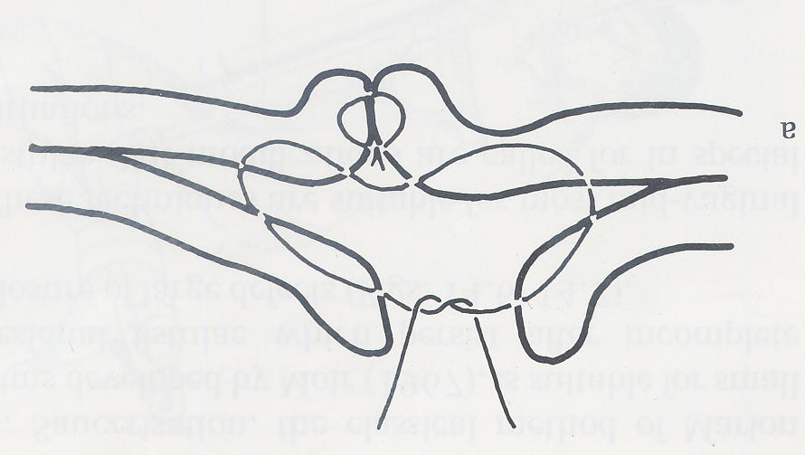
More concretely, the technique used to easily find the cleavage plane between the bladder and the vagina, is to make an incision in the vaginal wall, calibrating the depth to reach the exact cleavage plane. Begin by making a north-south incision, from the inferior margin, to keep the field free of blood as well as to improve the mobilisation of the interior margin.
Fig 24: How to begin the separation of the planes
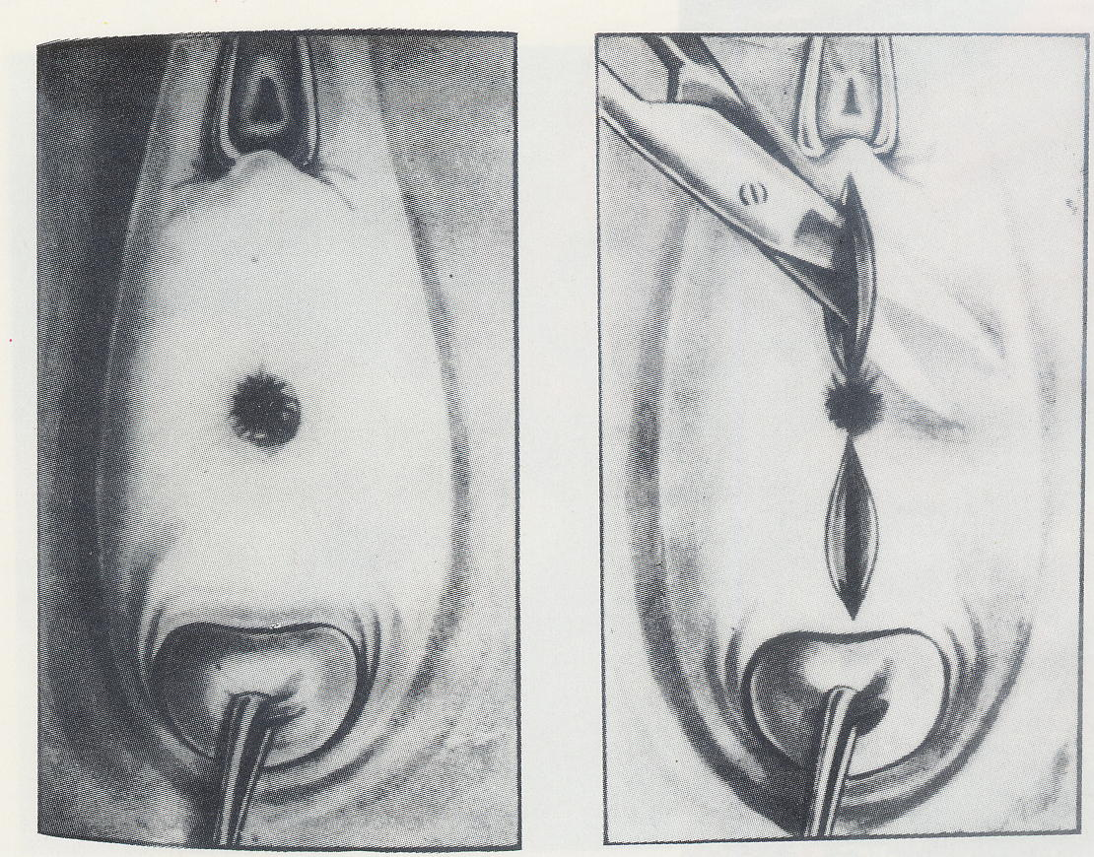
Subsequently, prolong the incision following the line of passage of the vaginal epithelium to the vesical epithelium, until the west to east points of the circumference of the VVF orifice. With a surgical scalpel blade No. 12 or with the point of a thin dissecting scissors) deepen the separation of the planes, lifting as if it were two petals. It is very important to separate at the cleavage plane, to keep bleeding to a minimum. If an arterial bleed occurs, use electrocoagulation. Alternatively, make a haemostatic stitch in the shape of an 8, in chrome 3/0 or 2/0. The extent of the dissection depends on the resistance offered by the tissues to the approximation of the VVF margins without any tension.
At this point make two incisions on the vaginal plane in a horizontal east-west direction, allowing for the more efficient lifting of the vaginal wall in relation to the bladder. This incision allows the beginning and completion of the bladder mobilisation in relation to the deeper and quite often intervening scar tissues between the bladder and the ascending borders of the pubis.
Once these regions have been mobilised, then proceed with the separation of the vaginal and vesical (or urethral) planes, beginning at the upper margin. Once again, use the south-north incision technique and the incision in the line of passage between the two walls, vaginal and urethral. At the end of the dissection, four petals should be formed between the four incisions which form a cross as from the margin. These are fixed with chrome 2/0 or 3/0, in extroversion, to allow for the best possible reconstructive surgical field of vision without the assistant having to constantly hold forceps to keep tissue apart.

Surgical Repair of VVF
Once the separation appears to be good, proceed with a test by taking the margins with the Allis forceps and approximating them to see if they may be sutured without any tension.
Four criteria govern the suture of the VVF margins, namely:
- Introverting, i.e. the vesical mucosa must remain in the interior of the suture and the same cannot be perforated by the suture thread;
- Tension-free repair;
- Begin at the edges;
- Separate sutures of vicryl 3/0 or 2/0 or chrome 2/0; ie NOT continuous sutures.
The most comfortable and convenient line of suture is the horizontal one, traditionally called east-west. There are, however, VVF which close with greater ease in the longitudinal direction of north-south.
Suturing in separate stitches allows for greater safety and firmness in the approximation of the margins, and therefore, it is preferred. However, there are surgeons who use two continuous sutures, beginning at the ends and joining at the middle.
The best thread is the vicryl (or other polyglycolic thread) 3/0 or 2/0, to be selected as appropriate according to the nature of the tissues. Where there is a need for stronger sutures in resistant tissues, select the 2/0, where there is a need to respect the fine and delicate structures, use the 3/0. Vicryl has the advantage of being extremely resistant to slipping of the knot and lasts approximately 6 weeks. In the absence of vicryl, chrome 2/0 may be used, which is also very resistant and maintains the knot well.
The needle must be appropriate to the space available to make a suture. It is possible to mould the needles of the atraumatic threads using the tip of the needle holder and the fingers. It is also very useful to increase the curvature of the tip, thereby reducing the radius.
Given that each stitch is introverted and tension-free, the success of the suture depends on the place where the needle passes in the lower half and the upper half.
The most difficult suture is the first one on each end. It should be made in a way that will reduce the possibility of urine leaking between the suture and the lateral extremity of the VVF.
Sutures should be placed close enough to avoid leakage of urine. If there is any doubt, you can always make another stitch in the middle.
The last stitches are the ones located in the middle. These may present some difficulty due to the low thickness of the upper wall, close to the urethra. This margin may not provide more mobility. It is the lower margin, by contrast, that may be mobilised a little more, to more easily place the stitch with its greater mobility.
When the orifice to be closed is small, it may be difficult to maintain a clear view of the margins to be sutured. In this case, apply the technique of first placing the stitches and keeping them untied on hold with mosquito/ small forceps and tying them one by one at the end.

Final test
The VVF cannot be considered to be properly closed without submitting the sutures to an intravesical liquid pressure test. To do this, inject the solution dyed methylene blue or gentian violet via a catheter using a 50 or 100 ml syringe, with a wide tip, the type used for naso-gastric feeding. In its absence, a 20 ml syringe adapted with a rubber of a solution system may be used.
In general, 100 ml is sufficient, given that there may also be some residual urine which would have accumulated in the bladder during the repair procedure.

The fatty flap of the labium majora
If the suture presents scarce tissue consistency or insufficient vascularisation, it is very useful to use the additional thickness and vascularisation offered by the flap around the fatty tissue, mobilised by opening one of the labia majora longitudinally. This technique is known as the Martius flap, after the name of the Austrian author who proposed it for the first time, or bulbo-cavernous graft.
Select the labium majora in the best position to transfer the fatty flap.
Make a longitudinal incision and with a hand forceps and scissors isolate a cylinder of fatty tissue, the size of the small finger. Achieve haemostasis. Cut the upper part and mobilise the flap to its base. Open a tunnel with a long and thin Kelly forceps, entering from the side of the vagina and exiting on the side of the labium majora. With the Kelly forceps take the edge of the flap and pull, through the tunnel, towards the detached vaginal space. The flap is fixed with chrome 2/0 suture on the line of suture of the VVF with a few stitches.
Then cover the flap with the vaginal wall detached previously. If it is not sufficient, cover it with a flap of tissue surrounding the wall of the labium minora.
Lastly, close the gap of the labium majora, joining the subcutaneous in chromic suture and close the skin with simple silk sutures, without much tension because there is a tendency to oedema formation a which will result in tearing of tissue by the tight stitches resulting in breakdown of the repair. The stitches may be removed on the 3rd or 4th day. This repaired area heals rapidly due to the excellent vascularisation.

Fig 25: Opening the labium majora and isolating the fatty flap
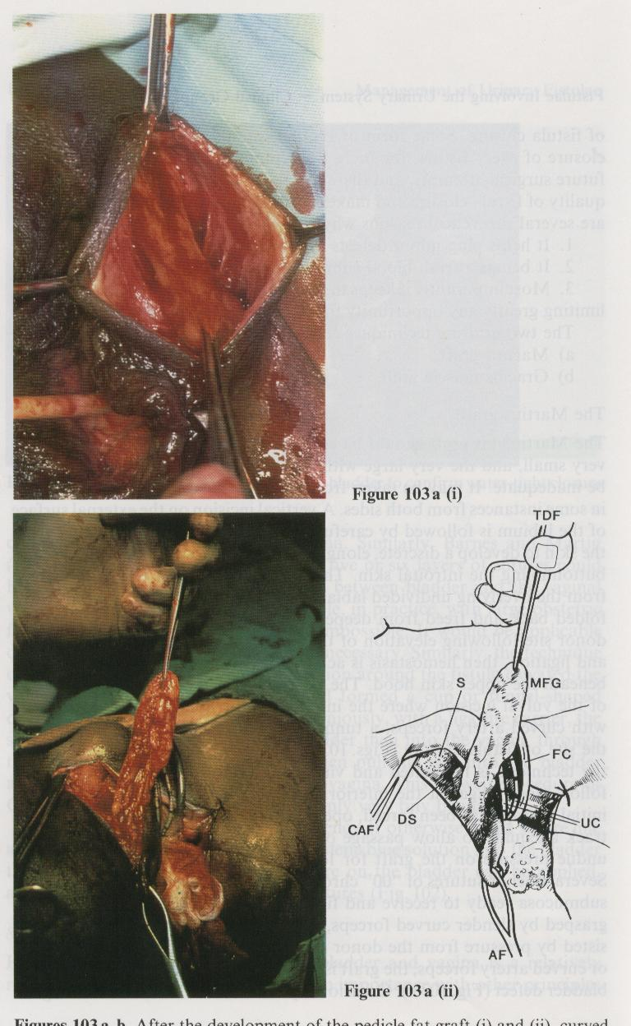
Fig 26: Tunnelling the flap
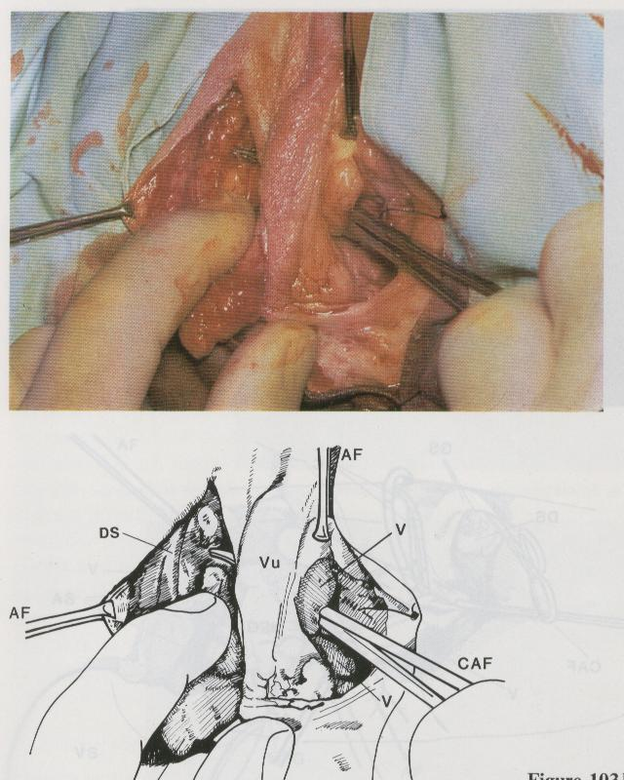

Fig 27: Extracting the flap on the vaginal side.
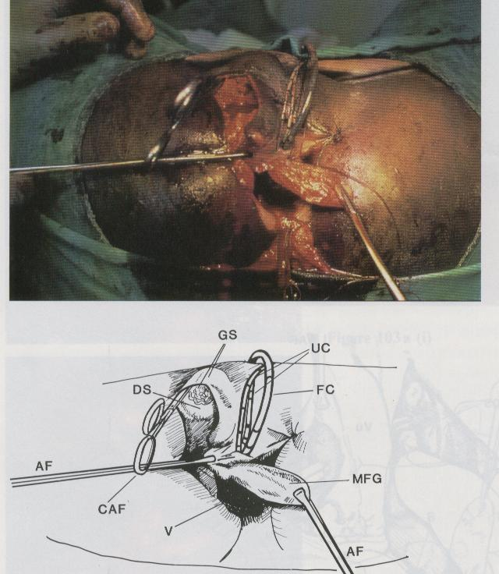
Fig 28: Fixing the flap over the VVF suture
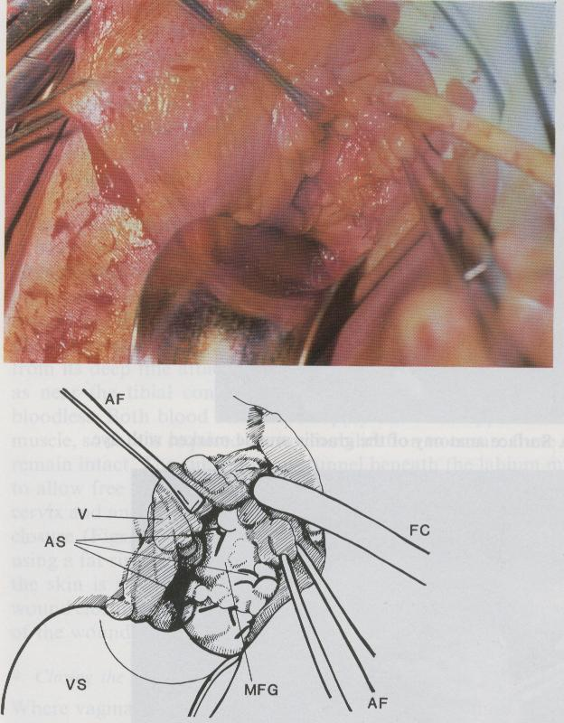

Fig 29: Another example of the Martius flap technique
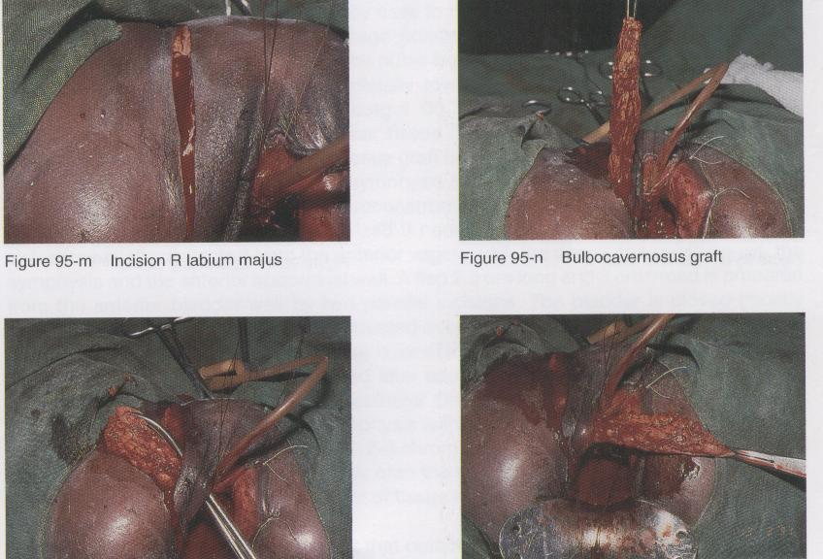

Completion of the operation
Once the VVF suture is completed, and possibly the fatty flap done, the vaginal plane is reconstructed in chrome 2/0. Sometimes there is a lack of tissue. If the skin edges are not excessively wide, you can leave it like this: it will reepithelise by secondary intention. If it is wide, you will need to cover with flaps from the labia minora or perineal skin.
If episiotomies were done, these need to be sutured.
At times the vagina may become too narrow. In this case, it is necessary to replace the episiotomies with a few flaps of the labia minora or the perineum.

Fig 30: Vaginal plasty with flaps of the labia minora
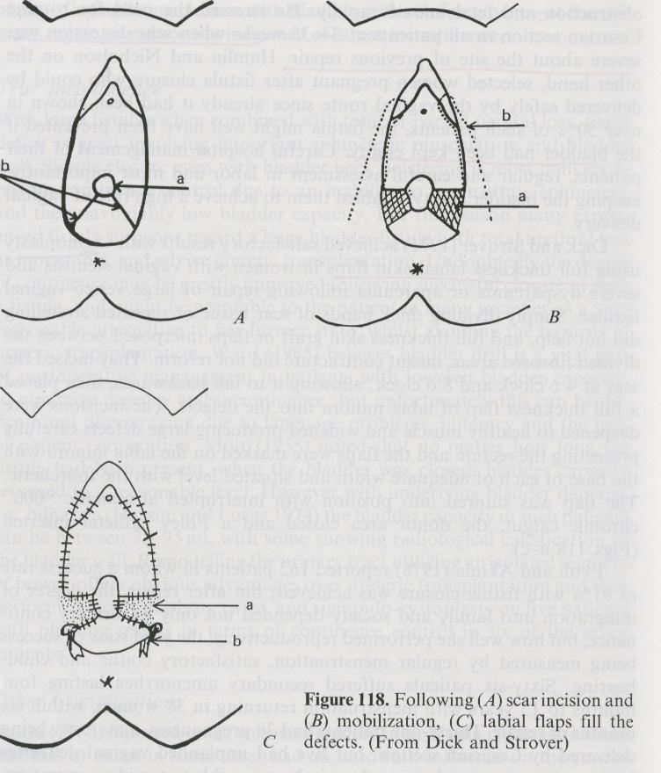

After suturing the vaginal plane, wash the vagina with saline solution and place a tamponade with some swabs or vaginal plug to control the residual haemorrhage and to compress the amply dissected tissues and cover swab over vaginal and vulvar stitches. The swabs must be removed the next day. A good rule is to confirm complete removal of all swabs by digital examination to avoid the possibility of any forgotten swabs which will result in severe infection and breakdown of repair.
The patient should remain with an indwelling catheter for 14 days (two weeks) post operatively. If it becomes blocked, it should be replaced immediately to avoid filling of bladder and damage to repair. It is best if the patient remains in hospital during this period to protect the operated area against pressure and infections.
Normally an antibiotic is administered such as amoxicillin or cotrimoxazol during one week to prevent infections.
When the patient is discharged, she is advised not to have sexual intercourse during a period of 2 months. Should the patient become pregnant, she should organise to be taken to a hospital where the baby can be delivered via a caesarean section to avoid damage to repair and recurrence of VVF.

Chapter 3: Surgical Repair of Recto-Vaginal Fistulae (RVF)
As mentioned before, RVF tend to form fairly high in vagina, since these are caused by the compression of the soft parts between the head of the foetus and the sacral promontory. There can be RVF formation in the lower half of the vagina and even third-degree perineal lacerations, generally due to tears in the soft tissue caused by the passage of the head or caused by extraction manoeuvres.
Its repair cannot be carried out without first clearing the RVF of the faecal bacterial contamination. To achieve this, a colostomy must be performed beforehand in the left transverse colon or in the sigmoid colon. The easiest and fastest is the left transverse colon.
Once the vagina is cleaned, a RVF repair may be scheduled.
It is advisable to conduct the closure of the RVF and the VVF during the same operating session. Normally we begin with the RVF, because the prior dissection of the lower vaginal plane, to mobilise the vaginal and rectal walls of the RVF, creates the most beneficial condition of viewing the operating field, as well as in the region of the VVF.
However, it is best to begin with the recto-vaginal mobilisation, to benefit from the good visibility to repair the VVF and, thereafter, complete the operation with the repair of the RVF. Other times it is more convenient to close the RVF completely before proceeding to the VVF.
The basic principles are the same:
- Introverting suture;
- Suture without tension.

High RVF
High RVF present the difficulty of mobilisation of the vaginal plane. Begin with a distal north-south incision that reaches the vaginal-rectral cleavage plane and has a length of approximately 2 cm. In the lower part of the incision it is easier to enter the cleavage plane with the tip of the scissors and, gradually separate the two planes in the entire circumference of the RVF. The electrocoagulator must always be on hand to maintain an efficient haemostasis.
Once the rectal orifice has been separated in its entire circumference, continue the separation on the cleavage plane, until the margins of the rectal wall may be approximated without any tension.
At times, some skills or “tricks” may be used to facilitate the mobilisation.
- The distal margin of the RVF may be retracted with a finger inserted in the rectum or by means of a small Farabeuf retractor.

Fig 31: Traction with finger in rectum
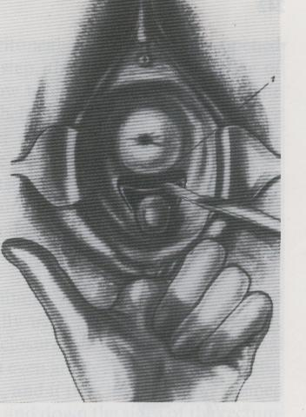
Fig 32: Traction with small retractor
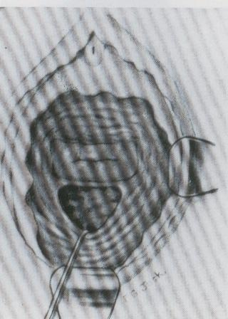

The margin between the RVF and the posterior fornix may be opened by deliberately entering in the end of the pouch of Douglas, to retract down the rectal wall without obstacles.
Fig 33: Opening of Douglas
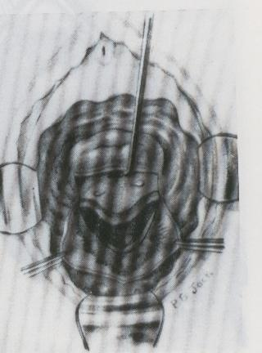

Fig 34: Traction to the bottom of the rectal wall and suture
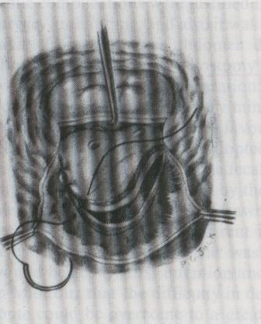

The rectal wall may be fixed to the vaginal margins in such a way as to substitute the vaginal wall when the latter is not enough.
Fig 35: Vaginal margins sutured to rectal wall
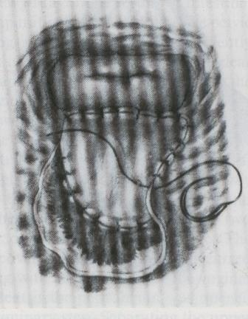

The vaginal margins are sutured to the rectal wall, which constitute the new vaginal plane.

Low RVF
The low RVF may be treated by separating the vaginal and rectal walls, following north-south incisions that reach the cleavage plane and continuing with the introverting suture and without tension.
In certain cases close to the anus it may be easier to convert the RVF into a third-degree perineal laceration and proceed with its repair with the well exposed tissues in front.

Fig 36: A probe is passed through the RVF
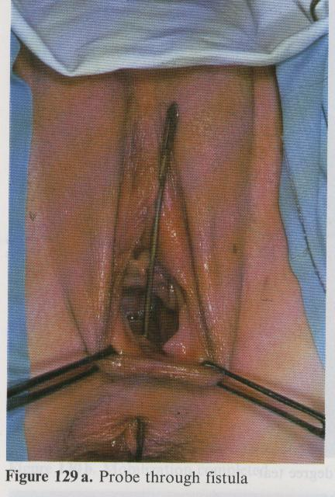
Fig 37: Probe on tension and incision of the septum
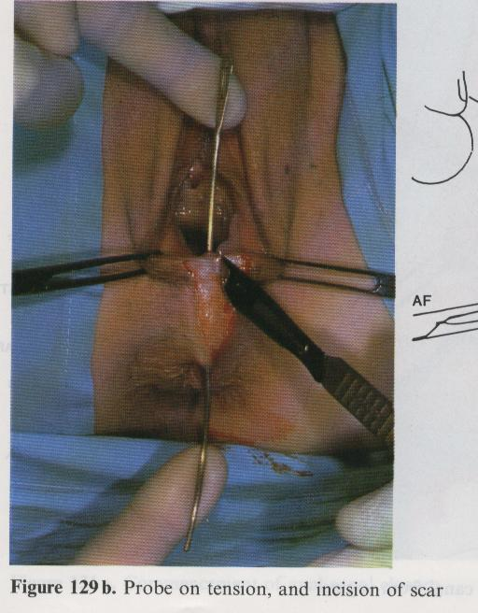
Fig 38: RVF converted to a 3rd degree perineal laceration
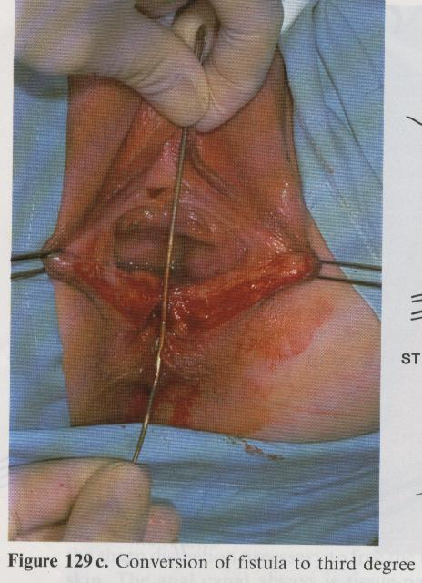

Fig 39: Recto-vaginal mobilisation
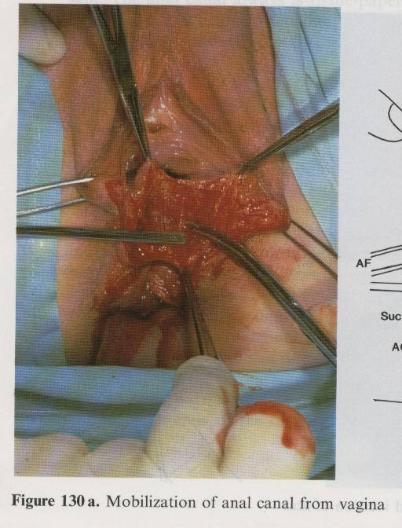
Fig 40: North-south suture of anal canal
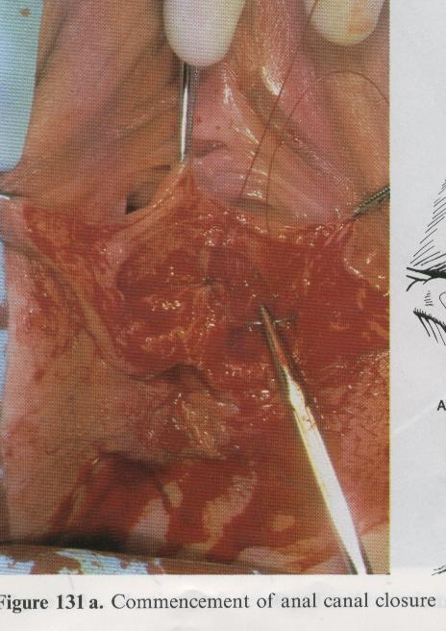
Fig 41: Completed suture
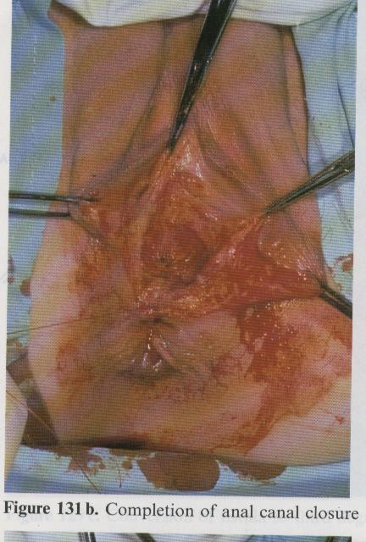
Fig 42: Sphincter suture
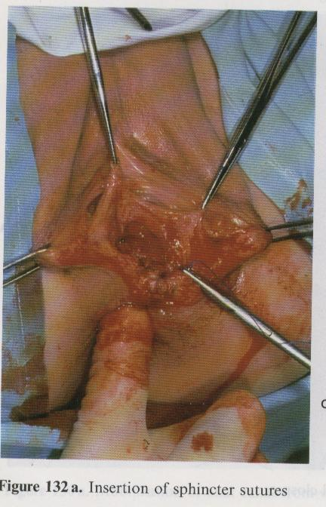
Fig 43: Isolation of the cut sphincter ends
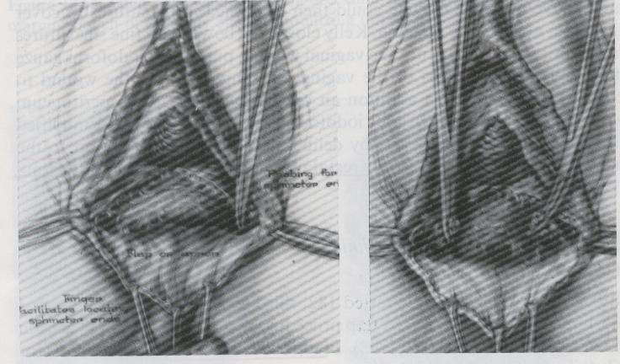
Fig 44: Sutured sphinter ends
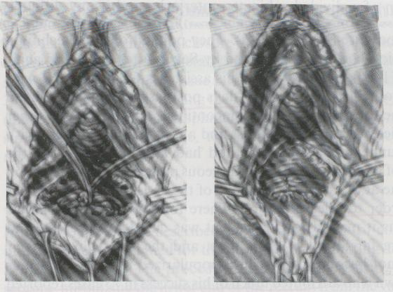

Finally, proceed with the closure with a suture on the vaginal plane. It is often useful to reinforce the rectal suture with a Martius fatty flap of the labium majora. Place a tamponade.

Postoperative Care
The following day remove the tamponade. Careful vaginal hygiene is recommended.
After a month, the patient is taken to theatre to examine if the suture of the RVF was successful.
Introduce a probe in the rectum and fill the balloon. Inject 100 to 200 ml of saline solution dyed methylene blue or gentian violet. If no colour exits the vagina, it can be concluded that the RVF has closed and you may proceed with the closure of the colostomy.

Other surgeries

4.1 Correction of incontinence
Following the successful repair of the VVF, the patient may remain incontinent due to the general loss of tissues in the bladder base and the urethral sphincter. The most current operation is, with a strip of fascia lata, to suspend retropubically, above the fascia of the rectus abdominal muscles, the proximal part of the urethra at the entrance to the bladder. This is a sling procedure that can also be done using many sling grafts now available. For example, TVT tape or obturator tape.
Fig 45: Retro-pubic colpo-urethral suspension of the passage area of the urethra to the bladder
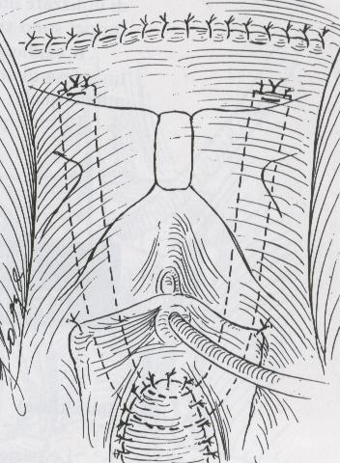
Results can be mediocre, and in the best cases, the patient is only continent when lying on a bed or sitting. Good results seen with newer sling tapes.

4.2 Ureterosigmoidostomy
No reconstructive surgery is possible in cases of extreme loss of vital tissues of the vagina and bladder. In these cases, the solution is to divert the urine into the rectosigmoid. Although this operation carries the risks of ascending urinary infection, it is sufficiently well tolerated and preferable to the ureterocutaneostomy which would burden the patient for the rest of her life to the use of collection bags on the abdominal wall.

Operar Fístulas Vesico-Vaginais (FFV)
Aldo Marchesini, Moçambique

South African Institute for Distance Education
P O Box 31822
Braamfontein
2017
South Africa
Tel: +27 11 403 2813
Fax: +27 11 403 2814
http://www.saide.org.za

© South African Institute for Distance Education e Aldo Marchesini
Permissão é concedida sob uma licença Creative Commons Attribution para duplicar, copiar, distribuir, transmitir ou adaptar este trabalho livremente, desde que a atribuição é fornecida como ilustrado na citação abaixo.
Citação:
Marchesini, A. 2011. Operar Fístulas Vesico-Vaginais (FFV).Johannesburg: Saide

ISBN: 978-0-9869837-7-1

Índice
Capítulo 1: Exame e Classificação das Fístulas 41
1. Como se forma uma fístula 41
2. Como se estabiliza a fístula 41
3. Como se examina a fístula 43
3.1 Localização 43
3.2 Dimensão 43
3.3 Natureza das margens 44
3.4 Dimensões da vagina 44
3.5 Fístula Recto-Vaginal 44
4. Exame pré-operatório 45
5. Classificação das FVV 45
5.1 Localização na parede vesico-vaginal 45
5.2 Dimensões da FVV 49
5.3 FVV de outro tipo 50
Capítulo 2: Reparação das FVV 53
1. Posição da paciente 53
2. Melhorar a exposição 55
3. Diminuir a possibilidade de sangramento 56
4. Separar o plano vaginal do plano vesical 58
5. A reparação cirúrgica da FVV 59
6. A prova final 60
7. O lembo adiposo do grande lábio 60
8. Finalização da operação 63
Capítulo 3: Reparação das Fístulas Recto-Vaginais 65
1. FRV altas 65
2. FRV baixas 68
3. Cuidados pós-operatórios 74
4. Outras cirurgias 74
4.1 Correcção da incontinência 74
4.2 Uretero-sigmoidostomia 74

Lista de figuras
Fig 1: Tecidos com necrose e Ecidos necróticos 41
Fig 2: Estenose vaginal, banda posterior 43
Fig 6: FVV que interessa só a parede vaginal 47
Fig 8: Meatos ureterais à vista – sua cateterização 48
Fig 9: FVV micro, visualizada injectando violeta de genciana 49
Fig 10: FVV grande, com prolapso da parede interna da bexiga 49
Fig 11: Destruição uretra parede anterior 50
Fig 12: Destruição uretra circunferencial 50
Fig 13: Destruição da parede anterior da uretra 52
Fig 14: Fístulas vesico-uterinas 52
Fig 15 Posição hiper-ginecológicas: 53
Fig 16: Nesta posição os assistentes ajudam comodamente 54
Fig 17: Pequenos lábios abertos e valva em posição 55
Fig 18: Posição em decúbito ventral 55
Fig 19: Visão antes da episiotomia 56
Fig 20: Visão depois da episiotomia 56
Fig 21: Visão depois da episiotomia e de colocar valva 56
Fig 22: O epitélio da bexiga continua-se naquele da vagina. É preciso separá-los 58
Fig 23: Plano vesical suturado de maneira introvertente, sem furar a mucosa 58
Fig 24: Como se inicia a separação dos planos 58
Fig 25: Abertura do grande lábio e isolamento do lembo adiposo 61
Fig 26: Tunelização do lembo 61
Fig 27: Extracção do lembo no lado vaginal 62
Fig 28: Fixação do lembo sobre a sutura da FVV 62
Fig 29: Outro exemplo de realização de lembo de Martius 63
Fig 30: Plastia vaginal com lembos de rotação dos pequenos lábios 64
Fig 31: Tracção com dedo no recto 66
Fig 33: Abertura do Douglas 67
Fig 32: Tracção com afastadorinho 22
Fig 34: Tracção para baixo da parede rectal e sutura 67
Fig 35: As margens vaginais são suturadas à parede rectal, que constitui o novo plano vaginal 68
Fig 36: Um estilete é passado através da FRV 69
Fig 37: Estilete em tensão e incisão da septo 69
Fig 38: FRV transformada em laceração perineal de 3º grau 70
Fig 39: Mobilização recto-vaginal 70
Fig 40: Sutura do canal anal norte-sul 71
Fig 41: Sutura completada 71
Fig 42: Sutura do esfíncter 72
Fig 43: Isolamento dos cabos do esfíncter cortado 72
Fig 44: Cabos do esfíncter suturados 72
Fig 45: Colpo-uretrosuspençao retropúbica da área de passagem da uretra para a bexiga 74

Agradecimentos

Uma tradução em inglês está disponível, preparada por Maria Teixeira de Maria Teixeira Translations cc.
A Dra. K. Lalloo, uma especialista em obstetrícia e ginecologia, verificou a exactidão da tradução inglesa e inseriu cinco explicações esclarecedoras.cc.

Uma Nota do Autor
Este texto tem por objectivo introduzir as FVV e os princípios que orientam a sua reparação cirúrgica.
Estou satisfeito por ter esta oportunidade de lançar o meu trabalho sobre a reparação cirúrgica de fístulas vesico-recto vaginais sob uma licença de Creative Commons. Este trabalho destina-se a todos os cirurgiões que decidam restaurar a dignidade dessas pacientes infelizes em situações de recursos pobres.
O folheto foi desenvolvido ao longo dos anos que trabalhei em Moçambique. Foi nessa altura que defrontei um número assustador de pacientes de fístula geralmente negligenciadas. Lentamente um pequeno grupo de cirurgiões começou a dedicar algum do seu tempo a este problema. Verifiquei igualmente que havia necessidade de publicar uma brochura detalhando os passos associados à reparação cirúrgica das FVV.
O Ministério da Saúde apoiou posteriormente sessões de formação especiais nos maiores hospitais moçambicanos, e assim um número de cirurgiões foi treinado nas técnicas de reparação cirúrgica das fístulas. Agora as fístulas são reparadas em Maputo, Beira, Tete, Chimoio, Búzi, Quelimane e noutros centros em Moçambique. As sessões de formação bianuais são realizadas em Beira envolvendo oito cirurgiões. Por conseguinte, este esforço tem contribuído para restaurar a dignidade e tratar um número progressivamente crescente de pacientes de FVV.

Dr. Aldo Marchesini, 26 de Novembro de 2010.

Capítulo 1: Exame e Classificação das Fístulas

Como se forma uma fístula
A fístula é, por definição, um orifício que não fecha mais espontaneamente. No nosso caso é um orifício que se forma entre a bexiga e a vagina.
Durante os partos complicados a cabeça do feto fica encravada no canal de parto e comprime as partes moles da vagina e bexiga contra a sínfise púbica e, por vezes, a vagina e o recto contra o promontório do sacro. Se esta compressão durar algumas horas, os tecidos ficam sem irrigação sanguínea e sem oxigénio e produz-se uma área de necrose por decúbito. Quando a necrose se descolar dos tecidos limítrofes, abre-se um orifício que não terá mais tendência para fechar: formou-se uma fístula.
Dependendo da sua localização, será uma fístula vesico-vaginal (FVV) ou recto-vaginal (FRV).
Naturalmente existem outras consequências: o feto em geral morre e, por vezes, o útero não aguenta à força das contracções e produz-se uma rotura uterina, com todas as graves consequências para a vida da mãe. A principal causa de obstrução do parto é a desproporção feto-pélvica. É portanto norma que as portadoras de FVV/FRV sejam primíparas muito jovens, e de pequena estatura (< m.1,50), sendo uma discreta percentagem delas sem mais o útero e portanto duplamente discriminadas, quer pela perda de urina quer pela infertilidade permanente residual.

Como se estabiliza a fístula
Logo a seguir ao parto arrastado, os tecidos vaginais encontram-se traumatizados, com edema e, em muitos casos, com áreas necrosadas em vários sítios do canal vaginal. Essas necroses parietais se descolam e iniciam processos de retracção cicatricial que podem reduzir a vagina a um canal estreito, distorcido e apresentando bandas cicatriciais transversais que alteram profundamente a arquitectura da vagina. Os processos de retracção e de reparação podem levar algumas semanas antes de se estabilizarem. Em geral dois meses consideram-se suficientes para a situação se estabilizar e tornar possível uma cirurgia reparadora. É por este motivo que não se opera uma fístula antes de passarem pelo menos dois meses do parto.
Fig 1: Tecidos com necrose e Ecidos necróticos
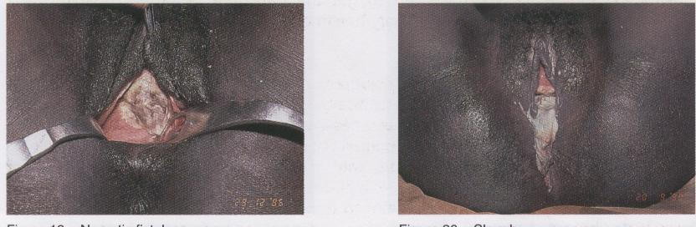

Fig 2: Estenose vaginal, banda posterior
Fig 3: Severo aperto vaginal e Atresia vaginal

Como se examina a fístula
Há um primeiro exame, simples, que consiste em fazer um toque vaginal. Com os dois dedos se avalia a situação de forma, dimensões e elasticidade da vagina e com a ponta do indicador ou do médio se procura o orifício da fístula. Na maior parte das vezes é simples detectar a sua localização a sua forma e dimensão, a natureza das margens, a elasticidade e espessura dos tecido etc. Vamos tomar em consideração as várias características.

3.1 Localização
- Perto do púbis, centro-vaginal, perto do colo uterino ou até na abobada vaginal, em caso de histerectomia por rotura uterina.
- Interessando ou não o colo vescical (a passagem da uretra para a bexiga). É importante porque pode ter havido destruição do esfíncter uretral e, uma vez reparada a FVV, pode manifestar-se uma incontinência.
- Se é ou não circunferencial, isto é se interessa circularmente toda a bexiga, deixando uma separação entre o orifício proximal da uretra e o orifício da fístula da bexiga.

3.2 Dimensão
Para avaliar correctamente a dimensão é preciso fazer passar a ponta do dedo sobre a circunferência toda da FVV. Só assim é que se pode ter uma ideia das reais dimensões nas fístulas grandes e nas que apresentam prolapso em extroversão da cúpula vescical.
Nas fístulas pequenas é necessária muita concentração para distinguir a sua presença e dimensão na parede vaginal anterior. Acontece com uma certa frequência que o dedo não consiga apreciar a fístula. Em tal caso dever-se-á examinar a paciente em posição ginecológica, com boa iluminação, auxílio de valvas e introduzindo soro com azul de metileno ou violeta de genciana através duma algália e seringa, para observar donde sai o líquido.

3.3 Natureza das margens
Este aspecto é importante, porque informa sobre a espessura, elasticidade ou rigidez cicatricial das margens. Se as margens forem espessas, bem estofadas e vascularizadas, será fácil que a sutura da FVV resista, se forem finas, cicatriciais ou aderenciadas aos ramos ascendentes do púbis sem plano de clivagem, o encerramento será bastante laborioso e com probabilidade de deiscência.
- A margem alta deve ser examinada com cuidado, especialmente quando está em contacto com a sínfise púbica. Se as partes moles forem muito finas ou até reduzidas a uma simples camada de tecido cicatricial sobre o ramo horizontal inferior do púbis, o encerramento apresentará severas dificuldades e a incontinência residual pós-encerramento será quase que inevitável.
- Examinando esta margem deve-se fazer mente local para detectar se se trata duma fístula circunferencial, caracterizada pela destruição circular do colo da bexiga. Em concreto o dedo apreciará a presença de dois orifícios separados: o da uretra proximal e o da bexiga.
- Outro pormenor que é necessário registar é o comprimento da uretra. Se for menor de 1 cm parte da uretra ficou destruída e a reparação da FVV deixará com probabilidade uma incontinência.

Dimensões da vagina
Devem-se avaliar também as dimensões da vagina. Podem complicar o encerramento da FVV duma maneira muito importante.
Vagina estreita, curta e cicatricial. Pode ter também bandas horizontais na parede inferior, que limitam o acesso e impedem a visão.
Vagina excessivamente ampla e profunda. Torna-se muito difícil trazer à vista o orifício da FVV. Será preciso inventar maneiras e truques para tornar visível e acessível a FVV.

3.5 Fístula Recto-Vaginal
Antes de finalizar o exame deve-se sempre perguntar à paciente se as fezes também saem pela vagina, de maneira a não dar por terminado o exame com a descrição da FVV.
É oportuno lembrar que o mecanismo de produção da FRV é a compressão das partes moles entre a cabeça do feto e o promontório sacral, pelo que a localização mais habitual é na parte alta da vagina. Existem, todavia FRV baixas e até lacerações perineais de 3º grau.
Não sempre é fácil descrever uma FRV. Frequentemente elas se encontram atrás duma banda cicatricial que dificulta a palpação do orifício. Elas têm uma forma elíptica, a grande eixo horizontal transversal e a margem mais lateral costuma ser muito rígida e fixa.
Pode acontecer que não se consiga sentir com o dedo a FRV. É preciso então ajudar-se com uma pinça de Kelly fina e comprida, até enfiar o orifício e introduzir um dedo no recto, para sentir a ponta no canal rectal.

Exame pré-operatório
A maior parte das vezes é suficiente examinar a paciente só com um toque vaginal. Todavia é sempre uma regra de ouro, mesmo quando se tem experiência, examinar previamente a paciente na sala operatória, com excelente iluminação, na posição hiperginecológica, que terá na operação. Não é infrequente descobrir pormenores que com o simples tacto não se colheram.
O exame na sala é indispensável para descobrir a localização daquelas FVV muito pequenas que não se conseguiram localizar com o toque.
Para o efeito algalia-se a paciente e com uma seringa de alimentação naso-gástrica (ou outra seringa grande, adaptada com a borracha dum sistema de soros) injecta-se soro fisiológico corado com azul de metileno ou com violeta de genciana. Desta maneira é fácil detectar o orifício da FVV, mesmo se pequeno. Por vezes é necessário enfiar até mais de 200 ml.
Se, mesmo assim, não houver saída de líquido, deve-se concluir que não há FVV.
Para explicar a perda de urina sem controlo existem duas possibilidades.
- Incontinência urinária. Demonstra-se facilmente tirando a algália com bexiga cheia. Imediatamente há saída de urina pelo meato uretral. Se não sair espontaneamente, manda-se tossir, tendo a advertência de colocar à frente uma cuvete ou uma mão com compressa, para não ficar molhados com o jacto
- Fístula uretero-vaginal. Ao retirar a algália não há saída de urina, nem com a tosse, nem carregando com a mão acima do púbis. Continuando a observar a vagina, nota-se, depois de alguns minutos, que se vai recolhendo no fórnix posterior uma pequena quantidade de líquido. Secando com uma compressa e continuando a observar, esse líquido recolhe-se de novo. A prova de que se trata duma fístula uretero-vaginal está no facto de que a bexiga está cheia de azul ou de violeta e o líquido que se recolhe é límpido e claro, a confirmar que é urina que não provém da bexiga mas directamente dum uréter. Deve-se fazer todo o esforço para detectar se o uréter interessado é o direito ou o esquerdo.

Classificação das FVV
Os dois parâmetros principais que se devem ter em consideração para classificar as FVV são

5.1 Localização na parede vesico-vaginal
O marco fundamental é o mecanismo de continência, isto é a integridade do colo vesical e do esfíncter uretral
Fig 4: O mecanismo de continência está no esfíncter uretral e colo vesical
- FVV que não interessam o mecanismo de continência, isto é aquelas cuja margem superior está longe do púbis. A reparação com sucesso destas FVV conduz à cura e à continência completa
- Fig 5: A FVV não interessa o mecanismo de continência
- FVV que interessam o mecanismo de continência, isto é aquelas cuja margem superior interessa o colo vesical e o esfíncter

Fig 6: FVV que interessa só a parede vaginal

Fig 7: FVV circunferencial

- FVV cuja margem inferior apresenta os meatos ureterais visíveis na margem. Podem ser FVV que interessam ou não interessam o mecanismo de continência
Fig 8: Meatos ureterais à vista – sua cateterização

5.2 Dimensões da FVV
- Microscópicas, que precisam de serem localizadas com azul ou violeta pela algália\
Fig 9: FVV micro, visualizada injectando violeta de genciana

- Pequenas, até 2 cm de diâmetro
- Médias, maiores de 2 cm, mas com margens bem estofadas e elásticas
- Grandes, cujas margens estão contra os ramos ascendentes do púbis
Fig 10: FVV grande, com prolapso da parede interna da bexiga

5.3 FVV de outro tipo
- Fístulas uretero vaginais
- Fístulas com destruição de porção importante da uretra
Fig 11: Destruição uretra parede anterior
Fig 12: Destruição uretra circunferencial

Fig 13: Destruição da parede anterior da uretra

- Fístulas que se abrem no canal cervical do útero ou no útero
Fig 14: Fístulas vesico-uterinas

Capítulo 2: Reparação das FVV
A cirurgia reparadora das FVV baseia-se sobre dois princípios fundamentais:
- Separação e mobilização dos planos vaginal e vesical
- Sutura sem tensão, introvertente, da parede vesical, sem perfurar a mucosa vesical.
Todo o resto da cirurgia das FVV é para tornar possível a materialização correcta destes dois princípios. A casuística é muito variada e é necessário ter por vezes uma iniciativa criadora que permita ultrapassar um impedimento à aplicação dos dois princípios. Há portanto sempre margem para novidades ao operar FVV e nunca se acaba de aprender e de inventar.

Posição da paciente
A posição habitual é a hiper-ginecológica, com as nádegas bem fora da marquesa, as coxas flexas contra a parede abdominal e abductas, o plano da marquesa inclinado na posição de Trendelemburg, mais ou menos acentuada.
Fig 15 Posição hiper-ginecológicas:
Nesta posição a visibilidade do campo é boa e os assistentes podem ajudar facilmente, vendo suficientemente bem e sem se dever submeter a posições incómodas.
Fig 16: Nesta posição os assistentes ajudam comodamente

Para ver bem dentro da vagina é preciso fixar com pontos de seda os pequenos lábios lateralmente em cima e em baixo e introduzir uma valva, possivelmente daquelas auto-estáticas pesadas, que não precisam de ajudante.
Fig 17: Pequenos lábios abertos e valva em posição
Existem todavia casos em que a posição da FVV é de tal modo contra o púbis ou tem outras particularidades, que a tornam praticamente inacessível na posição hiper-ginecológica.
Podem-se vencer as dificuldades virando a paciente de barriga para baixo, em decúbito ventral.
Fig 18: Posição em decúbito ventral
É claro que nesta posição os assistentes conseguem ver muito menos e estão em posições mais incómodas.

Melhorar a exposição
Para bem operar é necessário em primeiro lugar ver bem, isto é adoptar todos aqueles artifícios ou truques que permitam trazer a FVV à frente dos olhos numa posição acessível ao bisturi, às tesouras e ao porta-agulhas.
É muito útil levantar a parte superior da vagina, colocando duas pinças de Allis na sua porção sub-uretral: aparece facilmente à vista o orifício da FVV.
Quando a vagina é apertada ou há bandas cicatriciais horizontais na parede posterior da vagina é necessário praticar uma ou duas amplas episiotomias sem nenhum receio. Melhoram radicalmente a visão e são facilmente suturadas no fim de tudo.

Fig 19: Visão antes da episiotomia
Fig 20: Visão depois da episiotomia
Fig 21: Visão depois da episiotomia e de colocar valva
Dois instrumentos são particularmente úteis para melhorar a exposição: a algália metálica e as lâminas maleáveis finas e estreitas, que permitem afastar os excessos de amplidão das paredes vaginais laterais e superior.
No caso de prolapso da parede interior da bexiga, é útil introduzir uma compressa na bexiga através da FVV. Naturalmente é necessário lembrar-se dela e tirá-las antes de apertar demasiado o orifício.

Diminuir a possibilidade de sangramento
É conveniente infiltrar os tecidos que serão descolados para melhorar a clivagem e diminuir o sangramento do dissecção. Com uma seringa de 20 ml aspira-se uma ampola de adrenalina, puxando o êmbolo até à extremidade de maneira a molhar toda a superfície interna da seringa. A adrenalina é recolocada na ampola e com a mesma seringa aspiram-se 10-15 ml de soro fisiológico, obtendo assim uma solução de adrenalina a baixíssima concentração.

Com ela infiltram-se os tecidos peri-fistulosos, procurando acertar o plano de clivagem vesico-vaginal.

Separar o plano vaginal do plano vesical
Na FVV o epitélio vesical continua-se, sem solução de continuidade, no epitélio vaginal
Fig 22: O epitélio da bexiga continua-se naquele da vagina. É preciso separá-los
A separação é o primeiro passo para poder, mais a frente, suturar separadamente as duas superfícies, de maneira a que os dois epitélios constituam duas camadas totalmente separadas e independentes, sem alguma comunicação.
Fig 23: Plano vesical suturado de maneira introvertente, sem furar a mucosa
Concretamente, o truque que se utiliza para encontrar facilmente o plano de clivagem entre bexiga e vagina, é praticar uma incisão na parede vaginal, calibrando a profundidade para chegar exactamente ao plano de clivagem. Normalmente começa-se por uma incisão norte-sul, a partir da margem inferior, para ter o campo mais livre do sangue e também porque é a margem inferior a que precisa de maior mobilização.
Fig 24: Como se inicia a separação dos planos
A seguir prolonga-se a incisão seguindo a linha de passagem do epitélio vaginal para o vescical, até aos pontos oeste e leste da circunferência do orifício da FVV. Com o bisturi curvo em foice (nº12) ou com a ponta duma tesoura fina de Metz aprofunda-se a separação dos planos, levantando como que duas pétalas. É muito importante individuar o plano de clivagem, para reduzir ao mínimo o sangramento. Se se provocar um sangramento arteriolar, pode-se usar a electrocoagulação. Alternativamente é muito eficaz dar um ponto hemostático em 8, em crómico
3/0 ou 2/0. A extensão do descolamento depende da resistência que os tecidos opõem à aproximação sem tensão nenhuma das margens da FVV.
A este ponto praticam-se dois cortes do plano vaginal em sentido horizontal leste-oeste, permitindo levantar mais eficazmente a parede vaginal em relação à bexiga. Este corte dá a ocasião para iniciar e concluir com determinação a mobilização da bexiga em relação aos tecidos mais profundos e muitas vezes cicatriciais que se interpõem entre bexiga e ramos ascendentes do púbis.
Uma vez mobilizadas essas regiões, dedicamo-nos à separação dos planos vaginal e vescical (ou uretral) a partir da margem superior. Aqui também usa-se a técnica da incisão sul-norte e a incisão na linha de passagem entre as duas paredes, vaginal e uretral. No fim da dissecção devem-se ter formado quatro pétalas entre as quatro incisões que formam um cruz a partir da margem. Elas são fixadas com crómico 2/0 ou 3/0, em extroversão, para deixar a melhor visão possível do campo operatório reconstrutivo sem precisar que o assistente as mantenha levantadas com pinças.

A reparação cirúrgica da FVV
Uma vez que o descolamento parece ser bom, deve-se fazer uma prova, pegando com pinças de Allis e pinças de mão nas margens e aproximando-as, para ver se se podem suturar sem tensão nenhuma.
A sutura das margens da FVV obedece a 4 critérios:
- deve ser introvertente, isto é a mucosa vescical deve ficar na parte interna da sutura e a mesma não pode ser atravessada pelo fio de sutura.
- Deve ser sem tensão
- Deve começar nos cantos
- Deve ser em pontos separados de vicryl 3/0 ou 2/0 ou crómico 2/0
Quase sempre a linha de sutura mais cómoda e conveniente é a horizontal, chamada tradicionalmente leste-oeste. Existem porém FVV que se fecham com mais facilidade em sentido longitudinal norte-sul.
A sutura em pontos separados permite uma melhor segurança e firmeza na aproximação das margens e portanto é preferida, embora haja cirurgiões que usem duas suturas contínuas, iniciada nos cantos e unidas no meio.
O fio melhor é o vicryl (ou outro fio poliglicólico) 3/0 ou 2/0, a escolher cada vez, segundo a natureza dos tecidos. Onde há mais necessidade de pontos fortes em tecidos resistentes, escolhe-se o 2/0, onde há necessidade de respeitar estruturas finas e delicadas, usa-se o 3/0. O vicryl tem as vantagens de ser extremamente resistente, de manter o nó e de persistir em volta de 6 semanas.
Na falta de vicryl pode-se usar o crómico 2/0, que também é muito resistente e mantém bem o nó.
A agulha deve-se adaptar à situação, conforme o espaço disponível para dar o ponto. É possível moldar as agulhas dos fios atraumáticos usando a ponta do porta-agulhas e os dedos. Em particular é muito útil poder aumentar a curvatura da ponta, diminuindo o raio.
Uma vez que cada ponto seja introvertente e sem tenção, o êxito da sutura depende do lugar onde se faz passar a agulha na metade inferior e na metade superior.
O ponto mais difícil é o primeiro de cada canto. Deve ser dado de maneira a fechar a possibilidade de saída de urina entre o ponto e a extremidade lateral da FVV.
Entre um ponto e o outro não deve poder haver espaço para a urina escapar. Se ficar dúvida poder-se-á sempre dar mais um no meio.
Os últimos pontos, aqueles centrais, podem ser difíceis pela pouca consistência da parede superior, ao pé da uretra. Esta margem não pode dar mais segurança daquela que tem. É a margem inferior, pelo contrário, que pode ser mobilizada mais um pouco, até facilitar o ponto com uma sua maior mobilidade.
Quando o orifício para fechar é pequeno, pode ser difícil manter a visão clara das margens que ficam para serem suturadas. Em tal caso ajuda bastante a técnica de passar os pontos mantendo-os abertos e atando-os todos um após o outro, no fim.

A prova final
Não se pode considerar fechada bem a FVV sem submeter a sutura à prova da pressão líquida intra vesical. Para tal injecta-se soro corado de azul de metileno ou de violeta de genciana, através da algália, usando uma seringa de 50 ou de 100 ml, com bico largo, das que se usam para alimentação pela sonda naso-gástrica. Na sua falta pode-se usar uma seringa de 20 ml adaptada com a borracha de um sistema de soro.
Em geral consideram-se suficientes 100 ml, calculando que na bexiga há também uma parte de urina que se acumulou durante os últimos pontos, quando já quase não saia do orifício resíduo.

O lembo adiposo do grande lábio
Quando se tem a impressão de que a sutura apresente escassa consistência dos tecidos, ou que a vascularização seja insuficiente, é muito útil usar o espessamento e a vascularização suplementares, oferecidos pelo lembo de rotação do tecido adiposo, mobilizado abrindo longitudinalmente um dos grandes lábios. Esta técnica é conhecida como lembo de Martius, do nome do autor austríaco que o propôs por primeiro, ou “bulbocavernous graft”.
Escolhe-se o grande lábio em posição melhor para transferir o lembo adiposo.
Pratica-se uma incisão longitudinal e com pinça de mão e tesoura isola-se um cilindro de tecido adiposo, grande como o dedo mínimo da mão. Faz-se a hemóstase. Corta-se a parte superior e mobiliza-se o lembo até à sua base. Abre-se um túnel com uma pinça de Kelly comprida e fina, entrando do lado da vagina e saindo do lado do grande lábio. A Kelly pega a extremidade do lembo e o puxa, através do túnel, para o espaço vaginal descolado. O lembo é fixado em crómico 2/0 sobre a linha de sutura da FVV, com alguns pontos.
A seguir cobre-se o lembo com a parede vaginal descolada anteriormente. Se ela não for suficiente, cobre-se usando um lembo de rotação de parede do pequeno lábio.
Por último fecha-se a brecha do grande lábio, unido o subcutâneo em crómico e fechando a pele em pontos simples de seda, sem muita tenção, porque há tendência para se formar um edema que enfossará os fios de sutura dando decúbitos. Os pontos devem ser tirados ao 3º ou 4º dia. Esta zona “pega” com grande rapidez, devido à excelente vascularização.

Fig 25: Abertura do grande lábio e isolamento do lembo adiposo
Fig 26: Tunelização do lembo

Fig 27: Extracção do lembo no lado vaginal
Fig 28: Fixação do lembo sobre a sutura da FVV

Fig 29: Outro exemplo de realização de lembo de Martius

Finalização da operação
Depois de completada a sutura da FVV, e eventualmente realizado o lembo adiposo, reconstrói-se o plano vaginal em crómico 2/0. Por vezes falta tecido. Se a área cruenta não for excessivamente extensa, pode-se deixar assim: irá reepitelizar-se por segunda intenção. Se for extensa, será preciso cobrir com lembos de rotação dos pequenos lábios ou de pele perineal.
Se foram abertas episiotomias, devem ser suturadas.
Por vezes a vagina ficaria demasiado estreita e então é preciso substituir a episiorrrafia com uns lembos de rotação dos pequenos lábios ou do perineu.

Fig 30: Plastia vaginal com lembos de rotação dos pequenos lábios
Depois de suturar o plano vaginal, lava-se com soro fisiológico a vagina e coloca-se um tamponamento com algumas compressas com a finalidade de controlar a hemorragia residual e comprimir os tecidos amplamente descolados e depois encostados na sutura do plano vaginal. As compressas deverão ser tiradas no dia seguinte. É boa regra controlar de ter tirado todas as compressas fazendo um toque. Já aconteceu que compressas ficasse esquecidas no fundo da vagina, provocando infecção.
A paciente fica com algália permanente durante 14 dias (duas semanas). Se essa se entupir, será imediatamente trocada. Durante esse período é melhor que a paciente fique internada, protegendo a região operada de tracções e infecções.
Costuma-se dar um antibiótico como amoxicilina ou cotrimoxazol durante uma semana, para prevenir infecções.
Ao momento da alta deve-se recomendar para ficar 2 meses sem fazer relações e, no caso de ficar grávida, para se organizar para ir dar à luz num hospital onde se possa realizar uma cesariana.

Capítulo 3: Reparação das Fístulas Recto-Vaginais
A FRV, como já foi dito, costuma ser bastante alta, pois a sua causa está na compressão das partes moles entre a cabeça do feto e o promontório do sacro. Existem também FRV baixas, na metade inferior da vagina e até lacerações perineais de 3º grau, em geral devidas a rasgaduras dos tecidos moles à passagem da cabeça ou provocadas por manobras de extracção.
A sua reparação não pode ser enfrentada sem primeiro libertar a FRV da conspurcarão fecal. Para tal é muito oportuno praticar previamente uma colostomia no transverso de esquerda ou no sigma. A mais fácil e rápida é a do transverso de esquerda.
Uma vez que a vagina tenha ficado limpa, poder-se-á programar a plastia da FRV.
É aconselhável praticar o encerramento da FRV e da FVV na mesma sessão operatória. Normalmente começa-se pela FRV, porque o descolamento prévio do plano vaginal inferior, para conseguir mobilizar as paredes vaginal e rectal da FRV, cria condições vantajosas de visão do campo operatório, também na região da FVV.
Convém portanto iniciar com a mobilização recto-vaginal, aproveitar dessa boa visibilidade para reparar a FVV e, a seguir, finalizar a operação com a reparação da FRV. Outras vezes é mais conveniente fechar de vez a FRV e depois passar à FVV.
Os princípios fundamentais são os mesmos:
- Sutura introvertente
- Sutura sem tensão.

FRV altas
As FRV altas apresentam a dificuldade da mobilização do plano vaginal, que costuma estar “congelado” num plastrão cicatricial. Começa-se com uma incisão norte-sul distal, que chegue até ao plano de clivagem vagino-rectal e tenha um comprimento de pelo menos 2 cm. Na parte baixa da incisão pode-se mais facilmente entrar no plano de clivagem com as pontas da tesoura e, aos poucos, chegar a separar os dois planos em toda a circunferência da FRV. É bom ter sempre pronto o electrocoagulador, para manter uma hemóstase eficiente.
Uma vez separado o orifício do recto em toda a sua circunferência, aumenta-se a separação na clivagem, até as margens da parede rectal poderem ser aproximados sem nenhuma tensão.
Por vezes podem ser úteis alguns artifícios ou “truques” para facilitar a mobilização.
- A margem distal da FRV pode ser traccionada com um dedo enfiado no recto ou por meio dum pequeno afastador de Farabeuf

Fig 31: Tracção com dedo no recto
Fig 32: Tracção com afastadorinho

Tracção com afastadorinho
- A margem entre a FRV e o fórnix posterior pode ser aberta entrando assim no fundo de saco do Douglas deliberadamente, para poder traccionar a parede rectal sem entraves, para baixo.
Fig 33: Abertura do Douglas

Fig 34: Tracção para baixo da parede rectal e sutura
A parede rectal pode ser fixada às margens vaginais de maneira a substituir a parede vaginal quando esta não chegar.
Fig 35: As margens vaginais são suturadas à parede rectal, que constitui o novo plano vaginal

FRV baixas
As FRV baixas podem ser tratadas separando as paredes vaginal e rectal, depois de incisões norte-sul que cheguem ao plano de clivagem e prosseguindo à sutura introvertente e sem tensão.
Em certos casos perto do ânus pode ser mais fácil transformar a FRV numa laceração perineal de 3º grau e proceder à sua correcção com os tecidos bem expostos à frente.

Fig 36: Um estilete é passado através da FRV
Fig 37: Estilete em tensão e incisão da septo
Fig 38: FRV transformada em laceração perineal de 3º grau
Fig 39: Mobilização recto-vaginal
Fig 40: Sutura do canal anal norte-sul
Fig 41: Sutura completada
Fig 42: Sutura do esfíncter
Fig 43: Isolamento dos cabos do esfíncter cortado

Fig 44: Cabos do esfíncter suturados

Por fim procede-se à cobertura com a sutura do plano vaginal. Por vezes é útil reforçar a sutura rectal com um lembo adiposo de rotação do grande lábio à Martius. Coloca-se um tamponamento.

Cuidados pós-operatórios
No dia seguinte retira-se o tamponamento e recomenda-se que a higiene vaginal seja mantida cuidadosamente.
Depois de um mês leva-se a paciente à sala, para examinar se a sutura da FRV teve sucesso.
Introduz-se uma algália no recto e enche-se o balão. Injectam-se 100 a 200 ml de soro fisiológico corado com azul de metileno ou violeta de genciana. Se não houver saída de cor pela vagina, pode-se concluir que a FRV fechou e que se pode proceder ao encerramento da colostomia.

Outras cirurgias

4.1 Correcção da incontinência
Acontece com uma certa frequência que, depois de reparar a FVV, esta resulte estar fechada, mas que a paciente fique incontinente devido em geral à perda dos tecidos do colo vesical e do esfíncter uretral. A operação mais corrente é, com uma fatia de fascia lata, a de suspender por via retropúbica, acima da fáscia dos músculos rectos abdominais, a área a parte proximal da uretra na entrada na bexiga.
Fig 45: Colpo-uretrosuspençao retropúbica da área de passagem da uretra para a bexiga
Os resultados são medíocres, alcançando nos casos favoráveis, a continência apenas quando ficar deitada na cama ou sentada.

4.2 Uretero-sigmoidostomia
Há situações com tão grande perda de tecidos vitais da vagina e bexiga, que não é possível nenhuma cirurgia reconstrutiva. Aplica-se nestes casos a solução de desviar a urina para o rectosigmoide. Esta operação, embora acarrete riscos de infecção urinária ascendente, é suficientemente bem tolerada e é preferível à uretero-cutaneostomia, que acorrentaria a paciente toda a vida ao uso de sacos colectores na parede abdominal.

