

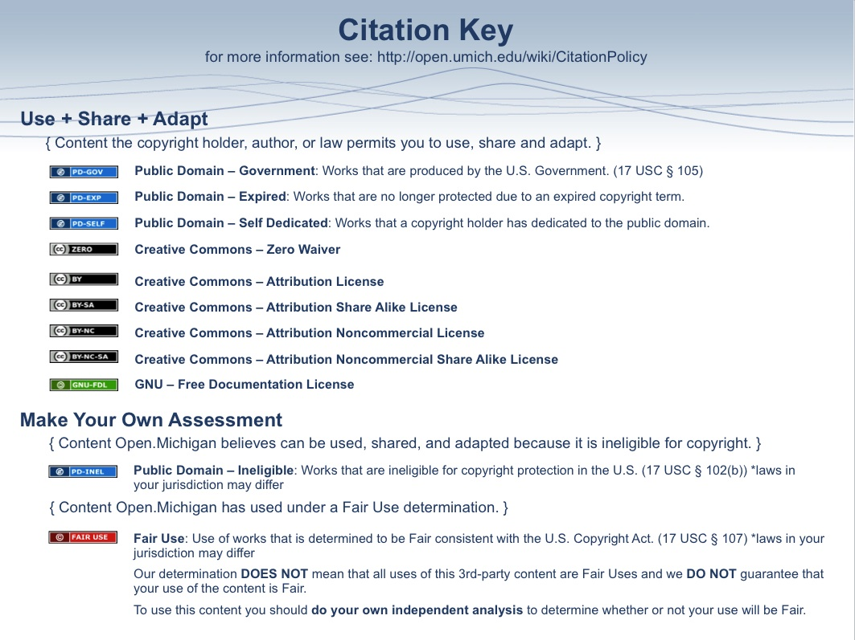
Personality and Personality Disorders

A. Personality Traits: “Enduring patterns of perceiving, relating to, and thinking about the environment and oneself that are exhibited in a wide range of social and personal contexts.” (DSM-IV)

B. Personality Disorder: “Only when personality traits are inflexible and maladaptive and cause significant functional impairment or subjective distress do they constitute Personality Disorders.” (DSM-IV)
1. Diagnostic criteria for a personality
disorder | General Diagnostic Criteria for a  Personality Disorder (DSM-IV)
C. Dimensions of Personality  1. Hippocrates - “Four humors”  a. Blood - Emotional lability  b. Black bile - Depression  c. Yellow bile - Anger  d. Phlegm - Slow, stolid, cold  2. Carl Jung - Psychological Types  (1921)  a. Introvert-Extravert  b. Thinking-Feeling  c. Sensing-Intuiting  d. Judging-Perceiving | A. An enduring pattern of inner experience and behavior that deviates markedly from the expectations of the individual's culture. This pattern is manifested in two (or more) of the following areas:  (1) cognition (i.e., ways of perceiving and interpreting self, other people and events)  (2) affectivity (i.e., the range, intensity, lability, and appropriateness of emotional response)  (3) interpersonal functioning  (4) impulse control  B. The enduring pattern is inflexible and pervasive across a broad range of personal and social situations.  C. The enduring pattern leads to clinically significant distress or impairment in social, occupational, or other important areas of functioning.  D. The pattern is stable and of long duration and its onset can be traced back at least to adolescence or early adulthood.  E. The enduring pattern is not better accounted for as a manifestation or consequence of another mental disorder.  F. The enduring pattern is not due to the direct physiological effects of a substance (e.g., a drug of abuse, a medication) or a general medical condition (e.g., head trauma).
3. Assessment Instruments
a. Self-report inventories
i. Minnesota Multiphasic Personality Inventory (MMPI, 1937)
1. >500 True-false questions (“I believe I am being plotted against.” “I sometimes tease animals.”)
2. Ten clinical scales (hypochondriasis, depression,...)
3. Three validity scales (detect “faking good” and “faking bad”)
4. Four special scales (ego strength, anxiety,...)
ii. Meyers-Briggs - Scores are plotted along Jung’s four dimensions
b. Structured clinical interview for diagnosis (SCID) - Based on diagnostic criteria, not dimensions
c. Clinical interview
d. Projective tests - Not diagnostic, but show patterns of thought, dynamics, defenses, disorders of thought, etc.
i. Rorschach (ink-blot)  ii. Thematic Apperception Test (TAT) -  (tell stories about evocative pictures)  iii. Sentence-Completion Test (SCT) -  (“I like...” “Sometimes I wish...”)  iv. Draw-A-Person (DAP) |   Plate I of the Rorschach Test

D. Etiology
1. Genetic and biologic factors - Concordance rates of personality traits for monozygotic twins are higher than for dizygotic twins, even if they are raised apart
a. Larry Siever
i. Cognitive disorganization (includes “interpersonal detachment”) - Cluster A
ii. Impulsivity - Cluster B
1. Decreased 5-HT and 5-HIAA (5-HT metabolite)
iii. Affective instability - Cluster B
1. Hyperresponsivity of noradrenergic system
iv. Anxiety/Inhibition - Cluster C
1. High autonomic arousal from infancy
b. Robert Cloninger
i. Novelty seeking
ii. Harm avoidance
iii. Reward dependence

2. Environmental factors
a. Parenting and family style
b. Psychosocial milieu

3. Psychodynamic factors
a. Internal drives and defenses
b. Developmental tasks and stages
E. Cluster A Personality Disorders: Odd or Eccentric

1. Paranoid Personality Disorder - “A pattern of distrust or suspiciousness such that others’ motives are interpreted as | Diagnostic Criteria for  Paranoid Personality Disorder  (DSM-IV)
malevolent.” (DSM-IV)  a. Prevalence: 2% of population  b. Sex ratio: F:M=3:1  c. Comorbidity: Brief reactive psychosis, delusional disorder, anxiety, substance abuse, depression, schizophrenia  d. Family: Delusional disorder, schizophrenia, Cluster A disorders.  e. Treatment  i. Psychotherapy - Treatment of choice, but patients have limited introspection  ii. Medication - Anxiolytics are | A. A pervasive distrust and suspiciousness of others such that their motives are interpreted as malevolent, beginning by early adulthood and present in a variety of contexts, as indicated by our (or more) of the following:  (1) suspects, without sufficient basis, that others are exploiting, harming, or deceiving him or her  (2) is preoccupied with unjustified doubts about the loyalty or trustworthiness of friends or associates  (3) is reluctant to confide in others because of unwarranted fear that the information will be used maliciously against him or her  (4) reads hidden demeaning or threatening meanings into benign remarks or events  (5) persistently bears grudges, i.e., is unforgiving of insults, injuries, or slights  (6) perceives attacks on his or her character or reputation that are not apparent to others and is quick to react angrily or to counterattack  (7) has recurrent suspicions, without justification, regarding fidelity of spouse or sexual partner  B. Does not occur exclusively during the course of Schizophrenia, a Mood Disorder With Psychotic Features, or another Psychotic Disorder and is not due to the direct physiological effects of a general medical condition.
often useful; antipsychotics sometimes helpful
f. Physician-patient interaction: A straightforward approach, without an expectation of personal warmth is most effective. Greater empathy may actually make the patient more anxious.

2. Schizoid Personality Disorder - “A pattern of detachment from social relationships | Diagnostic Criteria for  Schizoid Personality Disorder  (DSM-IV)
and a restricted range of emotional expression.”  a. Prevalence: 3% of population  b. Sex ratio: M>F  c. Comorbidity: Delusional disorder, schizophrenia | A. A pervasive pattern of detachment from social relationships and a restricted range of expression of emotions in interpersonal settings, beginning by early adulthood and present in a variety of contexts, as indicated by four (or more) of the following:  (1) neither desires nor enjoys close relationships, including being part of a family  (2) almost always chooses solitary activities  (3) has little, if any, interest in having sexual experiences with another person  (4) takes pleasure in few, if any, activities  (Cont.)
d. Family: Schizophrenia, Cluster A disorders, esp. schizotypal personality disorder  e. Treatment  i. Psychotherapy - Treatment of | (5) lacks close friends or confidants other than first-degree relatives  (6) appears indifferent to the praise or criticism of others  (7) shows emotional coldness, detachment, or flattened affectivity B. Does not occur exclusively during the course of Schizophrenia, a Mood Disorder With Psychotic Features, another Psychotic Disorder, or a Pervasive Development Disorder and is not due to the direct physiological effects of a general medical condition.
choice; introspection is usually good
ii. Medication - Low doses of antipsychotics or antidepressants are occasionally helpful
f. Physician-patient interaction: A straightforward approach, without an expectation of personal warmth is preferred. Greater empathy may actually make the patient more anxious.

3. Schizotypal Personality Disorder – “A  pattern of acute discomfort in close | Diagnostic Criteria for  Schizotypal Personality Disorder  (DSM-IV)
relationships, cognitive or perceptual distortions, and eccentricities of behavior.” (DSM-IV)  a. Prevalence: 3% of population, but uncommon in clinical settings  b. Sex ratio: M>F  c. Comorbidity: Depression, anxiety, brief reactive psychosis, delusional disorder, schizophrenia  d. Family: Schizophrenia, Cluster A disorders  e. Treatment  i. Psychotherapy - Treatment of | A. A pervasive pattern of social and interpersonal deficits marked by acute discomfort with, and reduced capacity for, close relationships as well as by cognitive or perceptual distortions and eccentricities of behavior, beginning by early adulthood and present in a variety of contexts, as indicated by five (or more) of the following:  (1) ideas of reference (excluding delusions of reference)  (2) odd beliefs or magical thinking that influences behavior and is inconsistent with subcultural norms (e.g., superstitiousness, belief in clairvoyance, telepathy, or "sixth sense"; in children and adolescents, bizarre fantasies or preoccupations)  (3) unusual perceptual experiences, including bodily illusions  (4) odd thinking and speech (e.g., vague, circumstantial, metaphorical, overelaborate, or stereotyped)  (5) suspiciousness or paranoid ideation  (6) inappropriate or constricted affect  (7) behavior or appearance that is odd, eccentric, or peculiar  (8) lack of close friends or confidants other than first-degree relatives  (9) excessive social anxiety that does not diminish with familiarity and tends to be associated with paranoid fears rather than negative judgments about self
choice. Insight may be limited.
ii. Medication - Antipsychotics may be useful
f. Physician-patient interaction: A straightforward approach, without an expectation of personal warmth is preferred. Greater empathy may actually make the patient more anxious. Care must be taken not to ridicule odd or over-valued ideas. Avoid overt rejection - even a limited personal interaction may be very important to the patient, and its loss distressing.

F. Cluster B Personality Disorders: Dramatic, Emotional, or Erratic

1. Antisocial Personality Disorder – “A  pattern of disregard for, and violation of, | Diagnostic Criteria for  Antisocial Personality Disorder  (DSM-IV)
the rights of others.”  a. Prevalence: 3% of males and 1% of females  - Sex ratio: M:F=3:1  c. Comorbidity: Substance abuse, attention deficit disorder, depression, anxiety  d. Family: Somatization disorder, substance abuse, Cluster B disorders, esp. antisocial personality disorder | A. There is a pervasive pattern of disregard for and violation of the rights of others occurring since age 15 years, as indicated by three (or more) of the following:  (1) failure to conform to social norms with respect to lawful behaviors as indicated by repeatedly performing acts that are grounds for arrest  (2) deceitfulness, as indicated by repeated lying, use of aliases, or conning others for personal profit or pleasure  (3) impulsivity or failure to plan ahead  (4) irritability and aggressiveness, as indicated by repeated physical fights or assaults  (5) reckless disregard for safety of self or others  (6) consistent irresponsibility, as indicated by repeated failure to sustain consistent work behavior or honor financial obligations  (7) lack of remorse, as indicated by being indifferent to or rationalizing having hurt, mistreated, or stolen from another
e. Major clinical issues  i. Violence  ii. Criminal behavior  iii. Suicide | B. The individual is at least age 18 years.  C. There is evidence of Conduct Disorder with onset before age 15 years.  D. The occurrence of antisocial behavior is not exclusively during the course of Schizophrenia or a Manic Episode.
f. Treatment – no psychiatric treatment addresses the core pathology
i. Psychotherapy - Not generally useful, although it may alleviate depression and anxiety, especially if the patient is immobilized (e.g., in jail)
ii. Medication - May be useful for comorbid disorders; uncontrolled rage may be helped somewhat by antipsychotics or mood stabilizers
g. Physician-patient interaction: Firm limits are essential. Substance abuse is a major problem, complicated by genuine distress and incessant manipulation.

2. Borderline Personality Disorder – “A  pattern of instability in interpersonal | Diagnostic criteria for  Borderline Personality Disorder  (DSM-IV)
relationships, self-image, and affects, and marked impulsivity.” (DSM-IV)  a. Prevalence: 3% of females and 1% of males  b. Sex ratio: F:M=3:1  c. Comorbidity: Depression, substance abuse, eating disorders, brief reactive psychosis  d. Family: Mood disorders, substance abuse, Cluster B disorders, esp. antisocial personality disorder  e. Major clinical issues  i. Suicide and self-mutilation  ii. Splitting – seeing the world as all | A pervasive pattern of instability of interpersonal relationships, self-image, and affects, and marked impulsivity beginning by early adulthood and present in a variety of contexts, as indicated by five (or more) of the following:  (1) frantic efforts to avoid real or imagined abandonment  (2) a pattern of unstable and intense interpersonal relationships characterized by alternating between extremes of idealization and devaluation  (3) identity disturbance: markedly and persistently unstable self-image or sense of self  (4) impulsivity in at least two areas that are potentially self-damaging (e.g., spending, sex, substance abuse, reckless driving, binge eating)  (5) recurrent suicidal behavior, gestures, or threats, or self-mutilating behavior  (6) affective instability due to a marked reactivity of mood (e.g., intense episodic dysphoria, irritability, or anxiety usually lasting a few hours and only rarely more than a few days)  (7) chronic feelings of emptiness  (8) inappropriate, intense anger or difficulty controlling anger (e.g., frequent displays of temper, constant anger, recurrent physical fights)  (9) transient, stress-related paranoid ideation or severe dissociative symptoms
good or all bad
iii. Rage
iv. Psychosis
v. Childhood trauma (especially sexual)
vi. Dissociation – depersonalization, derealization, amnestic episodes
f. Treatment
i. Psychotherapy - Dialectical/behavioral therapy (DBT) is preferred. Individual, group, and cognitive/behavioral therapy (CBT) are difficult, but may be useful.
ii. Medication - Low-dose antipsychotics, mood stabilizers, and standard-dose antidepressants are moderately useful. Anxiolytics are beneficial in a minority of patients.
g. Physician-patient interaction: Idealization, devaluation, and splitting are common. Firm limits and high tolerance for regressive (childish) behavior are essential. Countertransference must be monitored carefully.

3. Histrionic Personality Disorder – “A  pattern of excessive emotionality and | Diagnostic criteria for  Histrionic Personality Disorder  (DSM-IV)
attention seeking.” (DSM-IV)  a. Prevalence: 2-3% of population  b. Sex ratio: F>M  c. Comorbidity: Somatization and conversion disorders, depression, anxiety  d. Family: Cluster B disorders  e. Treatment  i. Psychotherapy - Dynamic therapy is the treatment of choice | A pervasive pattern of excessive emotionality and attention seeking, beginning by early adulthood and present in a variety of contexts, as indicated by five (or more) of the following:  (1) is uncomfortable in situations in which he or she is not the center of attention  (2) interaction with others is often characterized by inappropriate sexually seductive or provocative behavior  (3) displays rapidly shifting and shallow expression of emotions  (4) consistently uses physical appearance to draw attention to self  (5) has a style of speech that is excessively impressionistic and lacking in detail  (6) shows self-dramatization, theatricality, and exaggerated expression of emotion  (7) is suggestible, i.e., easily influenced by others or circumstances  (8) considers relationships to be more intimate than they actually are
ii. Medication - Antidepressants and anxiolytics may help comorbid depression and anxiety
f. Physician-patient interaction: Overly dependent or seductive behavior is common. A dramatic presentation may obscure the differences between major and minor physical problems. Rapid fluctuation between overwhelming anxiety about a medical problem and total indifference is common.

4. Narcissistic Personality Disorder - “A pattern of grandiosity, need for | Diagnostic Criteria for  Narcissistic Personality Disorder  (DSM-IV)
admiration, and lack of empathy” (DSM)  a. Prevalence: <1% of population  b. Sex ratio: 50-75% male  c. Comorbidity: Mood disorders, anorexia, substance abuse  - Family: Cluster B disorders  e. Treatment  i. Psychotherapy - Psychotherapy is difficult, but is the treatment of | A pervasive pattern of grandiosity (in fantasy or behavior), need for admiration, and lack of empathy, beginning by early adulthood and present in a variety of contexts, as indicated by five (or more) of the following:  (1) has a grandiose sense of self-importance (e.g., exaggerates achievements and talents, expects to be recognized as superior without commensurate achievements)  - is preoccupied with fantasies of unlimited success, power, brilliance, beauty, or ideal love  - believes that he or she is "special" and unique and can only be understood by, or should associate with, other special or high-status people (or institutions)  (4) requires excessive admiration  (5) has a sense of entitlement, i.e., unreasonable expectations of especially favorable treatment or automatic compliance with his or her expectations
choice. Interpersonal therapy (IPT) may be most effective. | (6) is interpersonally exploitative, i.e., takes advantage of others to achieve his or her own ends  (7) lacks empathy: is unwilling to recognize or identify with the feelings and needs of others  (8) is often envious of others or believes that others are envious of him or her  (9) shows arrogant, haughty behaviors or attitudes
ii. Medication - Antidepressants or mood stabilizers may be helpful for comorbid mood disorders
f. Physician-patient interaction: Idealization gives way rapidly to contemptuous devaluation. Entitlement and condescension are common. Be aware that it is more often the physician than the patient who has these traits.

G. Cluster C Personality Disorders: Anxious or Fearful

1. Avoidant Personality Disorder – “A | Diagnostic criteria for  Avoidant Personality Disorder (DSM-IV)
pattern of social inhibition, feelings of inadequacy, and hypersensitivity to negative evaluation.” (DSM-IV)  a. Prevalence: 0.5-1% of population  b. Sex ratio: M=F  c. Comorbidity: Social phobia, depression, anxiety  d. Family: Cluster C disorders  e. Treatment  i. Psychotherapy - Individual and group therapy, typically | A pervasive pattern of social inhibition, feelings of inadequacy, and hypersensitivity to negative evaluation, beginning by early adulthood and present in a variety of contexts, as indicated by four (or more) of the following:  (1) avoids occupational activities that involve significant interpersonal contact, because of fears of criticism, disapproval, or rejection  (2) is unwilling to get involved with people unless certain of being liked  (3) shows restraint within intimate relationships because of the fear of being shamed or ridiculed  (4) is preoccupied with being criticized or rejected in social situation  (5) is inhibited in new interpersonal situations because of feelings of inadequacy  (6) views self as socially inept, personally unappealing, or inferior to others  (7) is unusually reluctant to take personal risks or to engage in any new activities because they may prove embarrassing
interpersonal (IPT), is the treatment of choice
ii. Medication - Antidepressants and anxiolytics are often useful for accompanying depression and anxiety
f. Physician-patient interaction: Unconditional respect and concern are very helpful. Avoid implications of rejection. Be aware that even a limited personal interaction may be very important, and its loss very distressing.

2. Dependent Personality Disorder - “A pattern of submissive and clinging | Diagnostic criteria for  Dependent Personality Disorder  (DSM-IV)
behavior related to an excessive need to be taken care of.” (DSM-IV)  a. Prevalence: 2.5-27% of population  b. Sex ratio: F>M  c. Comorbidity: Mood and anxiety disorders, adjustment disorders | A pervasive and excessive need to be taken care of that leads to submissive and clinging behavior and fears of separation, beginning by early adulthood and present in a variety of contexts, as indicated by five (or more) of the following:  (1) has difficulty making everyday decisions without an excessive amount of advice and reassurance from others  (2) needs others to assume responsibility for most major areas of his or her life  (3) has difficulty expressing disagreement with others because of fear of loss of support or approval  (Cont.)
d. Family: Cluster C disorders  e. Treatment  i. Psychotherapy - Dynamic, behavior, group, and family therapies are all used successfully  ii. Medication - Anxiolytics are often helpful. Antidepressants may be used with comorbid depression. | (4) has difficulty initiating projects or doing things on his or her own (because of lack of self-confidence in judgment or abilities rather than a lack of motivation or energy  (5) goes to excessive lengths to obtain nurturance and support from others, to the point of volunteering to do things that are unpleasant  (6) feels uncomfortable or helpless when alone because of exaggerated fears of being unable to care for himself or herself  (7) urgently seeks another relationship as a source of care and support when a close relationship ends  (8) is unrealistically preoccupied with fears of being left to take care of himself or herself
f. Physician-patient interaction: Physicians should take an active role in treatment planning, with clear explanations and recommendations. Patients may need encouragement to make decisions about treatment plans. Family involvement is often helpful.

3. Obsessive Compulsive Personality Disorder - “A pattern of preoccupation | Diagnostic Criteria for  Obsessive Compulsive Personality Disorder  (DSM-IV)
with orderliness, perfectionism, and control.” (DSM-IV)  a. Prevalence: 1% of population  b. Sex ratio: M:F=2:1  c. Comorbidity: Slight increase in mood and anxiety disorders  d. Family: Obsessive compulsive personality disorder  e. Treatment  i. Psychotherapy - Psychoanalytic, behavioral, and group therapies are often useful  ii. Medication - Serotonin-specific | A pervasive pattern of preoccupation with orderliness, perfectionism, and mental and interpersonal control, at the expense of flexibility, openness, and efficiency beginning by early adulthood and present in a variety of contexts, as indicated by four (or more) of the following:  - is preoccupied with details, rules, list, order, organization, or schedules to the extent that the major point of the activity is lost  - shows perfectionism that interferes with task completion (e.g., is unable to complete a project because his or her own overly strict standards are not met)  - is excessively devoted to work and productivity to the exclusion of leisure activities and friendships (not accounted for by obvious economic necessity)  (4) is overconscientious, scrupulous, and inflexible about matters of morality, ethic, or values (not accounted for by cultural or religious identification)  (5) is unable to discard worn-out or worthless objects even when they have no sentimental value  (6) is reluctant to delegate tasks or to work with others unless they submit to exactly his or her way of doing things  (7) adopts a miserly spending style toward both self and others; money is viewed as something to be hoarded for future catastrophes  (8) shows rigidity and stubbornness
reuptake inhibitor (SSRI) antidepressants may be useful
f. Physician-patient interaction: Thorough explanations and specific, detailed information are valued. Uncertainty is rarely tolerated. Treatment options should be presented with clear risk-benefit analyses.

