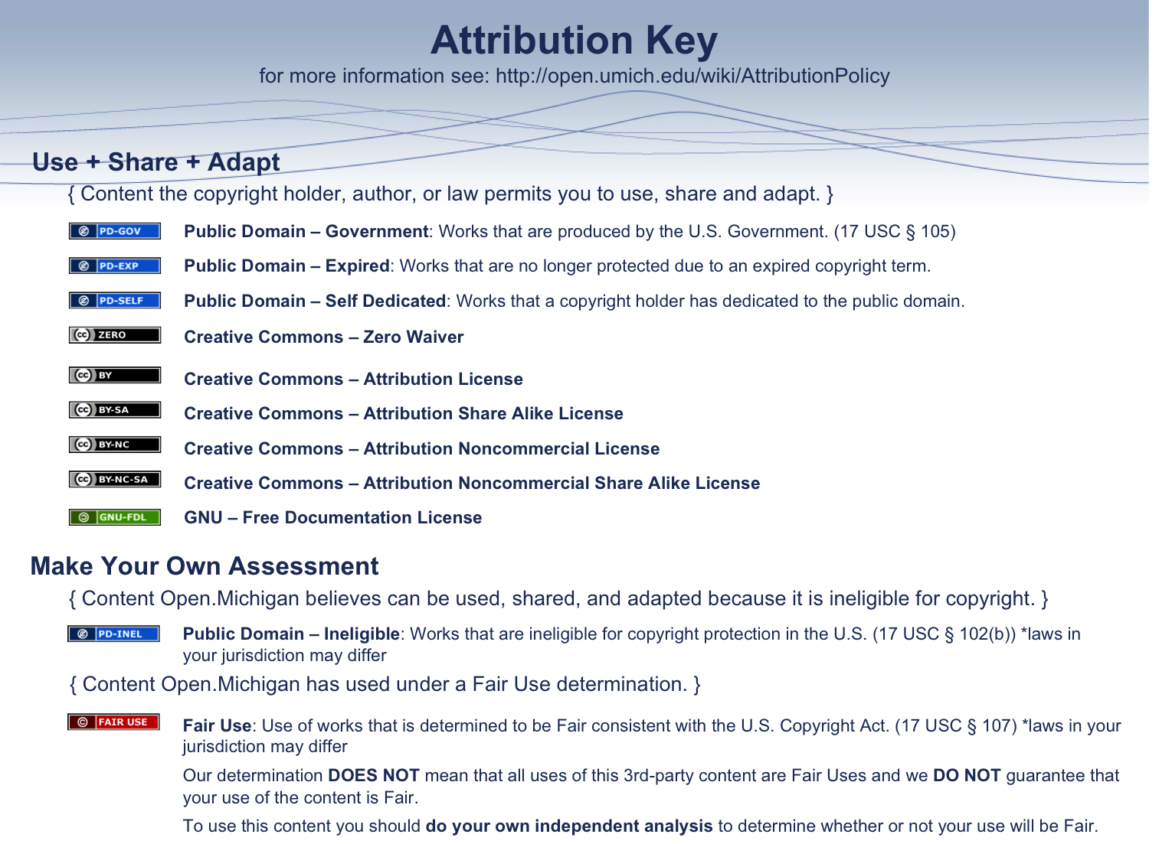Assessment Table:
ID | Unique_ID  Bioreserve | Township | Property_owner | Parcel | Date_assessed | . Wetland sheets | . Grassland sheets | Additional Data
5 | 604 | Lyndon | Bauer | 16-19-100-006, 16-19-100-012 | 7/12/2008 | 3 | 0
6 | 407 | Scio | Russell | H-08-12-400-001 | 6/18/2008 | 1 | 1
7 | 639 | Scio | Manny | H-08-19-300-003 | 7/6/2008 | 1 | 0
8 | 638 | Scio | Loveland | H-08-17-100-009-011 | 7/8/2008 | 1 | 0
11 | 644 | Scio | Allen Property | H-08-14-100-001 | 6/22/2008 | 1 | 0
12 | 399 | scio | Maxwell | H-08-33-200-013 | 8/4/2008 | 0 | 1
13 | 400 | Scio | Aprill | H-08-28-400-010 | 7/13/2009 | 1 | 0
14 | 639 | Scio | Parker | H-08-30-200-005 | 6/14/2008 | 3 | 0
15 | 292 | Lyndon | Kline |  | 7/26/2008 | 1 | 0
16 | 22 | Highland | Berent |  | 7/22/2008 | 1 | 0
17 | 386 | Lima | Adams | G-07-06-400-003 | 9/15/2008 | 2 | 0
18 | 314 | Freedom | Keen | N-14-34-300-001,N-14-34-300-001 | 6/17/2008 | 1 | 0
21 | 310 | Freedom | Sanford | 16-19-100-008 | 8/14/2008 | 0 | 1
22 | 310 | Freedom | Sanford2ndVisit | 11-02-300-012 | 8/15/2009 | 3 | 2

Parcel Table:
SiteName | Township | uniqueID | FinalRank | AcresThisPolygon | ParcelNumber | OwnerName | Address
Lyndon292Koker | LYNDON | 292 | 733 | 30 | E -05-06-100-003 | Koker | 123 Street
Lyndon298Lewis | LYNDON | 298 | 675 | 17 | E -05-18-300-014 | Lewis | 124 Street
Lyndon604Bauer | LYNDON | 604 | 816 | 31 | E -05-35-300-008 | Bauer | 125 Street
Lyndon604Bauer | LYNDON | 604 | 816 |  | E -05-35-300-008 | Bauer | 126 Street
Lyndon604Schneider | SYLVAN | 604 | 816 | 37 | F -06-02-200-013 | Schneider | 127 Street
Lyndon604Schneider | LYNDON | 604 | 816 |  | E -05-35-300-003 | Schneider | 128 Street
Freedom314Keen | FREEDOM | 314 | 500 |  | N -14-34-300-001 | Keen | 129 Street
Freedom314Keen | FREEDOM | 314 | 500 |  | N -14-34-300-002 | Keen | 130 Street
Scio399Maxwell | SCIO | 399 | 533 |  | H -08-33-200-013 | Maxwell | 131 Street
Scio400Aprill | SCIO | 400 | 558 |  | H -08-28-400-010 | Aprill | 132 Street
Scio403Umich | SCIO | 403 | 450 | 82 | H -08-26-400-001 | UofM | 133 Street
Scio406Ceppos | SCIO | 406 | 375 |  | H -08-14-440-800 | SCIO HILLS | 134 Street
Scio407Russel | SCIO | 407 | 525 |  | H -08-12-400-001 | Russel | 135 Street
Wetlands Survey Table:
ID | Unique ID | Township | Property owner | Parcel | Eco_unit | Date | Time_at_site | Size_wet | Hydro1
8 | 604 | Lyndon | Bauer | E-05-35-300-008 | wetland A&B | 7/12/08 | 2.5 | 12 | 0
9 | 604 | Lyndon | Bauer | E-05-35-300-008 | wetland C | 7/12/08 | 2.5 | 2.2 | 0
10 | 604 | Lyndon | Bauer | E-05-35-300-008 | wetland D | 7/12/08 | 2.5 | 2.2 | 0
11 | 407 | Scio | Russell | H-08-12-400-001 | wetland A | 6/18/08 | 2.0 | 1.1 | -1
12 | 639 | Scio | Manny | H-08-19-300-003 | wetland A | 7/6/08 |  | 4 | -1
14 | 638 | Scio | Loveland |  | wetland A | 7/8/08 | 03:30 | 3 | 0
17 | 644 | Scio | Allen | H-08-14-100-001 | wetland A | 6/22/08 | 2.5 | 2 | -1
18 | 400 | Scio | Aprill | H-08-28-400-010 | wetland A | 7/13/08 | 2.0 | 6 | 0
19 | 639 | Scio | Parker | H-08-30-200-005 | wetland A | 6/14/08 | 3.0 | 30 | 0
20 | 639 | Scio | Parker | H-08-30-200-005 | wetland B | 6/14/08 | 3.0 | 6 | 0
21 | 639 | Scio | Parker | H-08-30-200-005 | wetland C | 6/14/08 | 3.0 | 2 | 0
27 | 521 | Lima | Merkel | G-07-05-200-011, G-07-06-400-003 | wetland E | 8/18/08 |  | 1.5 | -1
30 | 292 | Lyndon | Kline |  | wetland A | 7/26/08 | 2:00 | 7 | -1
31 | 22 | Highland | Berent |  | wetland A | 7/22/08 | 10-12+ |  | 0

