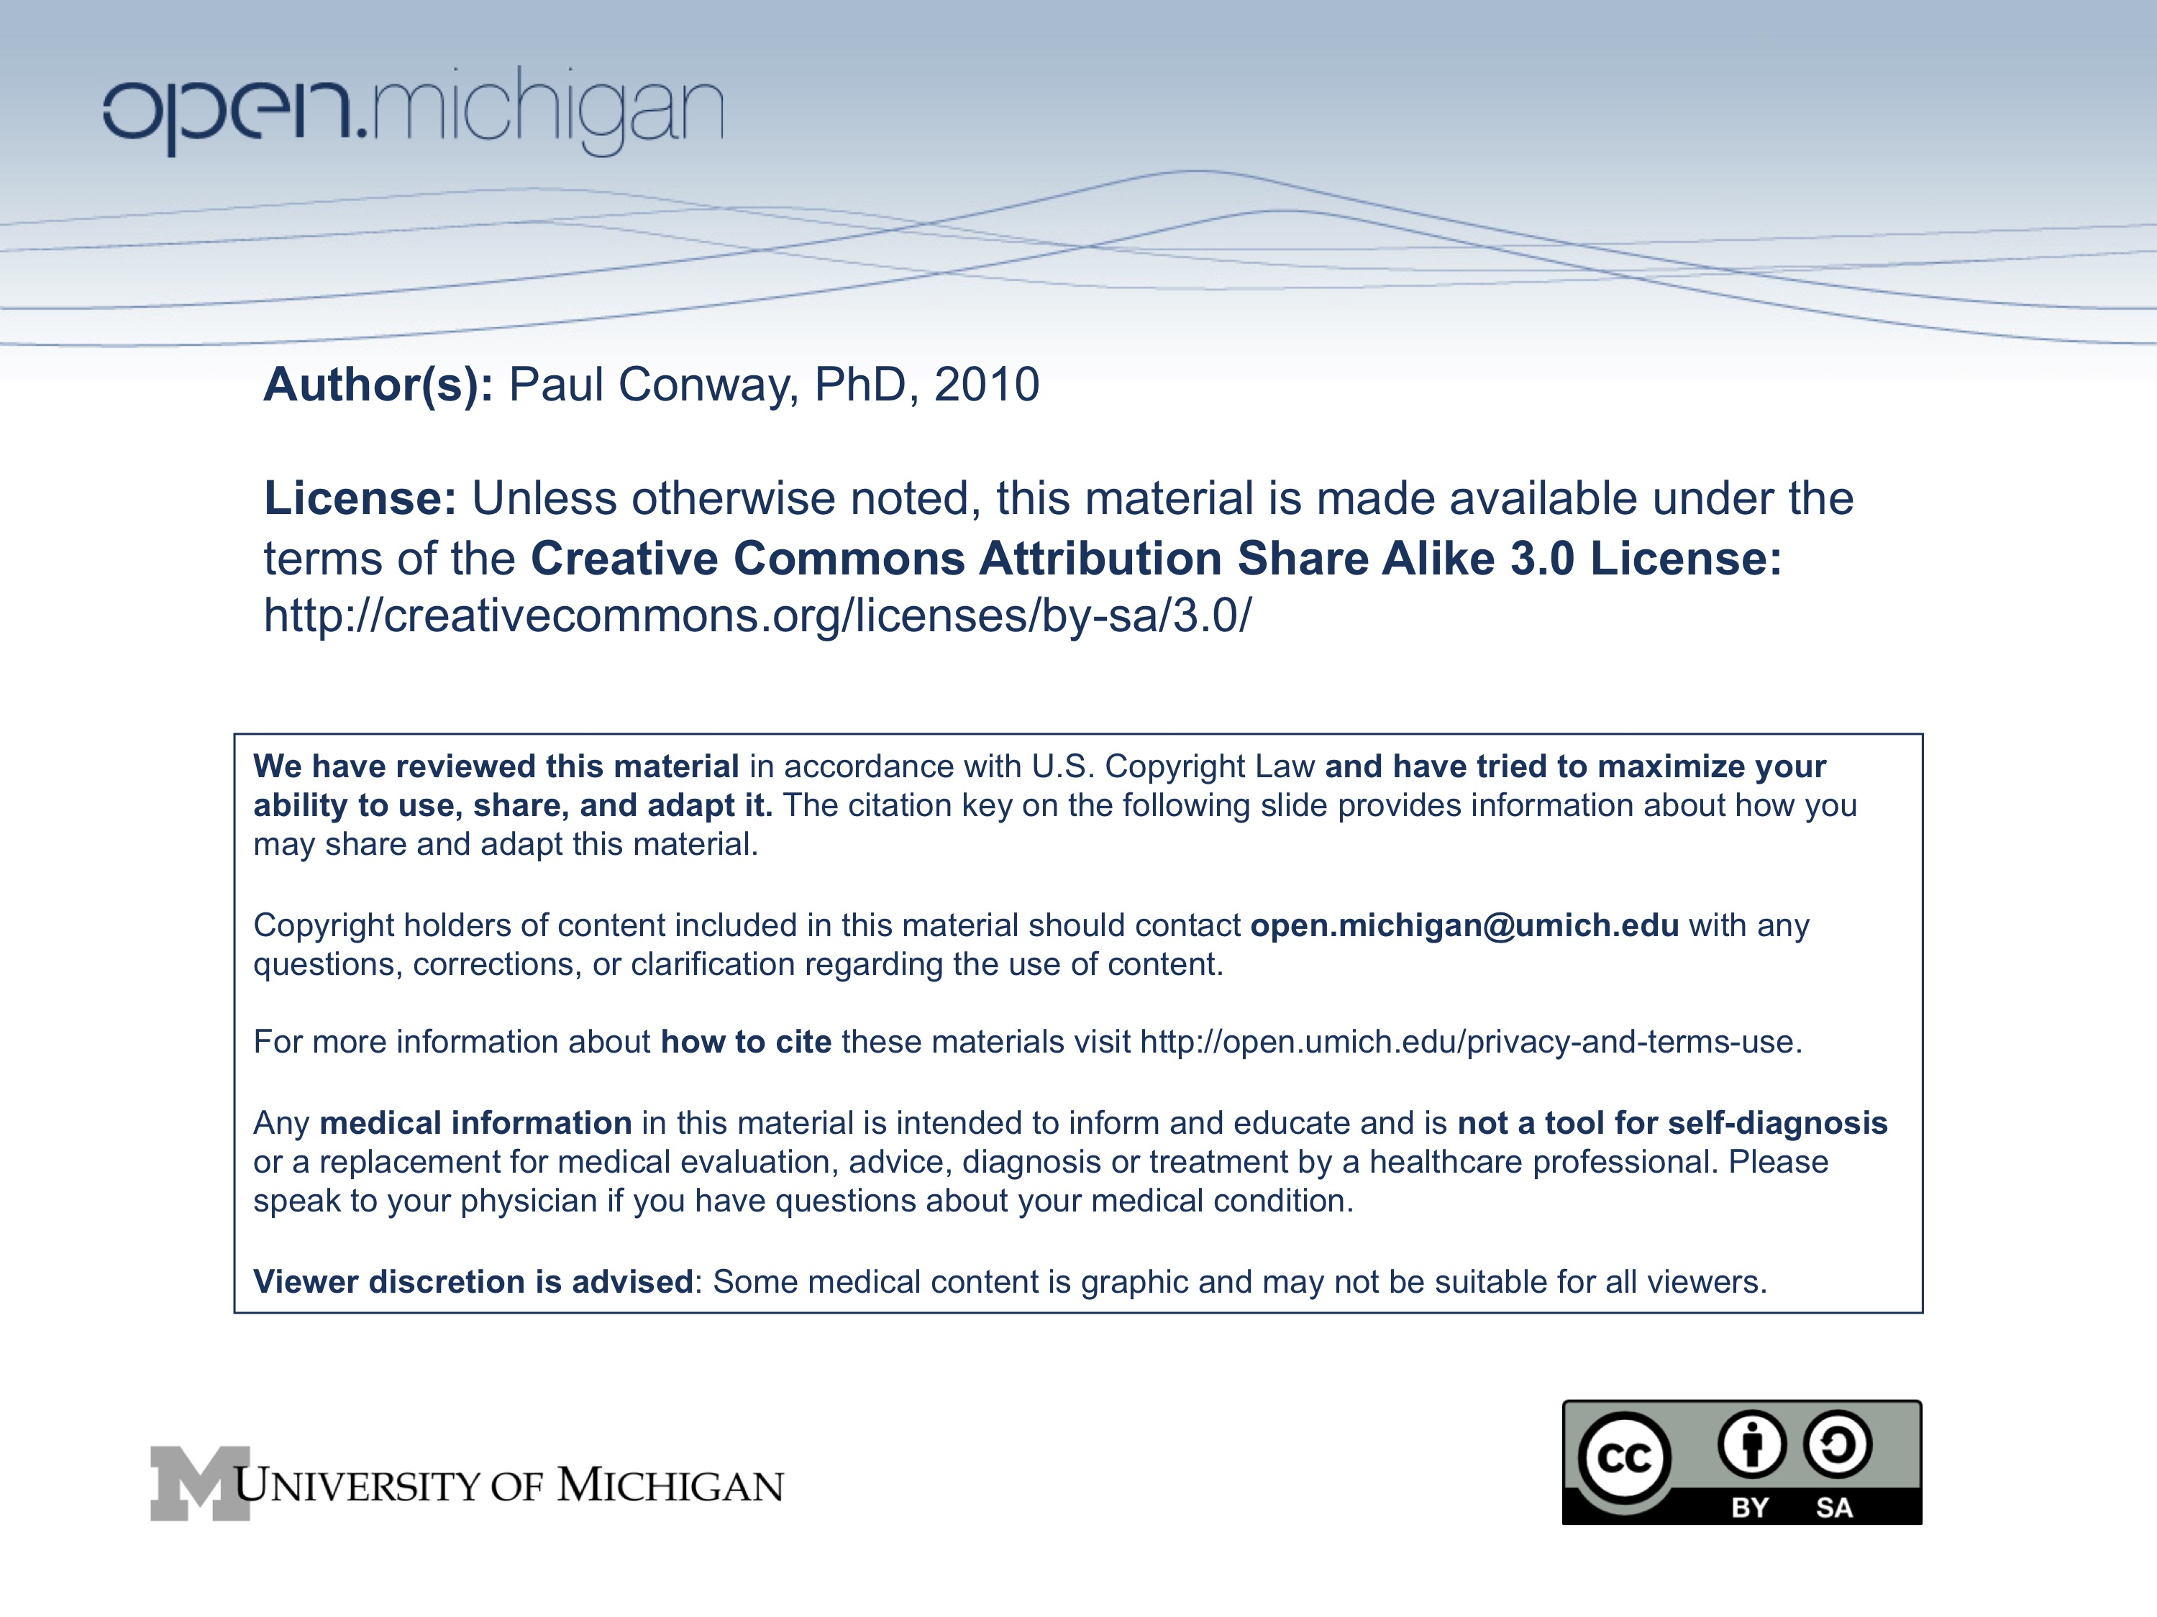

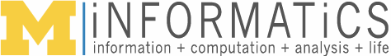

SI 410 Ethics and Information Technology

Reading and Discussion Guide 2
Information Integrity

This reading and discussion guide covers the three-week module on some of the key constructs of information integrity. This module focuses on what people do to either increase or decrease the trustworthiness of digital information. One assumption for this section of the course is that text in digital form is born and lives through human intervention. Another assumption is that how we understand the world and sometimes each other – how we interact with each other – is moderated through the design and administration of technology systems. Wikipedia is the case study for exploring the ethical issues of collaborative writing and editing. The guide also describes briefly the purpose of lab/discussion section.

Week 4: Information Integrity

- Tuesday September 28 Topic: Boundaries of Trust

Readings:
- Ebersbach, A., Glaser, M. , and Heigl, R., Wiki Web Collaboration, Chapter 1.1, “What is a Wiki?” Berlin: Springer, 2005, pp. 9-30.
- Mathiesen, K. “Censorship and Access to Expression,” in Himma and Tavani (2008), pp. 573-588.

What to Read For:

Ebersbach provides an excellent overview of both the theory and the technical practice behind wiki technologies. The theory is accessible and the tech talk is highly relevant to what we discuss with Wikipedia. Read this article as a model of what a wiki is, so that when we discuss Wikipedia and MediaWiki, you will have a context for discovering how collaborative content development works.

Much has been written on censorship in the Internet age. Mathiesen offers a definition that provides a moral basis for censorship. Read her chapter for that definition and how she works her way toward acceptable censorship.

Discussion Questions:
1. Is censorship always wrong? Who censors and why?

- Wednesday September 29

Lab/Discussion

The lab is a tutorial on the MediaWiki software tool that serves as a platform for the assignment in module 2. The lab will demonstrate the tool, provide an opportunity to practice, and explain the assignment.

- Thursday September 30 Topic: Wikipedia as an Information System

Readings:
- Riehle, D., “How and Why Wikipedia Works: An Interview with Angela Beesley, Elisabeth Bauer, and Kizu Naoko,” WikiSym ’06, August 21-23, Odense Denmark.
- Chesney, T., “An empirical examination of Wikipedia’s credibility,” First Monday 11 (November 2006). http://firstmonday.org/issues/issue11_11/chesney/index.html

What to read for:

Riehle interviews three people who are very actively involved in building and maintaining the reputation system that is a key part of Wikipedia’s trustworthiness. Read this interview both for the attitude of the three people about trust and also for some of the specific strategies utilized to tag potential error. You will be rewarded by following some of the links in the footnotes to Wikipedia policies and procedures.

Lots of researchers use Wikipedia as a testbed on trust and credibility. Chesney provides a short and precise report on a test of how experts view the credibility of authors and content by comparing assessments of traditional articles with Wikipedia articles.

Discussion questions:
1. How have you used Wikipedia and similar online information “supermarkets”?
2. Give an example or two of where you have found Wikipedia to be less than accurate, complete, or trustworthy in any way?
3. What are the barriers to your own contributions to Wikipedia?

Week 5: Information Integrity

- Tuesday October 5 Topic: Wikipedia and Trust Management

Required Readings:
- Wilkinson, D. M. and Huberman, B. A., “Assessing the value of cooperation in Wikipedia,” First Monday 12 (April 2007). http://firstmonday.org/issues/issue12_4/wilkinson/index.html
- Santana, A, and Wood, D., “Transparency and social responsibility issues for Wikipedia,” Ethics and Information Technology 11 (2009): 133-44.

What to look for:

Santana & Wood take a particular position on transparency of information in Wikipedia. Read this article for that position and decide for yourself how you feel about it. Given that alternative ways to handle authorship are emerging beyond Wikipedia, pay careful attention to how the authors of this chapter make their case.

Wilkinson presents a small, specific study of the relationship between the quality of Wikipedia articles and the number of edits. This article one of many that is trying to quantify information quality in a database of information that is too large for common, intuitive assessment.

Discussion questions:
1. Can trust in information quality be reduced to statistical probability?
2. How much is trust in information tied to knowing who the author is? Consider your position in the context of other web-based information.
3. What are the limits of transparency as an ethical principle applied to text?

- Wednesday October 6

Lab/Discussion

The lab this week is an advanced tutorial on the MediaWiki tool. Students will have an opportunity to share editing tricks. The use of images and references will be reviewed.

- Thursday October 7 Topic: Wikipedia and Anonymity

Readings:
- Zittrain, Jonathan. [2008]. “The Lessons of Wikipedia,” in The Future of the Internet and How to Stop It. New Haven: Yale University Press, Chapter 6, pp. 127-48.

What to read for:

Zittrain is an easy to read overview of what is particularly innovative and about Wikipedia. The focus of today’s discussion is on how to think about trust in information when you cannot know who is providing that information.

Discussion questions:
1. How is control exercised in Wikipedia?
2. Wikipedia has lots of errors, some detectible and some not. What are some strategies for identifying the weaknesses in Wikipedia content?

Week 6: Information Integrity

- Tuesday October 12 Topic: Plagiarism in the Online Environment

Readings:
- Snapper, J., “The Matter of Plagiarism: What, Why, and If,” in Himma and Tavani (2008), pp. 533-552.
- Wikipedia content reuse: http://wikimediafoundation.org/wiki/Press_releases/Dual_license_vote_May_2009

What to read for:

Snapper has an innovative approach to understanding plagiarism that avoids some of the “just don’t do it” admonitions that you hear all The issue for this week is re-use of content and how re-use and re-branding may affect trust and reliability. Read the new Wikipedia re-use license policy and the related policy documents on Wikipedia itself.

Discussion questions:
1. What is plagiarism? Think creatively.
2. How do we find the boundaries of plagiarism in the online environment?

- Wednesday October 13

Lab/Discussion

This is a discussion session designed to help synthesize the readings and lectures for this module.

- Thursday October 14 Topic: Enforcing Integrity

Readings:
- de Laat, P., “Trusting virtual trust,” Ethics and Information Technology 7 (2005): 167-80.
- Read Wikipedia entries for Bots and Bureaucrats

What to read for:

On the surface, de Laat has nothing to say about Wikipedia or trust in text oriented information. Indeed, the focus of this piece is on virtual environments and trust, an issue with which we are now familiar. You should read de Laat for the two forms of trust (reliance and confidence) and how the author applies these ideas in the Internet context.

Discussion questions:
1. In what ways is Wikipedia “like” a virtual environment?
2. How is trust managed (controlled) in Wikipedia? What happens when trust is violated?
3. How does Wikipedia handle censorship, both as a matter of community practice and as a matter of control?

Week 7: Study Break and Presentations

- Tuesday October 19 Study Break: No Class

- Wednesday October 20 Topic: Student Presentations
- Thursday October 21 Topic: Student Presentations

The lab session and the following day’s lecture session features brief (5 minute) individual presentations on the content and technical issues associated with constructing collaborative content in MediaWiki.

